# Violence and voting: Evidence from the 2006, 2011, and 2018 Presidential Elections in the Democratic Republic of Congo[1]

John Quattrochi  
Georgetown University

17 January 2023

# Abstract

How do voters respond to internationalized civil conflict? Do they rally around the incumbent, or hold him accountable? Do combatant identities and civilian killings matter? We combine a novel dataset of district-level (n=166) vote counts across three presidential elections in the Democratic Republic of Congo (DRC) with publicly-available conflict data on a war involving 122 groups. We find that more conflict in the preceding 5-7 years is associated with higher incumbent vote share in the 2006 election, lower vote share in 2011, and is uncorrelated with vote share in 2018. Disaggregating by combatant identity, civilian killings by Congolese armed groups or foreign states, and conflict between foreign states and foreign non-state groups, were associated with increased incumbent support, consistent with a rally effect. However, conflict between Congolese armed groups, or between those groups and the DRC military, and civilian killings by foreign groups or the DRC military were associated with decreased incumbent support, consistent with an accountability effect. We argue that intergroup bias explains why combatant identity matters. Intra-Congolese conflicts make subnational identity more salient, decreasing incumbent support, whereas conflict with foreign actors makes national identity more salient, increasing incumbent support.

# Introduction

Do voters punish incumbents for violent conflict? On one hand, violent conflict may be seen as the state failing to maintain peace and order, a failure for which the incumbent could be held accountable in competitive elections (Downs 1957; Ashworth 2012). Violence has been associated with less electoral support for or lower trust in the head of state in Columbia, Mali, Nepal, Peru, and Turkey (Weintraub, Vargas, and Flores 2015; Birnir and Gohdes 2018; Gates and Justesen 2020; De Juan and Pierskalla 2016; Aksoy and Carlson 2022; Kibris 2011; Gallego 2018)

On the other hand, voters may rally around the flag in response to conflict, and increase incumbent support (Lee 1977). While most evidence for this theory comes from the developed world, several recent studies from the developing world show that violence can increase incumbent support in democracies where right-wing parties are seen as protectors of national security (Hintson and Vaishnav 2021), and in subnational regions with very low or high levels of violence (Weintraub, Vargas, and Flores 2015; Birnir and Gohdes 2018).

Voters’ reactions to violence also likely depend on the identities of the conflict actors. Violence by foreign groups may be more likely to trigger a rally around the flag effect, if the salience of insider loyalties increases, and the incumbent is seen as the chief insider. In contrast, violence instigated by domestic groups may be seen as indicative of the executive failing to maintain law and order.

# Conflict and elections in DRC

On 1 Oct 1990, the Rwandan Patriotic Front, with assistance from Uganda, invaded Rwanda, reigniting an old conflict that has yet to be contained. By the end of the 1994 genocide of Tutsis and moderate Hutus, nearly two million Rwandans and Burundians had fled into DRC. beginning a series of conflicts that continues to the present day. After X years of relative peace, a series of conflicts over land between local ethnic groups began in eastern Congo in the early 1990s. This insecurity was exacerbated by an influx of approximately one million Rwandan refugees following the civil war and genocide in 1994. The refugees included the government in power at the time of the genocide and a fraction of its military, the FDLR. The new Rwandan regime, the RPF, regarded this as a security threat, and did not view the Congolese President, Mobutu Sese Seko, as a credible ally. Thus the Rwandans, in partnership with Uganda, organized a Congolese-fronted rebellion in 1996 that marched across the DRC and deposed Mobutu in 1997. This is referred to as the First Congolese War. The Second Congolese War began in 1998 when the Congolese frontman, now president, Laurent Kabila, ordered that his Rwandan allies leave the DRC. The Congolese territory was quickly parceled into three pieces: one controlled by Kabila out of Kinshasa, one by Rwanda, and one by Uganda.

# Hypotheses

In the UCDP dataset, there are 122 armed groups who were involved in at least one conflict event in DRC from 2001 to 2018, and 57 that experienced at least one death. I divide them into four categories: (i) DRC military, (ii) Congolese armed groups, (iii) foreign non-state armed groups, and (iv) foreign states and their proxies.

H1: DRC military killing civilians will decrease incumbent support

H2: DRC military conflict with Congolese armed groups will decrease incumbent support

H3: DRC military conflict with foreign groups will increase incumbent support

H4: Conflict between Congolese armed groups, foreign groups, or foreign states and their proxies will decrease incumbent support

# Data and empirical approach

## Data

The dependent variable, territory-level vote share for the incumbent, was constructed using three datasets (one for each presidential election in 2006, 2011, and 2018). The 2006 results consist of vote counts for each territory (n=193) as published in (Saint Moulin 2006).

The 2011 results were never officially released at the territory level. From a journalist, we obtained provisional results from 164 electoral wards (*circonscription electorale)* that include a total of 17,789,995 votes, 98.1% of the vote number reported by the Carter Center’s election observers.(Carter Center 2011) We are missing votes for the territories of Kiri (Bandundu province), and Mambasa, Niangara, Wamba, and Watsa (Orientale province).

The 2018 results consist of “a partial tally of election results from the central database of the Independent National Electoral Commission (CENI)…which was leaked by a whistleblower.”(Stearns 2019) The data are at the level of voting site, with roughly 300-4,000 votes per site, and roughly 16,380 sites, for a total of 14,712,827 votes (80% of the total valid votes reported by the CENI). We aggregated votes to the territory level. We are missing votes for the territories of Beni, Beni Ville, Butembo (North Kivu), and Yumbi (ex-Bandundu, now Mai-Ndombe).

Conflict data came from the UCDP GED dataset (Sundberg and Melander 2013), which includes geocoded conflict events that (i) feature at least 1 fatality; and (ii) involve only organized armed groups that have fought in battles that directly caused at least 25 fatalities. These data are based on print, radio, and television reports from regional newswires, major and local newspapers, secondary sources, and expert knowledge. Eck (2012) found that UCDP have higher quality and include many more events in rural and remote areas compared to ACLED.

In the UCDP dataset, there are 122 armed groups who were involved in at least one conflict event in DRC from 2001 to 2018, and 57 that experienced at least one death. I divide them into four categories: (i) DRC military, (ii) Congolese armed groups, (iii) foreign non-state armed groups, and (iv) foreign states and their proxies.

H1: DRC military killing civilians will decrease incumbent support

H2: DRC military conflict with Congolese armed groups will decrease incumbent support

H3: DRC military conflict with foreign groups will increase incumbent support

H4: Conflict between Congolese armed groups, foreign groups, or foreign states and their proxies will decrease incumbent support

Voters near the conflict are more likely to identify with the armed groups (armed groups as in-group), whereas voters far away are more likely to identify with the national military.

A more parsimonious categorization of these groups would be foreign and domestic. However, given that local affinities to ethnic group or region may outweigh affinity to the nation, it is not clear who is the outside or insider in each conflict. One might think that the DRC military would be perceived as an insider, but it has at times integrated armed groups who were likely serving as proxies for Rwanda or Uganda. Many Congolese armed groups were originally organized for self-defense, and thus would be perceived as domestic, yet some ally with foreign countries. I have attempted to include all such allies in ‘foreign states and their proxies’, but it is possible that I mischaracterized some. Foreign non-state armed groups and foreign states and their proxies are likely to be perceived as foreign.

As a sensitivity analysis, I repeat the main analyses with an alternate conflict dataset from ACLED (Clionadh et al. 2010). The ACLED data include 546 groups with at least one event in the study period, and 344 with at least one fatality (Table 18). For 'deaths', we use all fatalities from battles, explosions/remote violence, riots, and violence against civilians. We do not include fatalities from protests (there are 24 such fatalities during the study period) (Table 19). For conflict events, we again exclude protests, and also strategic developments.

## Empirical approach

The unit of analysis is the territory, analogous to a county in the United States. To estimate the effect of changes in conflict on changes in vote share, we used two-way fixed effect models:

(1)

where is the vote share for the incumbent in territory *i* in election year *t.* and are fixed effects for territory and election year, respectively. This controls for time-invariant characteristics of territories and for the country-wide secular trend in support for the incumbent. We model conflict events and conflict deaths separately. Due to the severe right-skew of the conflict data, we repeat the analysis with log events and deaths. Conflict includes all deaths or events in the five years preceding the election. captures the effect of changes in conflict across two pre-election periods on changes in vote share across two elections.

The validity of two-way fixed effects models relies on multiple assumptions that may not hold in this context, namely: constant treatment effects within treated units; past treatments do not affect current outcomes; and past outcomes do not affect current treatment (Jakiela 2021; Imai and Kim 2019). Therefore, we also model each election period separately:

(2)

In additional models of the 2011 and 2018 elections, we add controls for vote share in previous elections

We then disaggregate conflict by conflict actor dyads, and model vote share as a function of dyad-specific conflict:

(3)

Again, in these models for the 2011 and 2018 elections, we control for vote share in earlier elections.

# Results

Kabila’s share of the vote declined from 58% in 2006 to 49% in 2011, and Shadary (his chosen successor) garnered just 19% in 2018. His support was initially concentrated in the east (**Figure 1**). He made some gains in the west (particularly the southwest) and southeast in 2011, before losing support throughout the country in 2018 (Figure 2). In 2018 Shadary improved on Kabila’s 2011 vote share in less than 10 territories (Figure 3).

The UCDP data record 39,626 conflict deaths in 2,978 events in DRC between 30 July 2001 and 30 Dec 2018 (Table 22).

**Associations between incumbent vote share and aggregate conflict**

In the 2006 election, voters in territories that experienced higher levels of conflict since the incumbent took office in 2001 were more likely to choose the incumbent. A 1% higher level of conflict events was associated with 0.6 percentage points higher vote share for the incumbent. A 1% higher level of conflict deaths was associated with 0.3 percentage points higher vote share for the incumbent. The direction and statistical significance of these associations remain consistent when using the alternative conflict dataset (ACLED) and when modeling spatial dependence.

In the 2011 election, in our preferred specification which controls for 2006 vote share and 2001-2006 conflict, voters in territories that experienced higher levels of conflict since the 2006 election were less likely to choose the incumbent. A 1% higher level of conflict events was associated with 0.2 percentage points lower vote share for the incumbent. A 1% higher level of conflict deaths was associated with 0.1 percentage points lower vote share for the incumbent.

In the 2018 election, in our preferred specification which controls for 2006 and 2011 vote share and 2001-2011 conflict, voters in territories that experienced higher levels of conflict since the 2011 election were no more or less likely to choose the incumbent. However, conflict in 2006-2011 was again negatively associated with incumbent support.

**Associations between incumbent vote share and conflict disaggregated by combatant identities**

In the 2001-2006 period, the most deaths occurred in conflict between Congolese armed groups and civilians (4,731 deaths), followed by foreign states and their proxies and civilians (3,863), and Congolese armed groups and other Congolese armed groups (2,155).

In the 2006-2011 period, the most deaths occurred in conflict between foreign groups and civilians (2,235), which is particularly striking since there were zero such deaths in 2001-2006. Conflicts between Congolese armed groups and foreign states/proxies resulted in nearly as many deaths (2,227). Conflicts between Congolese armed groups and civilians accounted for the next highest number of deaths (1,281). From 2001-2006 to 2006-2011 deaths from conflicts involving the FARDC more than doubled: from 909 to 2,710.

In the 2011-2018 period, the most deaths occurred in conflicts between the FARDC and Congolese armed groups (4,919).(Table 18)

In the 2006 election, incumbent vote share was positively associated with conflict between foreign non-state groups and foreign states, and with civilian killings by Congolese non-state groups and by foreign states (Table 11). Incumbent vote share was negatively associated with conflict between Congolese non-state groups, and between those groups and the FARDC.

In the 2011 election, in our preferred specification which controls for 2006 vote share, incumbent vote share is negatively associated with 2001-2011 conflict between Congolese armed groups and the FARDC, and civilian killings by the FARDC and foreign groups. (Table 12).

In the 2018 election, in our preferred specification with controls for 2006 and 2011 vote share, incumbent vote share is negatively associated with 2001-2018 conflicts between Congolese armed groups. Incumbent vote share is positively associated with civilian killings by Congolese armed groups (Table 13).

An alternative approach simply distinguishes between civilian and non-civilian deaths. In 2006, civilian deaths are associated with higher support for Kabila. In 2011, controlling for 2006 vote share, non-civilian deaths 2001-2006 and civilian deaths 2006-2011 are associated with lower incumbent support. In 2018, controlling for 2006 and 2011 vote share, again non-civilian deaths 2001-2006 and civilian deaths 2006-2011 are associated with lower incumbent support, and civilian deaths 2011-2018 are associated with higher incumbent support. Some of these associations are conditional on whether or not deaths are log transformed.

While these correlations may not be causal, they are consistent with theories that voters respond to changes in security conditions, even in a young democracy in which ethnicity and patronage are thought to be major determinants of vote share. The results suggest that voters punish the incumbent for incursions by neighboring states, and reward the incumbent for military action against domestic armed groups.

# Discussion

The incumbent president lost some support between the 2006 and 2011 elections, and then his chosen successor lost a large amount of support in the 2018 elections. At the territory level, these changes are associated with changes in nightlights; areas that became brighter supported the incumbent less. However, very few areas experienced any change in nightlights. Changes in exposure to conflict were also associated with changes in support. Areas which saw increased conflict between non-state armed groups and civilians, and between non-state armed groups and the national military, increased their support for the incumbent. In contrast, areas which saw increased conflict between foreign militaries and non-state armed groups decreased their support for the incumbent.

## Limitations

This study uses observational data. Territories were not randomly assigned to electrification or to armed conflict. The measured associations may not be causal, but instead driven by omitted variables. Theory and evidence from other studies suggest that the economic well-being of households, and access to public services like education, water, and sanitation, may also be important for vote share.

This study analyzes changes after the 2006 election. It is possible that the influence of post-2006 events depends on pre-2006 events, such as earlier waves of conflict and violence during the First (1997) and Second (1998-2003) Congo Wars.

This study uses aggregate data. The associations observed at the level of the territory may not hold at the individual level. For example, while we find that areas experiencing more conflict between non-state armed groups and civilians increased their support for the incumbent, that may be driven by the individuals in those areas who were least exposed to those conflicts. In other words, within territories, it may be that individuals who were most exposed to this type of conflict *decreased* their support of the incumbent, but that was outweighed at the aggregate level by individuals less exposed.

# References

Aksoy, Deniz, and David Carlson. 2022. “Electoral Support and Militants’ Targeting Strategies.” *Journal of Peace Research* 59 (2): 229–41. https://doi.org/10.1177/00223433211047719.

Ashworth, Scott. 2012. “Electoral Accountability: Recent Theoretical and Empirical Work.” *Annual Review of Political Science* 15: 183–201.

Birnir, Jóhanna K, and Anita Gohdes. 2018. “Voting in the Shadow of Violence: Electoral Politics and Conflict in Peru.” *Journal of Global Security Studies* 3 (2): 181–97. https://doi.org/10.1093/jogss/ogy001.

Carter Center. 2011. “Presidential and Legislative Elections in the Democratic Republic of the Congo.” https://aceproject.org/ero-en/regions/africa/CD/democratic-republic-of-congo-final-report.

Clionadh, Raleigh, Andrew Linke, Håvard Hegre, and Joakim Karlsen. 2010. “Introducing ACLED-Armed Conflict Location and Event Data.” *Journal of Peace Research* 47 (5): 651–60.

De Juan, Alexander, and Jan Henryk Pierskalla. 2016. “Civil War Violence and Political Trust: Microlevel Evidence from Nepal.” *Conflict Management and Peace Science* 33 (1): 67–88. https://doi.org/10.1177/0738894214544612.

Downs, Anthony. 1957. “An Economic Theory of Political Action in a Democracy.” *Journal of Political Economy* 65 (2): 135–50.

Gallego, Jorge. 2018. “Civil Conflict and Voting Behavior: Evidence from Colombia.” *Conflict Management and Peace Science* 35 (6): 601–21. https://doi.org/10.1177/0738894218788362.

Gates, Scott, and Mogens K. Justesen. 2020. “Political Trust, Shocks, and Accountability: Quasi-Experimental Evidence from a Rebel Attack.” *Journal of Conflict Resolution* 64 (9): 1693–1723. https://doi.org/10.1177/0022002720906446.

Hintson, Jamie, and Milan Vaishnav. 2021. “Who Rallies Around the Flag? Nationalist Parties, National Security, and the 2019 Indian Election.” *American Journal of Political Science* n/a (n/a). https://doi.org/10.1111/ajps.12677.

Imai, Kosuke, and In Song Kim. 2019. “When Should We Use Unit Fixed Effects Regression Models for Causal Inference with Longitudinal Data?” *American Journal of Political Science* 63 (2): 467–90.

Jakiela, Pamela. 2021. “Simple Diagnostics for Two-Way Fixed Effects.” *ArXiv Preprint ArXiv:2103.13229*.

Kibris, Arzu. 2011. “Funerals and Elections: The Effects of Terrorism on Voting Behavior in Turkey.” *Journal of Conflict Resolution* 55 (2): 220–47. https://doi.org/10.1177/0022002710383664.

Lee, Jong R. 1977. “Rallying around the Flag: Foreign Policy Events and Presidential Popularity.” *Presidential Studies Quarterly* 7 (4): 252–56.

Saint Moulin, Léon de. 2006. “Les Leçons Du Premier Tour de l’élection Présidentielle En RDC.” *Congo-Afrique: Économie, Culture, Vie Sociale* 46 (408): 332–54.

Stearns, Jason. 2019. “Who Really Won the Congolese Elections?” Congo Research Group | Groupe d’Etude Sur Le Congo. 2019. http://congoresearchgroup.org/congolese-election-leaks/.

Sundberg, Ralph, and Erik Melander. 2013. “Introducing the UCDP Georeferenced Event Dataset.” *Journal of Peace Research* 50 (4): 523–32.

Weintraub, Michael, Juan F Vargas, and Thomas E. Flores. 2015. “Vote Choice and Legacies of Violence: Evidence from the 2014 Colombian Presidential Elections.” *Research & Politics* 2 (2): 2053168015573348. https://doi.org/10.1177/2053168015573348.

**APPENDIX**

**Conflict in Yumbi (missing 2018 votes)**

In Yumbi, “On December 16 and 17, 2018, hundreds of ethnic Batende [farmers] assailants killed at least 535 people and wounded 111 more, [mostly ethnic Banunu, fishers] though the actual death toll is most likely much higher. The assailants also damaged, destroyed, and pillaged more than 1,500 houses as well as health centers, schools, and polling places, according to witnesses, the United Nations, and the Congolese government.”  
“The ostensible cause of the violence was the secret burial of a Banunu customary chief on private land claimed by the Batende on the night of December 14, said Batende leaders and a UN report. The region has long experienced rivalries between the two groups over customary land rights.”  
“The tensions in Yumbi territory stem in part from a 1943 decision by the Belgian colonial administration that gave some of the land previously controlled by Batende customary leaders to the Banunu. The fight over land is often a top issue during elections in rural areas, with constituencies largely voting for members of their own ethnic group, whom they believe will protect their interests and access to land. In the Yumbi region, elections have been flashpoints for violence. Clashes broke out during both the 2006 and 2011 elections.”  
“The authorities arrested Jean-Paul Leka Mbaka, the sector chief of Mongama, 40 kilometers from Yumbi, following the massacres. A senior judicial officer said that Mbaka had been detained because he had “spoken to local Batende chiefs who mobilized young Batende for the attack. There were meetings in his village [Mongama]. All the youth met in Mongama to go attack Yumbi [town] and other villages.”  
https://www.hrw.org/news/2019/12/19/dr-congo-no-justice-2018-yumbi-massacres

**Delayed voting in Beni and Butembo (missing 2018 votes)**

Explaining the delay, the CENI cited “the persistence of the Ebola epidemic that continues to dangerously strike the electoral districts of Beni, the city of Beni and the city of Butembo…as well as the terrorist threat that lingers in the region”.  
<https://www.africanews.com/2018/12/26/drc-polls-ceni-says-no-election-in-beni-butembo-and-yumbi-cities-until-march//>

**Luminosity as a proxy for economic development**

Most territories did not experience any change in luminosity between 2006 and 2018 (Figure 4).

**Alternative conflict actor categorization: DRC military; foreign state; domestic non-state; foreign non-state; civilians.**

Deaths and events involving non-state armed groups vs civilians increase incumbent support (Table 2: columns 3,6, and 7). Deaths (but not events) involving DRC military vs non-state armed groups increase incumbent support. Events (but not deaths) in foreign military vs non-state armed groups decrease incumbent support. There are no associations between vote share and non-state vs non-state conflict, foreign military and civilian conflict, nor DRC military and civilian conflict. Nor are there associations between deaths suffered by any particular actor and vote share (column 7).

Each additional conflict death in non-state armed groups vs civilians is associated with a 0.00013 increase in incumbent support (p=0.02).

Each additional conflict death in DRC military vs armed groups is associated with an increase in incumbent support by 0.004 (p=0.002).

Each additional conflict death in foreign military vs armed groups is associated with a decrease in incumbent support by 0.0003 (p=0.001).

Each additional conflict event between non-state armed groups is marginally associated with a 0.003 decrease in incumbent support

**Figure @. Conflict deaths in the Kivus and Ituri, from Kivu Security Tracker, 2017 to 2021**

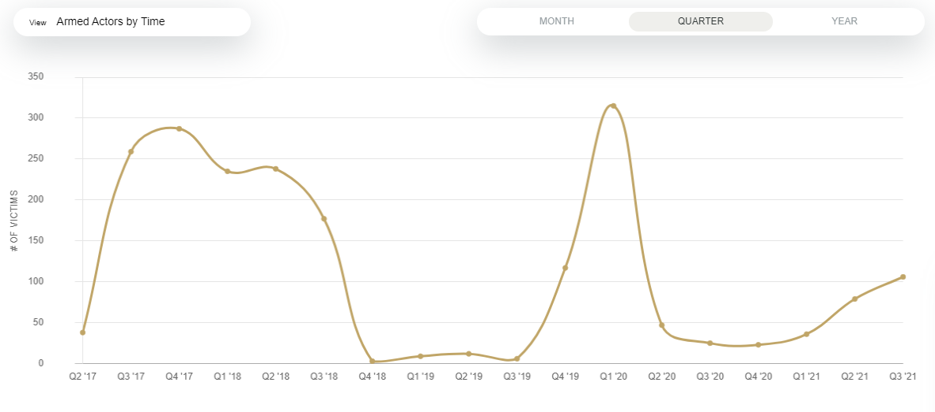

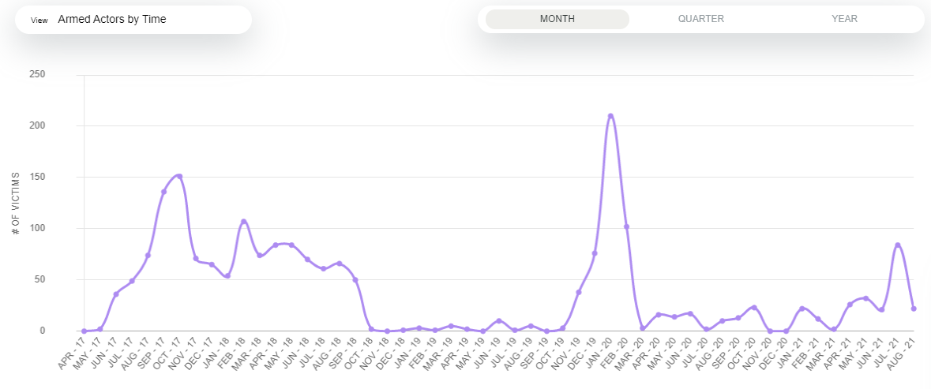

**Table @. Turnout by election**

|  |  |
| --- | --- |
|  | **2011** |
| Total registered voters | 32 024 640 |
| Total votes | 18 911 572 |
| Participation | 58,81% |
| Blank or null votes | 768 468 |
| Total polling stations | 63 865 |
| Polling stations reporting | 60 417 |
| Reporting percentage | 94,60% |
| Votes cast | 18 143 104 |
| Source: Commission électorale nationale indépendante septembre 2011, as cited in Makutu and Tshimananga | |

**Timeline of key events**

1996-1997 First Congo War. Laurent Kabila, backed by Rwanda and Uganda, overthrows Mobutu.

1998-2003 Second Congo War. RCD armed group formed with Rwandan and Ugandan support.

2006 Elections. CNDP (successor to RCD) is established with support from Rwanda.

2009 Peace deal between CNDP and DRC

2011 Elections

2012-2013 M23 rebellion (successor to CNDP), created and supported by Rwanda

2018 Elections

# Figures and tables

Figure . Vote share for Kabila/Shadary, 2006, 2011, and 2018 elections

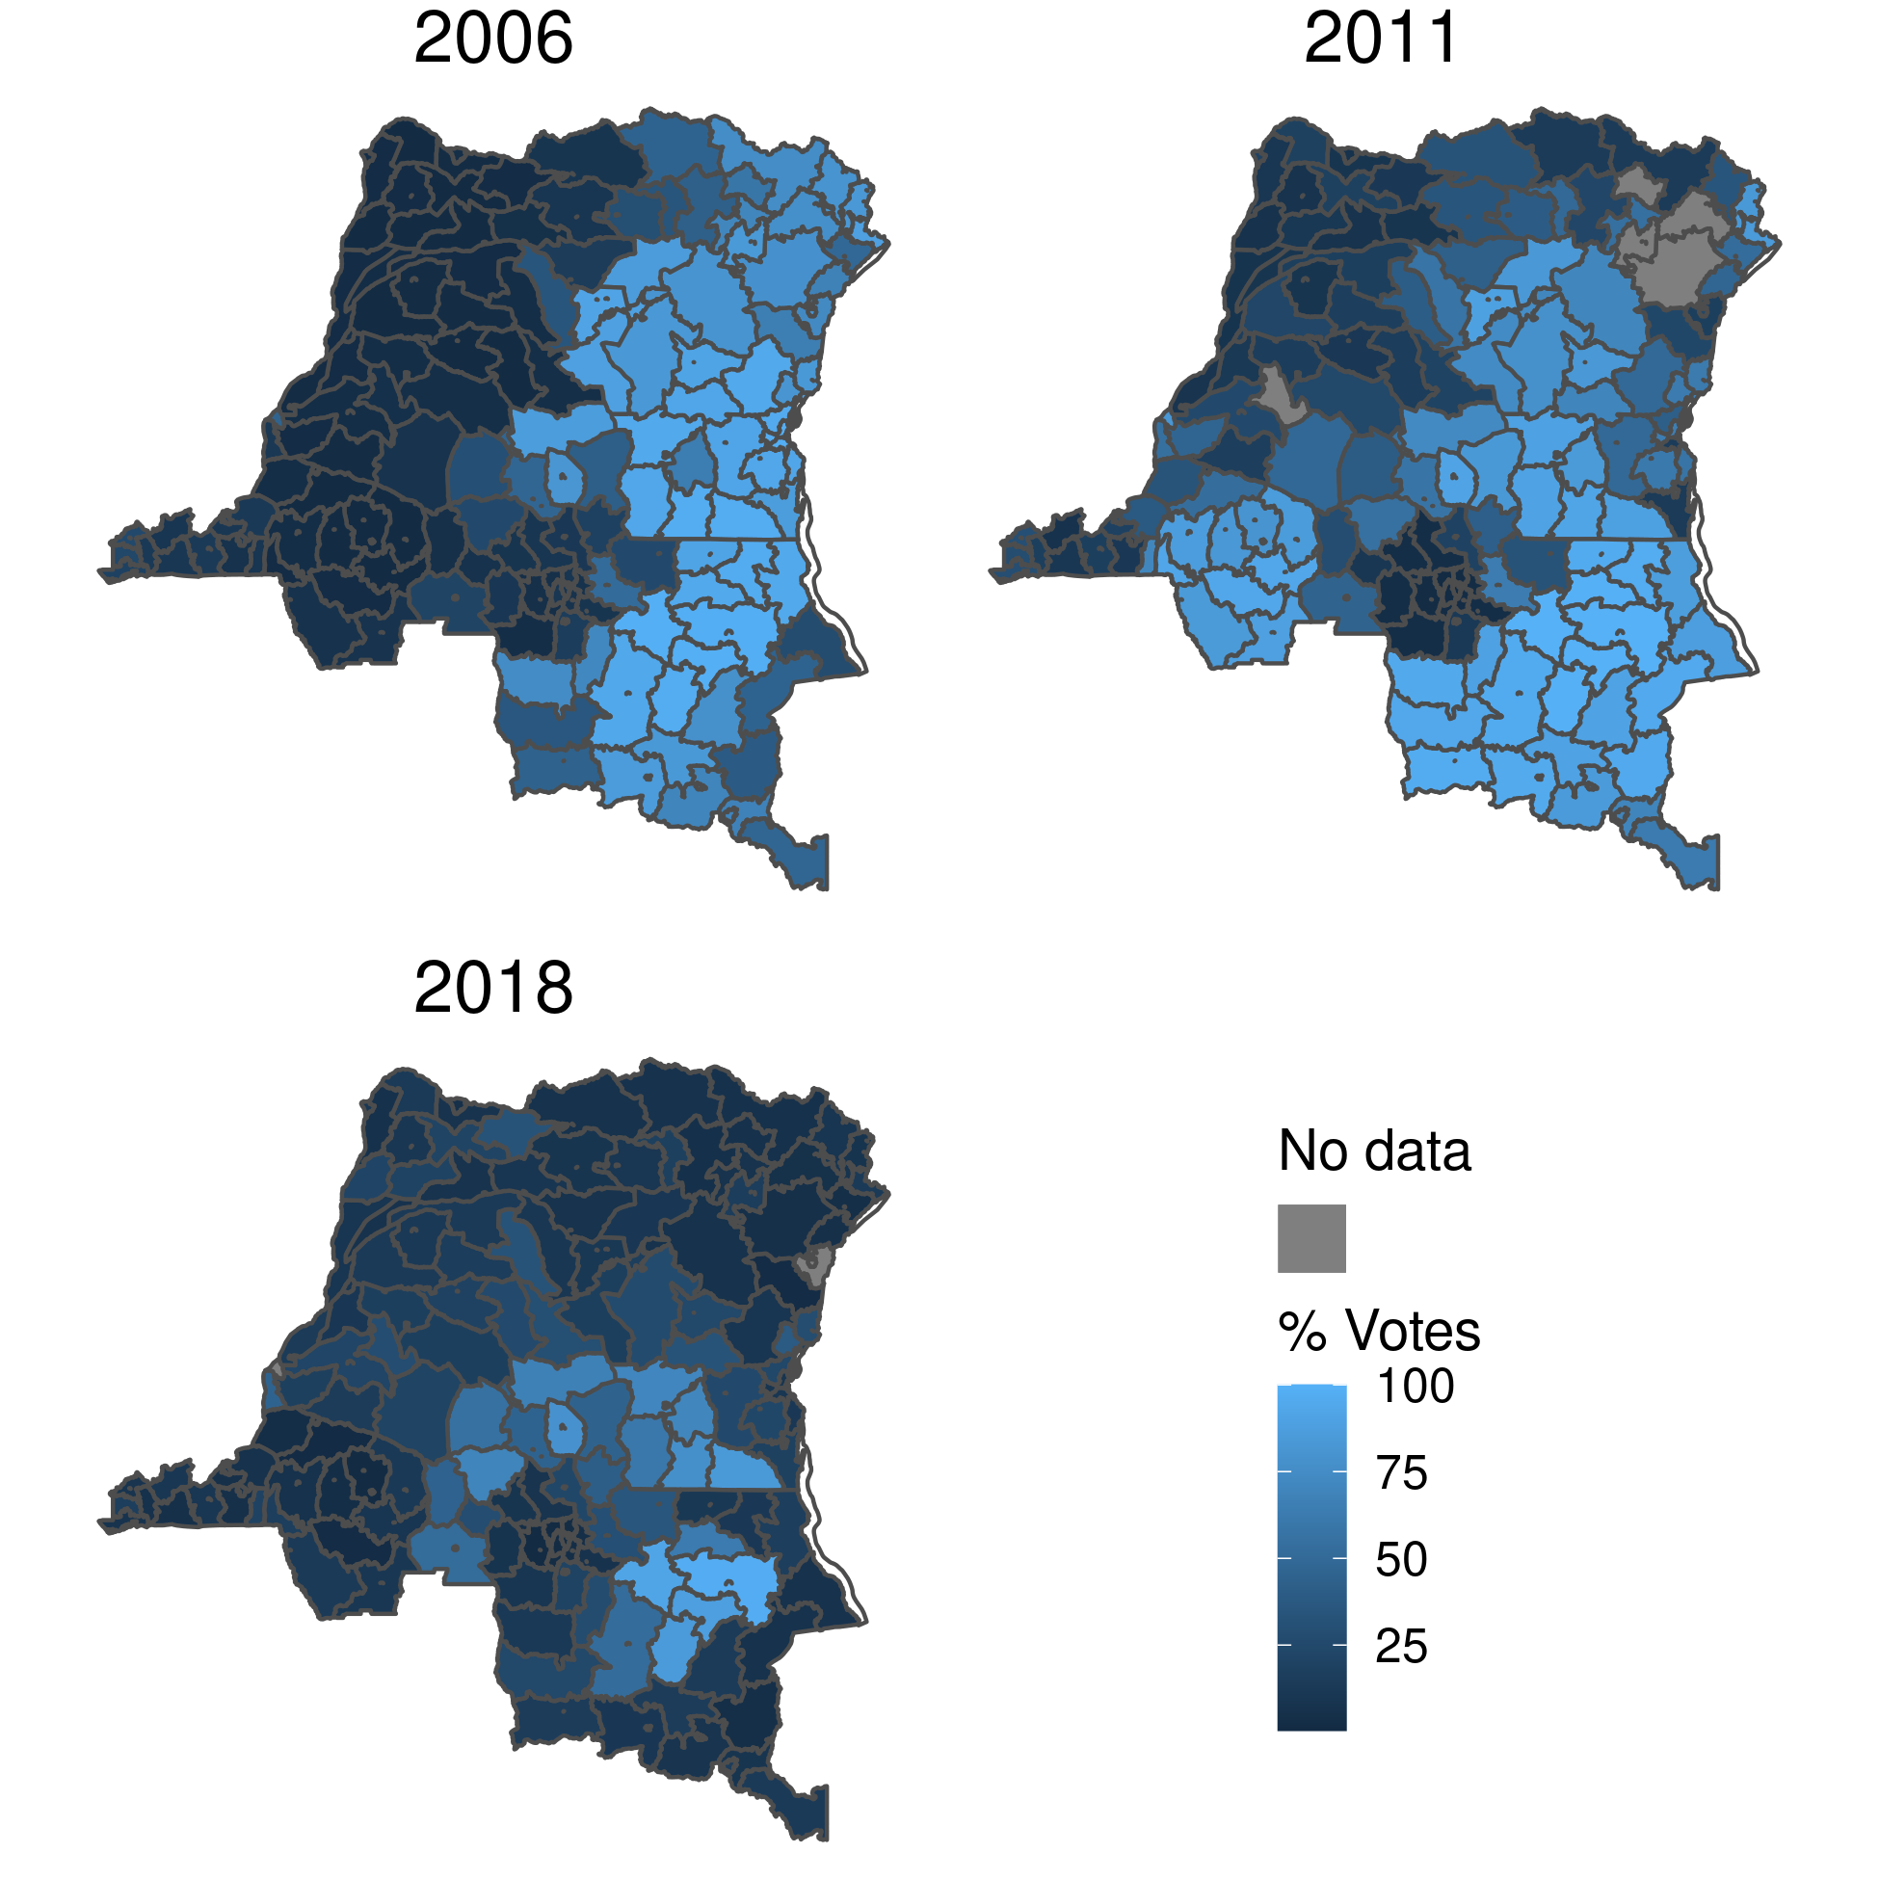

Figure . Change in vote share for Kabila/Shadary

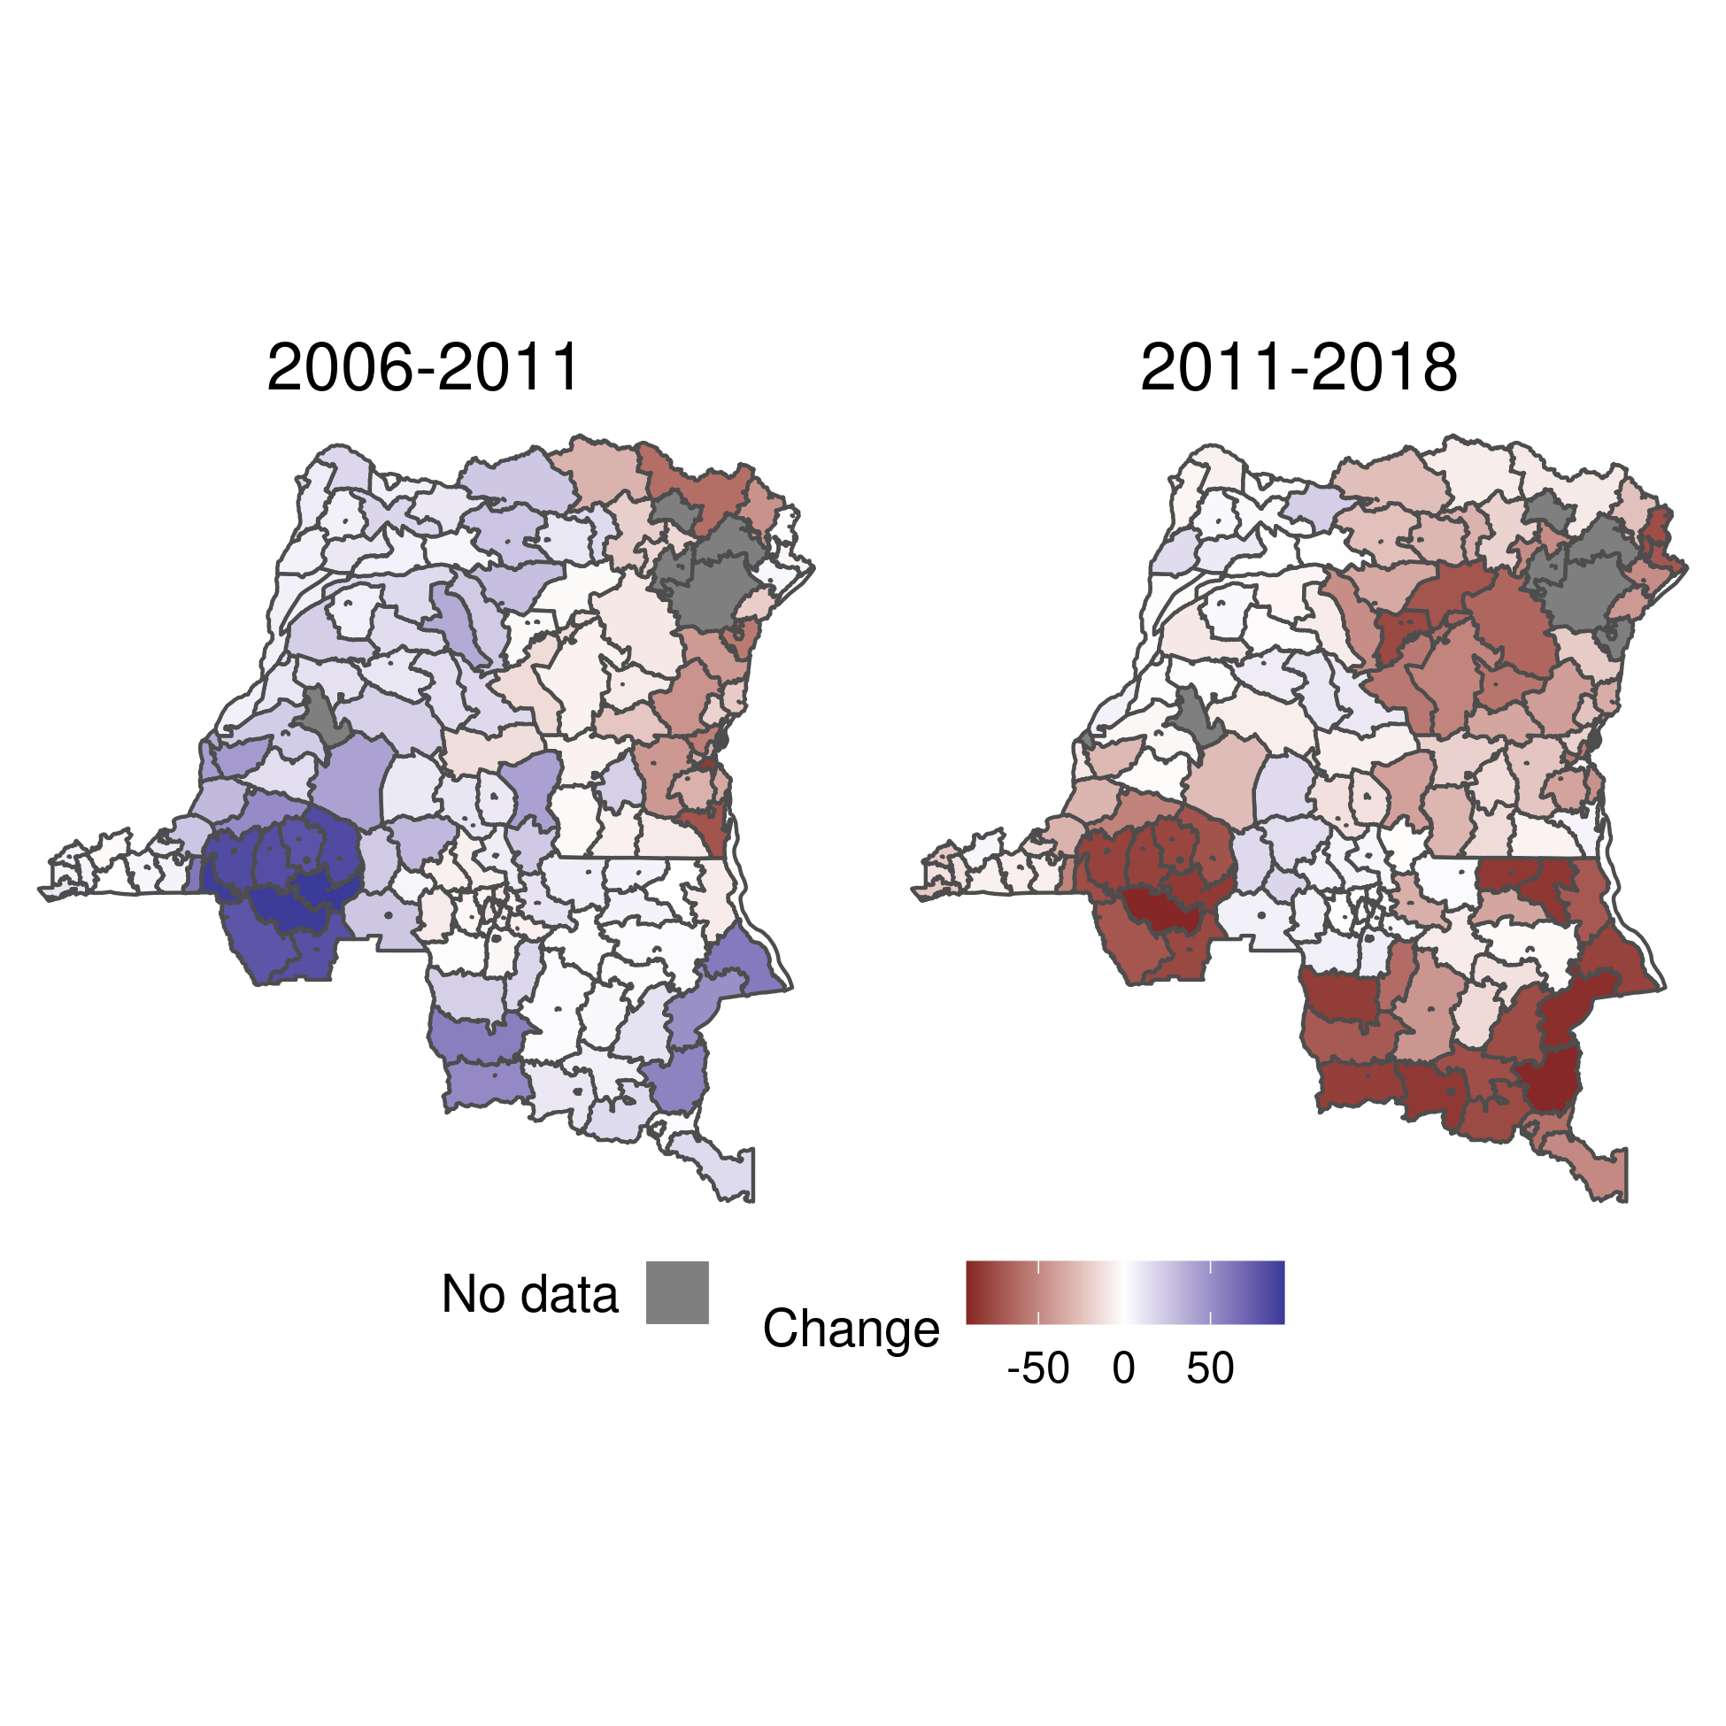

Figure . Distribution of change in vote share for Kabila/Shadary by territory, 2006-2011

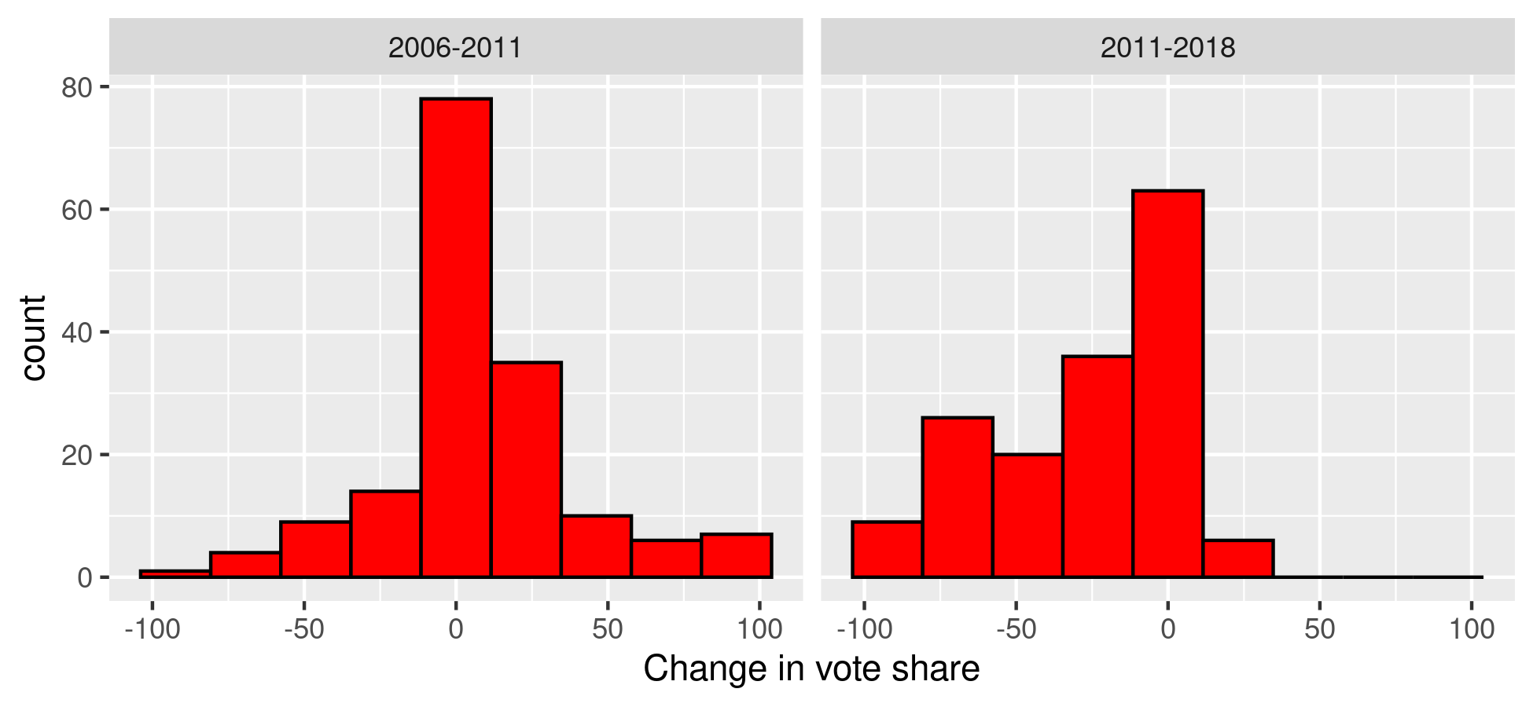

Figure . Change in luminosity by territory, 2006-2011 and 2011-2018

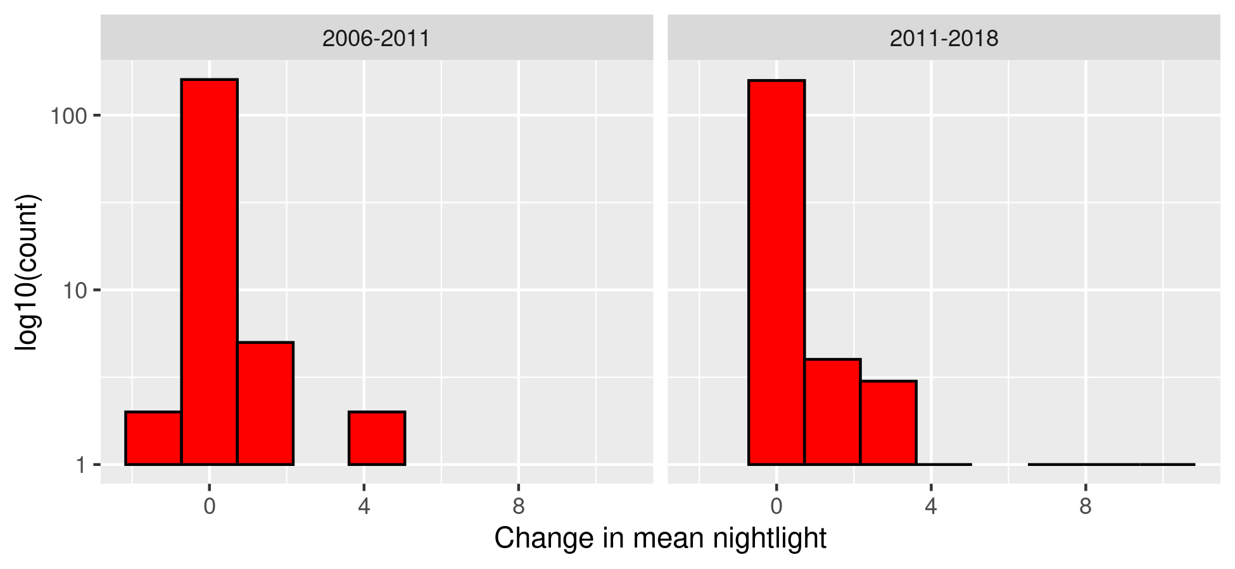

Figure . Number of deaths in territories experiencing at least one death

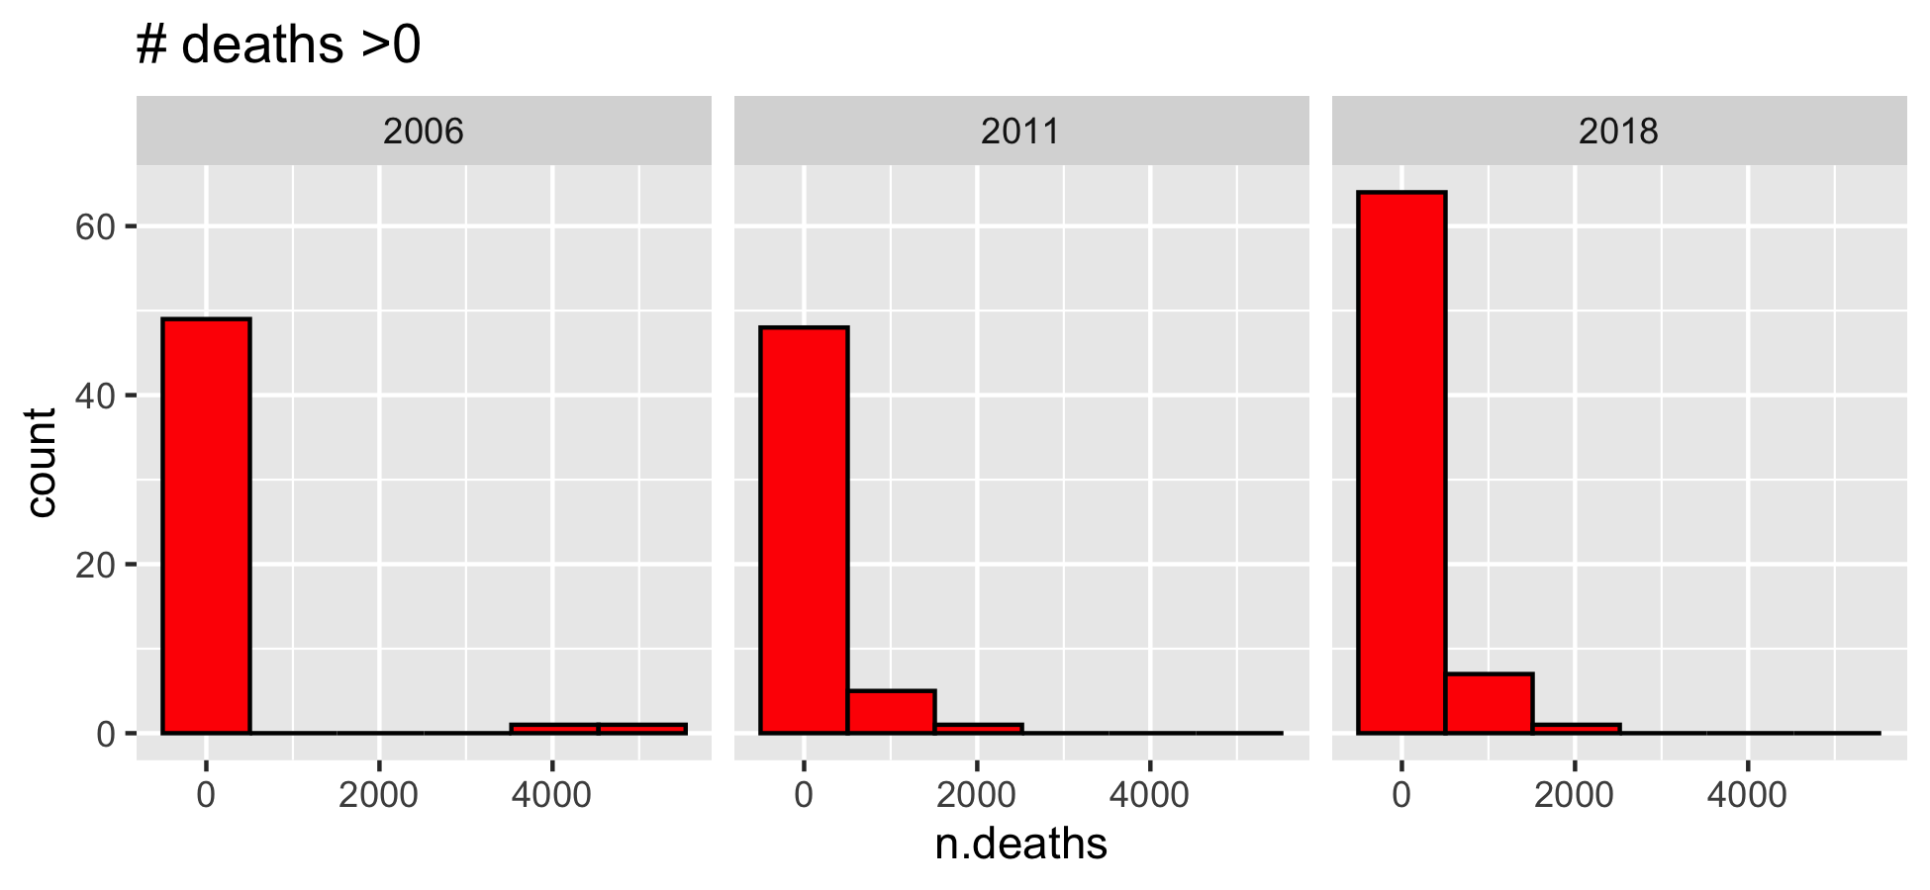

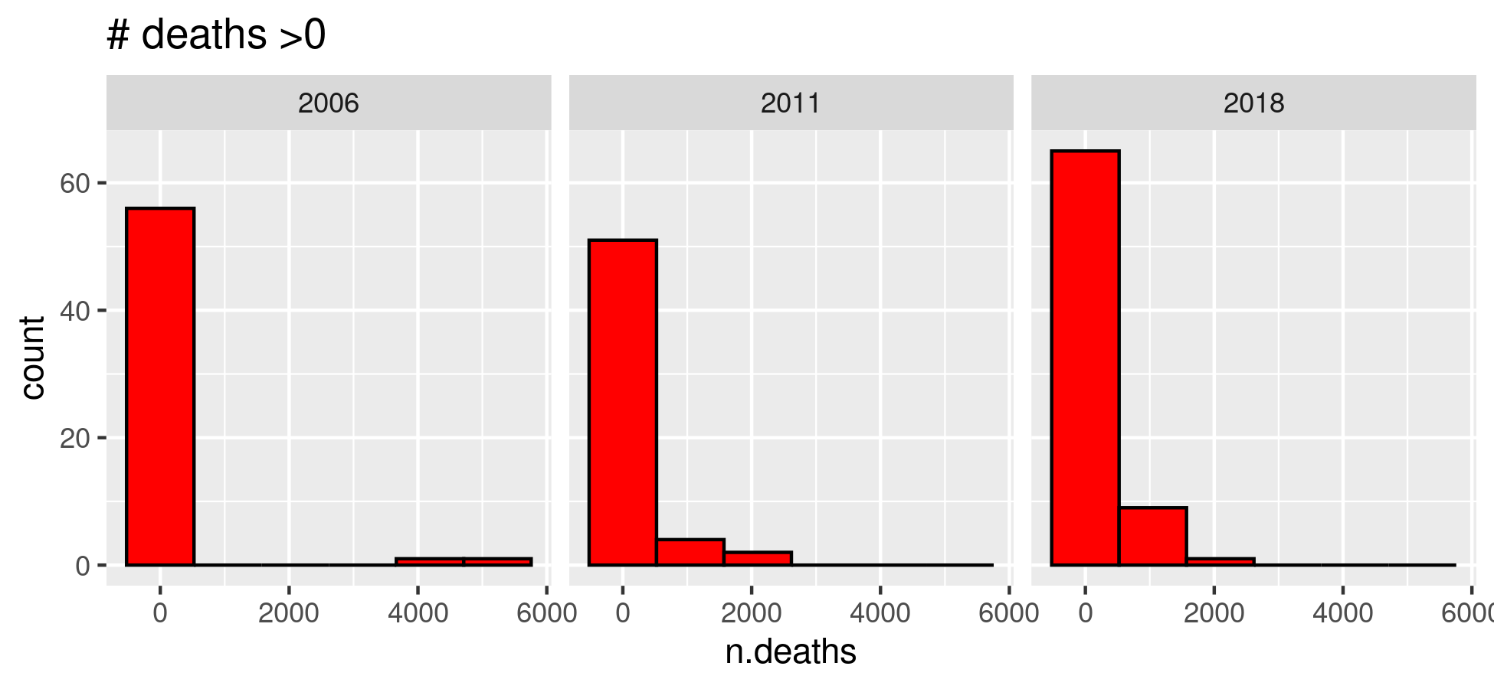

Figure . Change in conflict deaths by territory

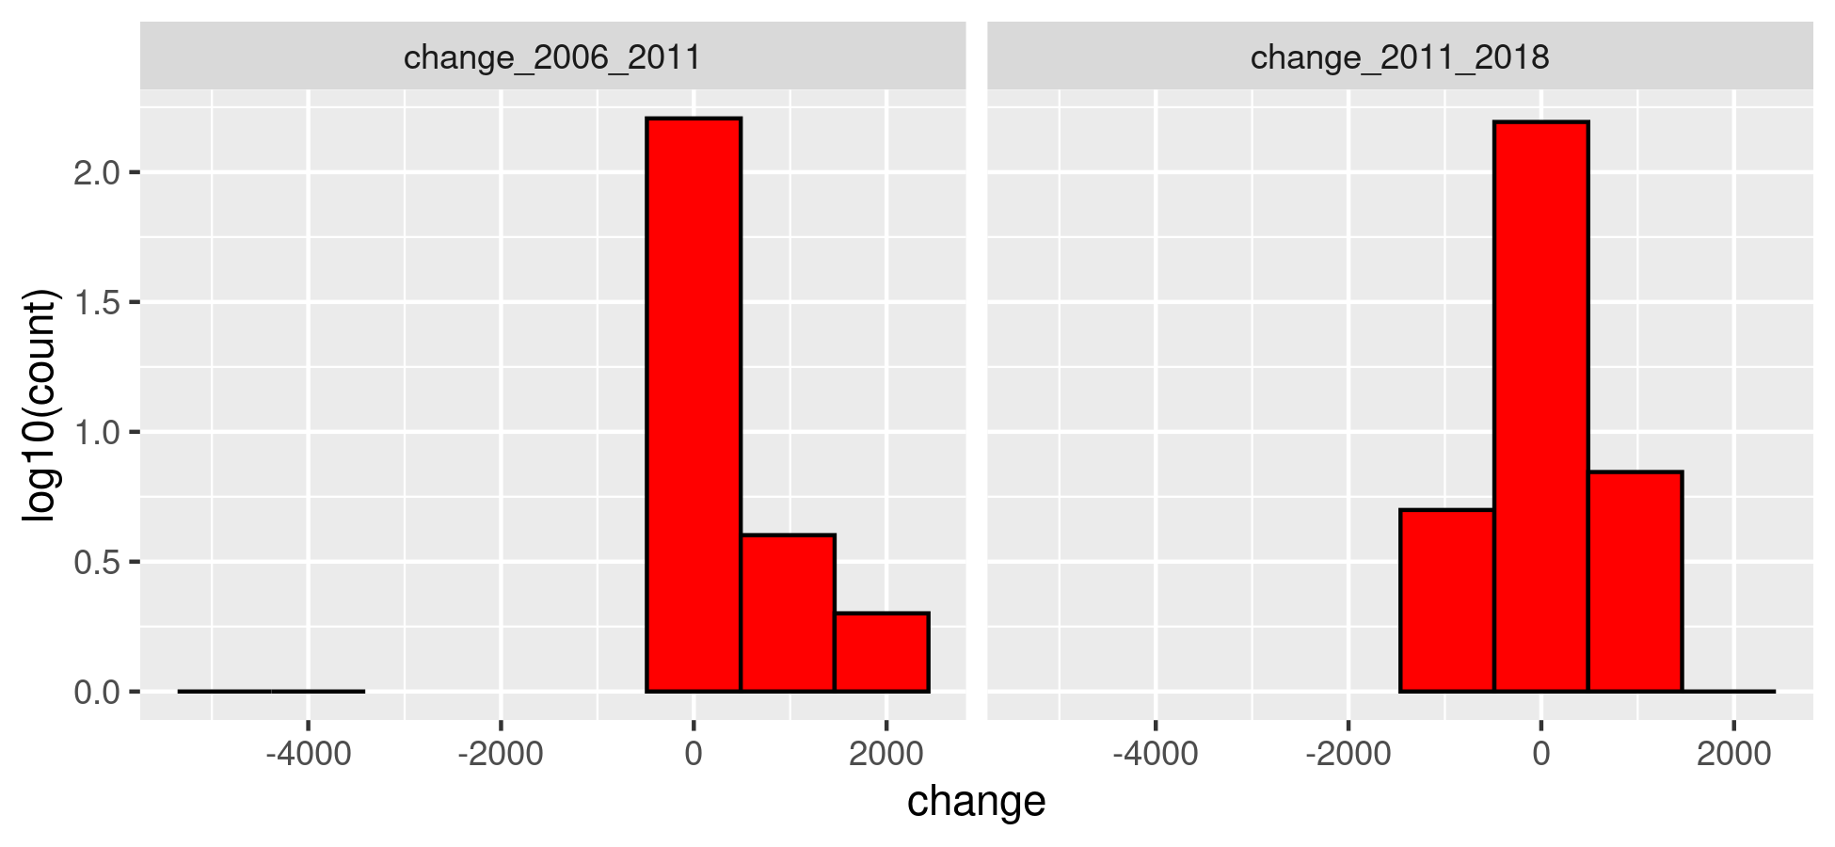

Figure . Conflict events by territory, in territories experiencing at least one event

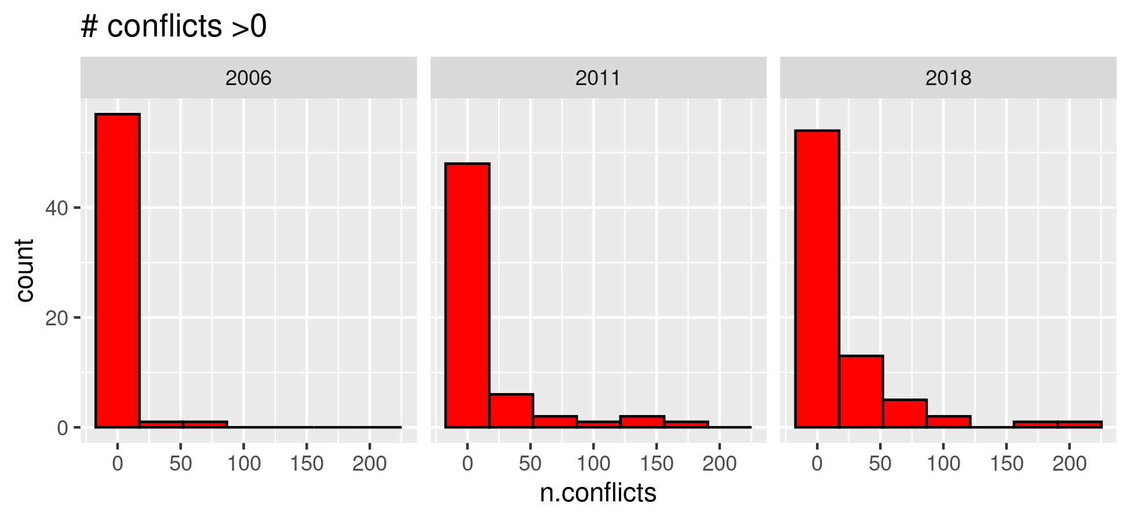

Note: the ‘0’ bin in the histogram includes territories that have experienced >0 conflict events

Figure . Change in conflict events by territory

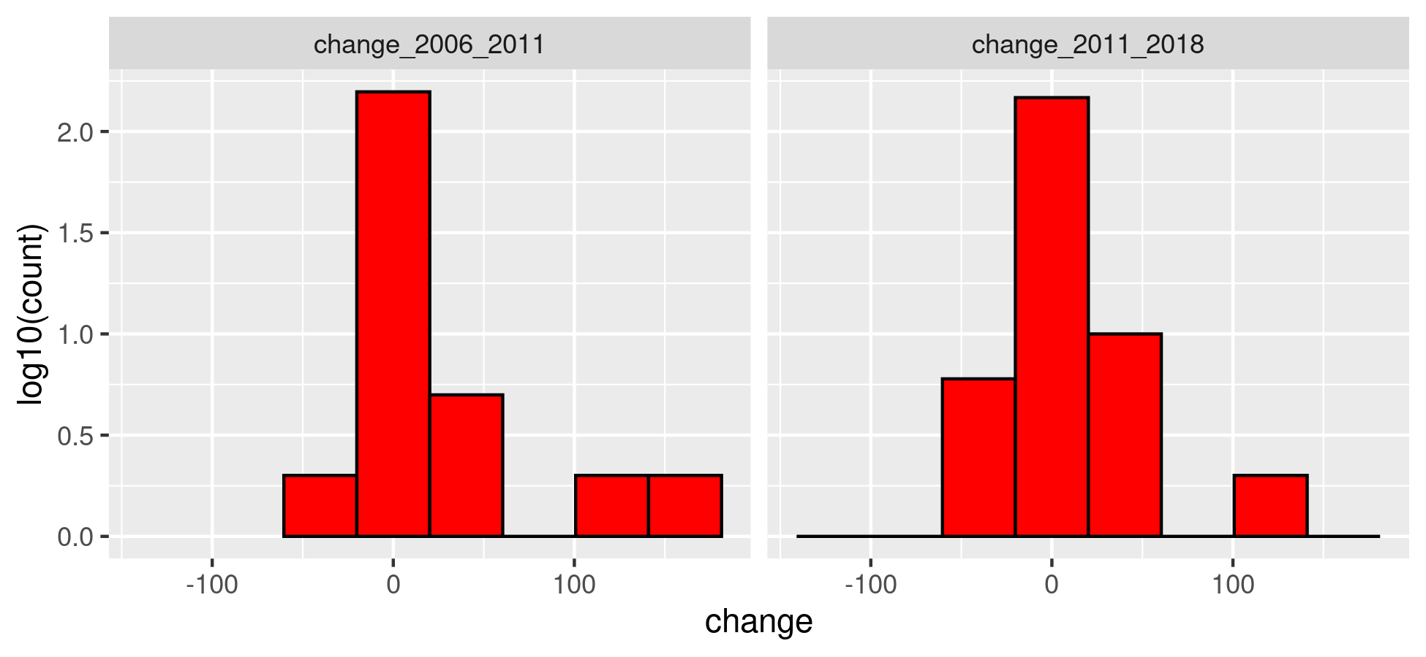

Figure . Turnout in 2006, 2011, 2018 presidential elections

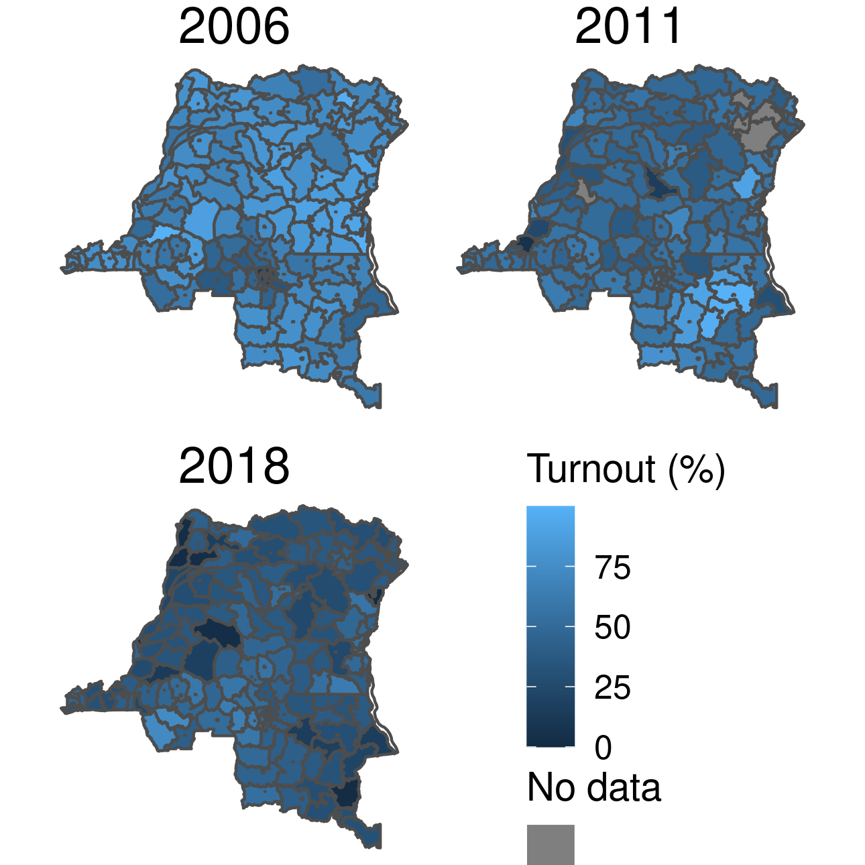

Figure . Change in turnout between 2006-2011 and 2011-2018 presidential elections

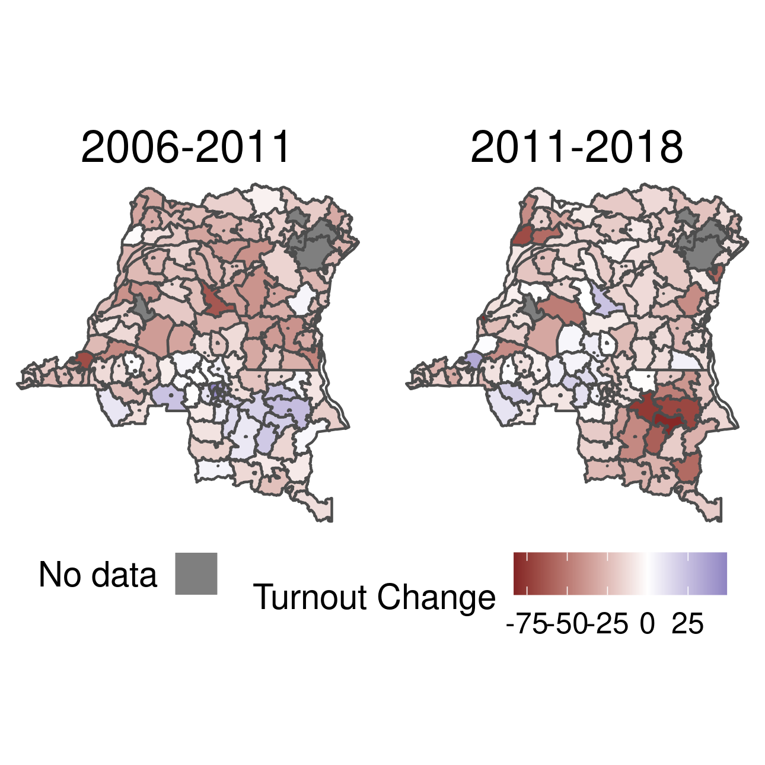

Figure . Distribution of vote share for territories with 0 conflict events vs territories with 1 or more conflict events.

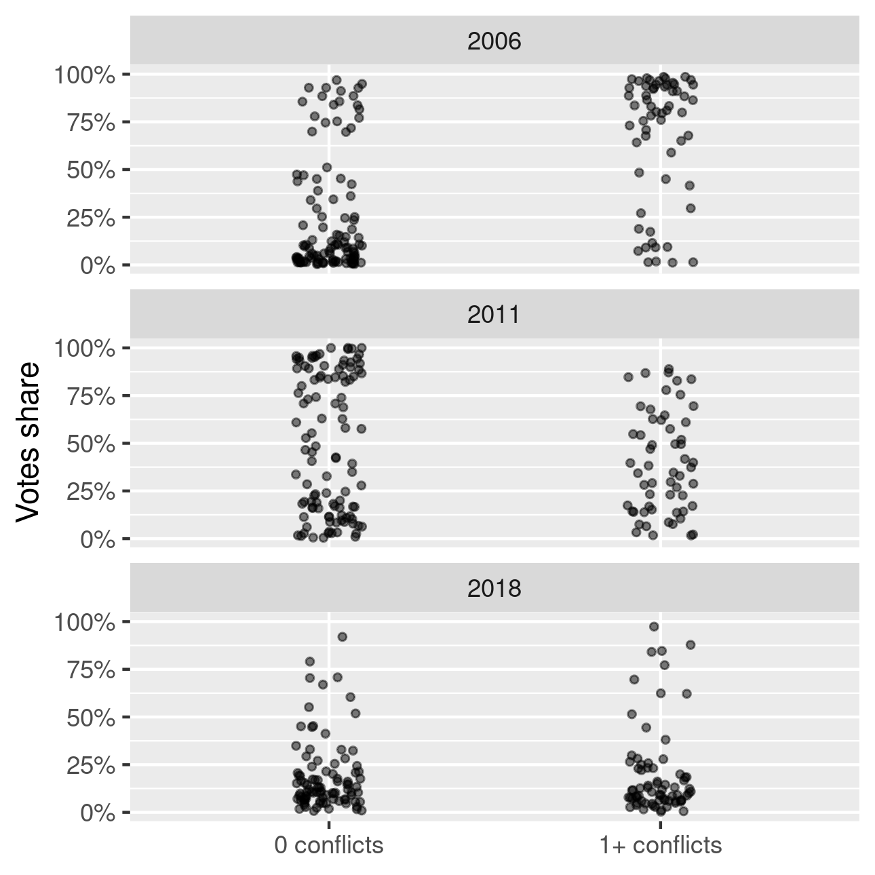

Figure . Distribution of turnout for territories with 0 conflict events vs territories with 1 or more conflict events.

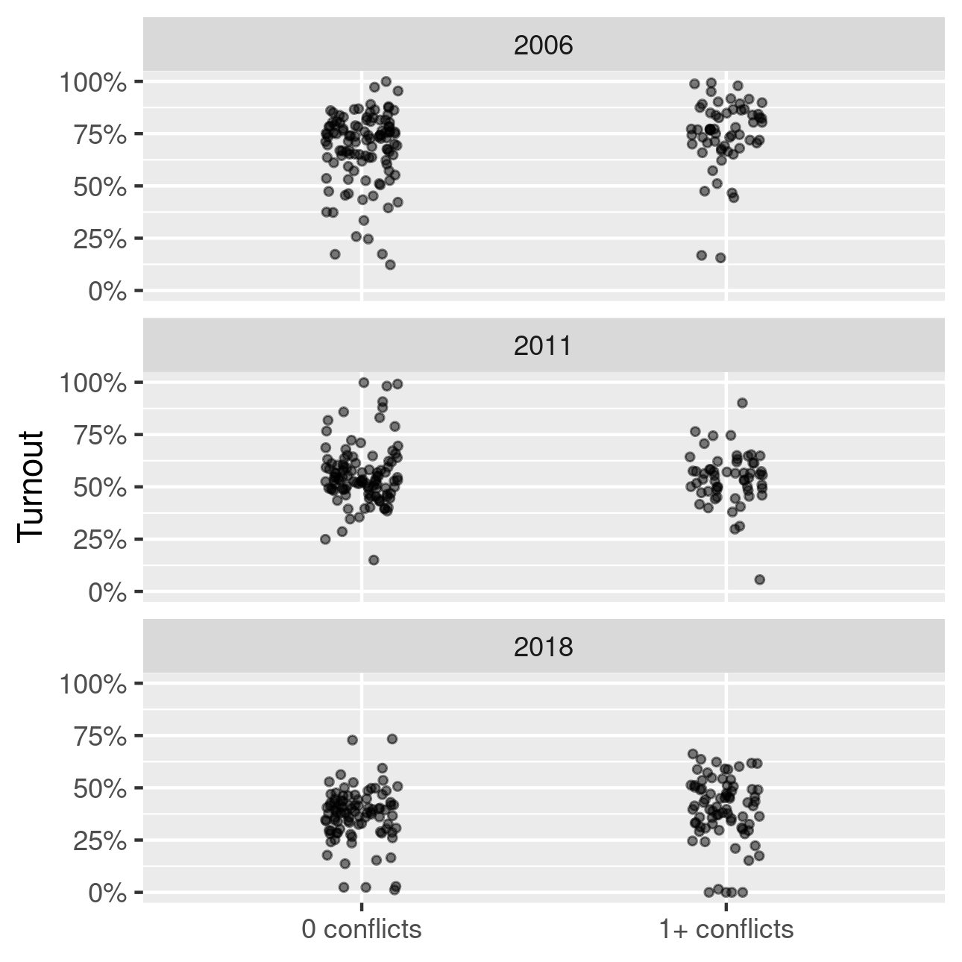

Figure . Scatterplots of vote share vs number of conflict events for each time period.

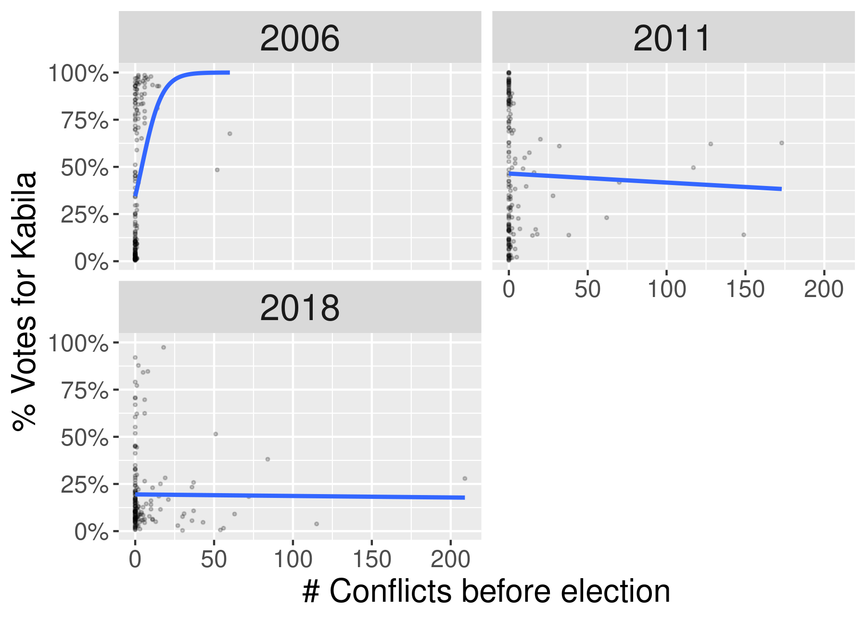

Figure .Scatterplots of vote share vs number of deaths for each time period.

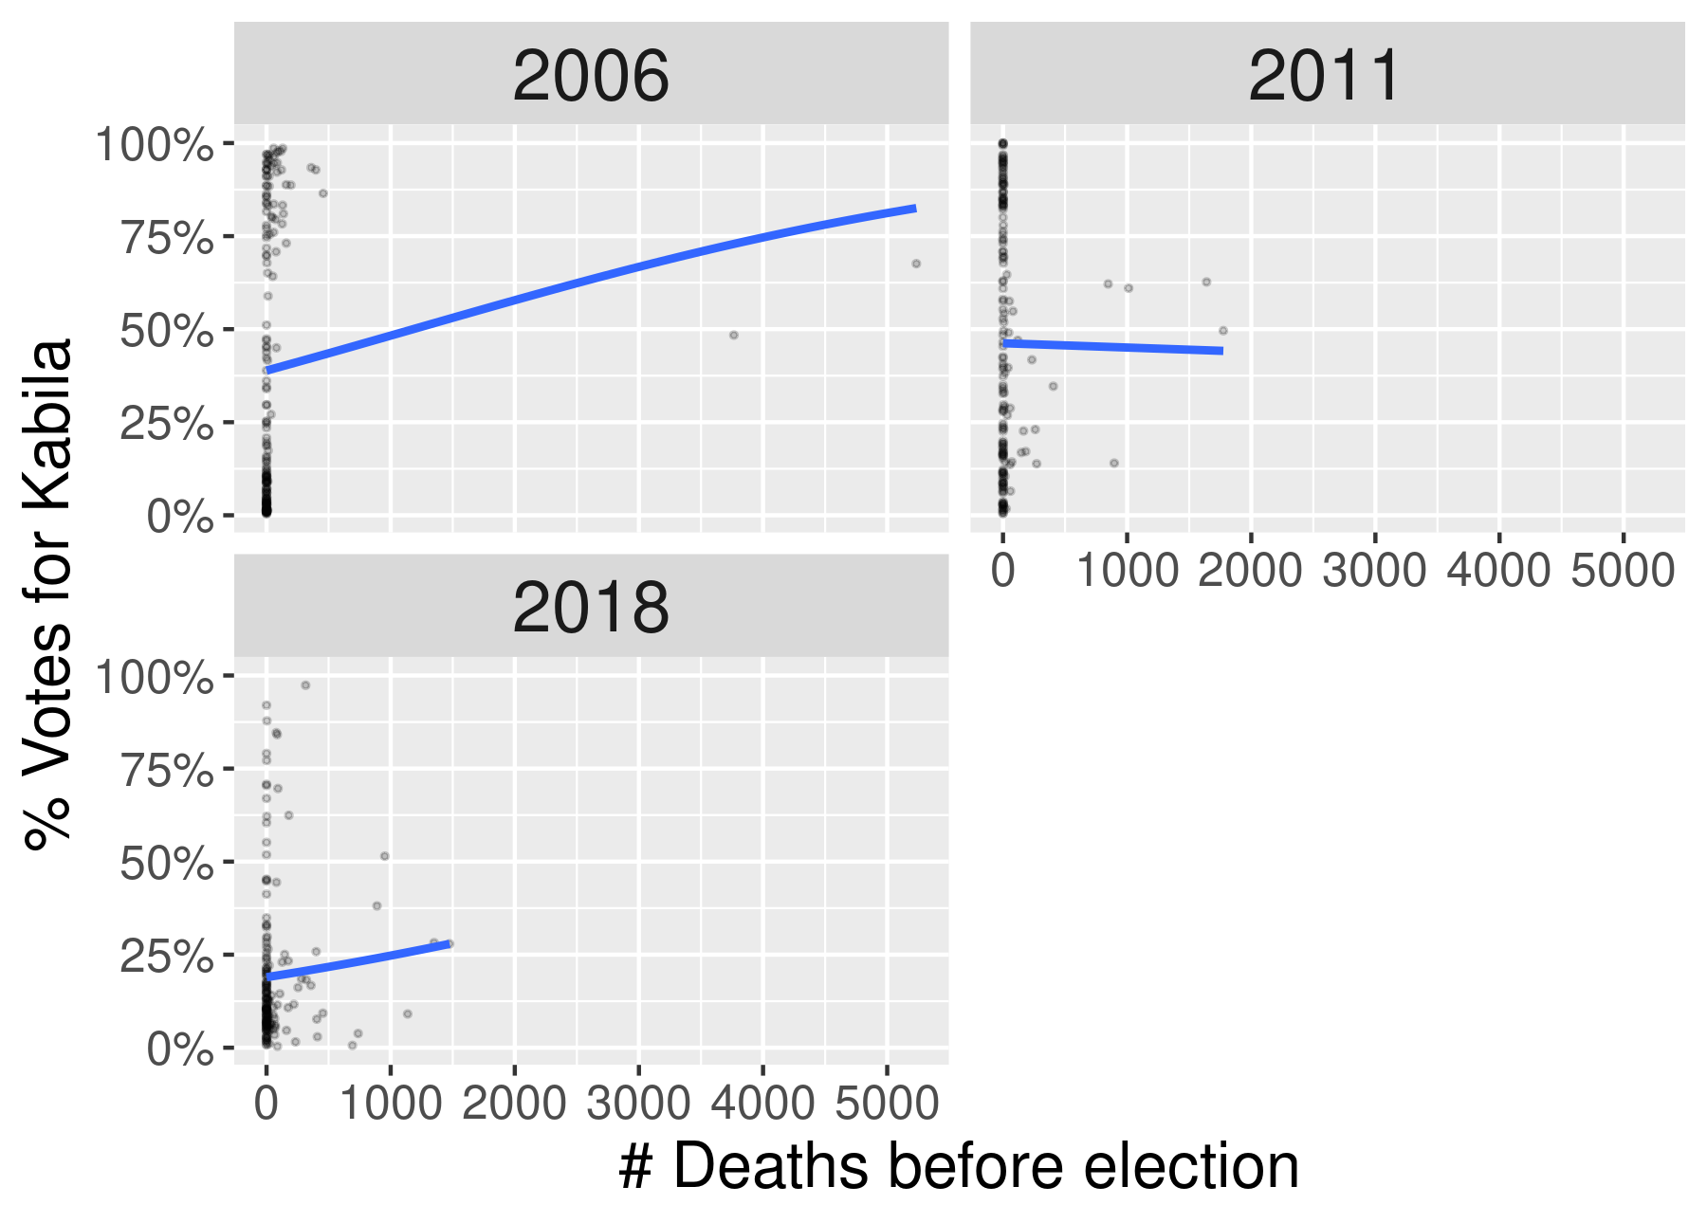

Figure . Scatterplots of vote share vs log of the number of conflict events for each time period.

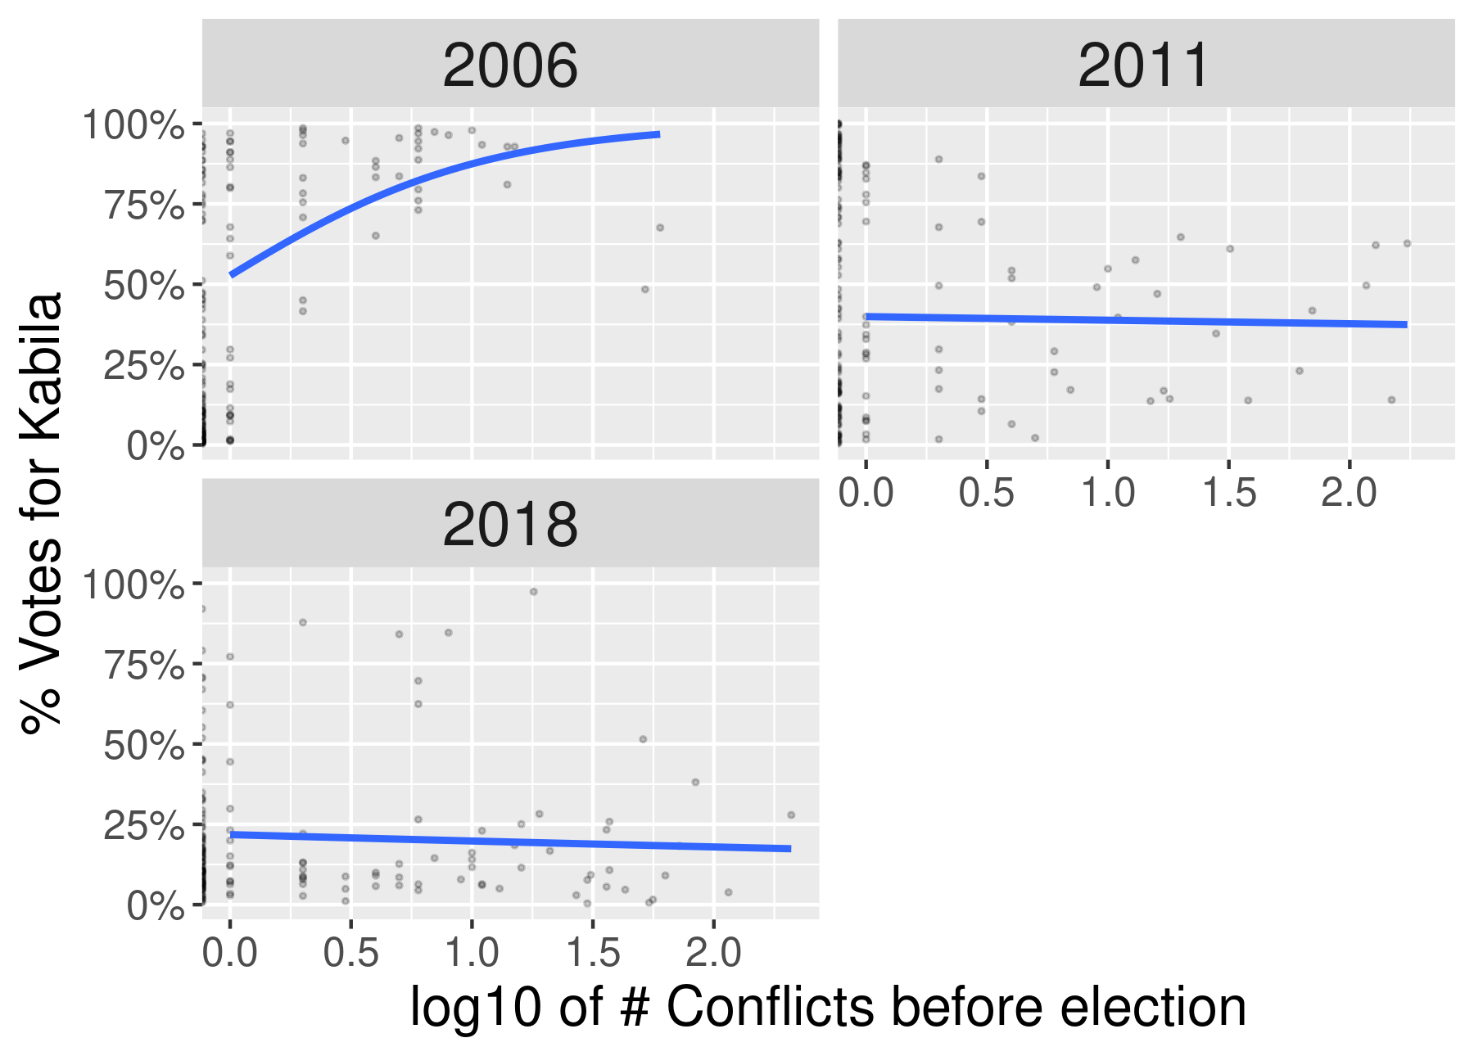

Figure . Scatterplots of vote share vs log of the number of deaths for each time period.

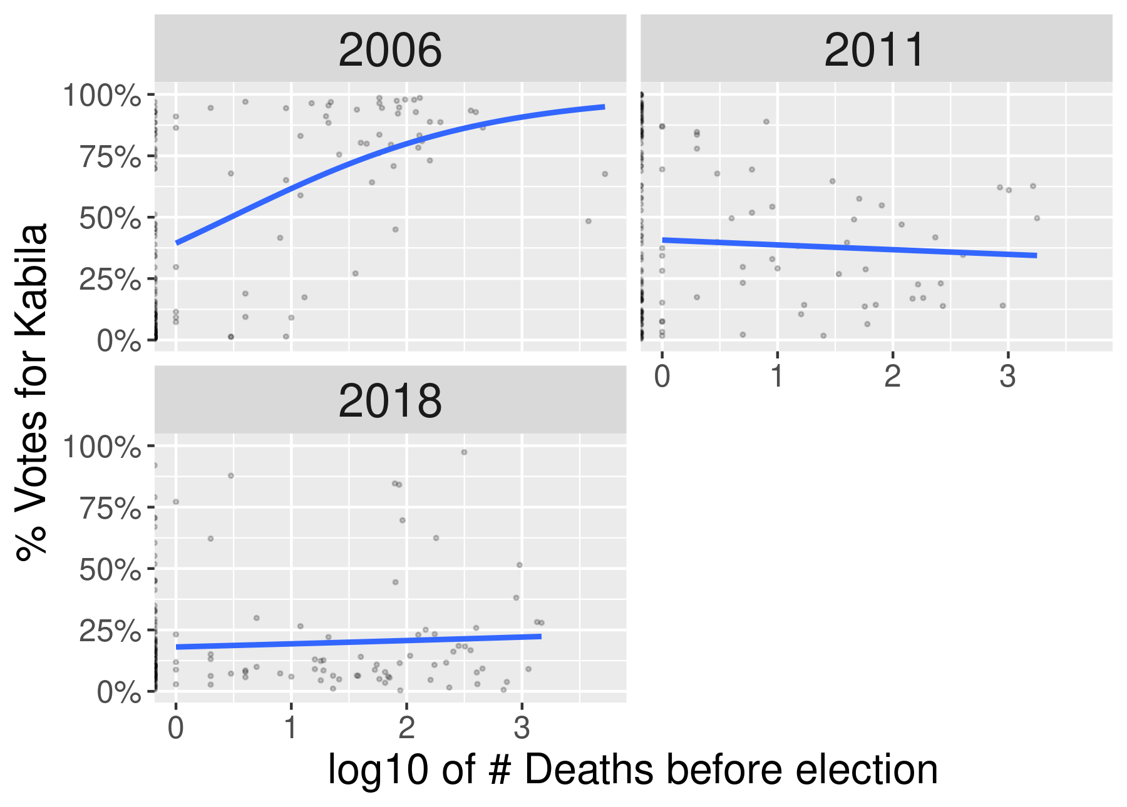

Figure . Conflict map

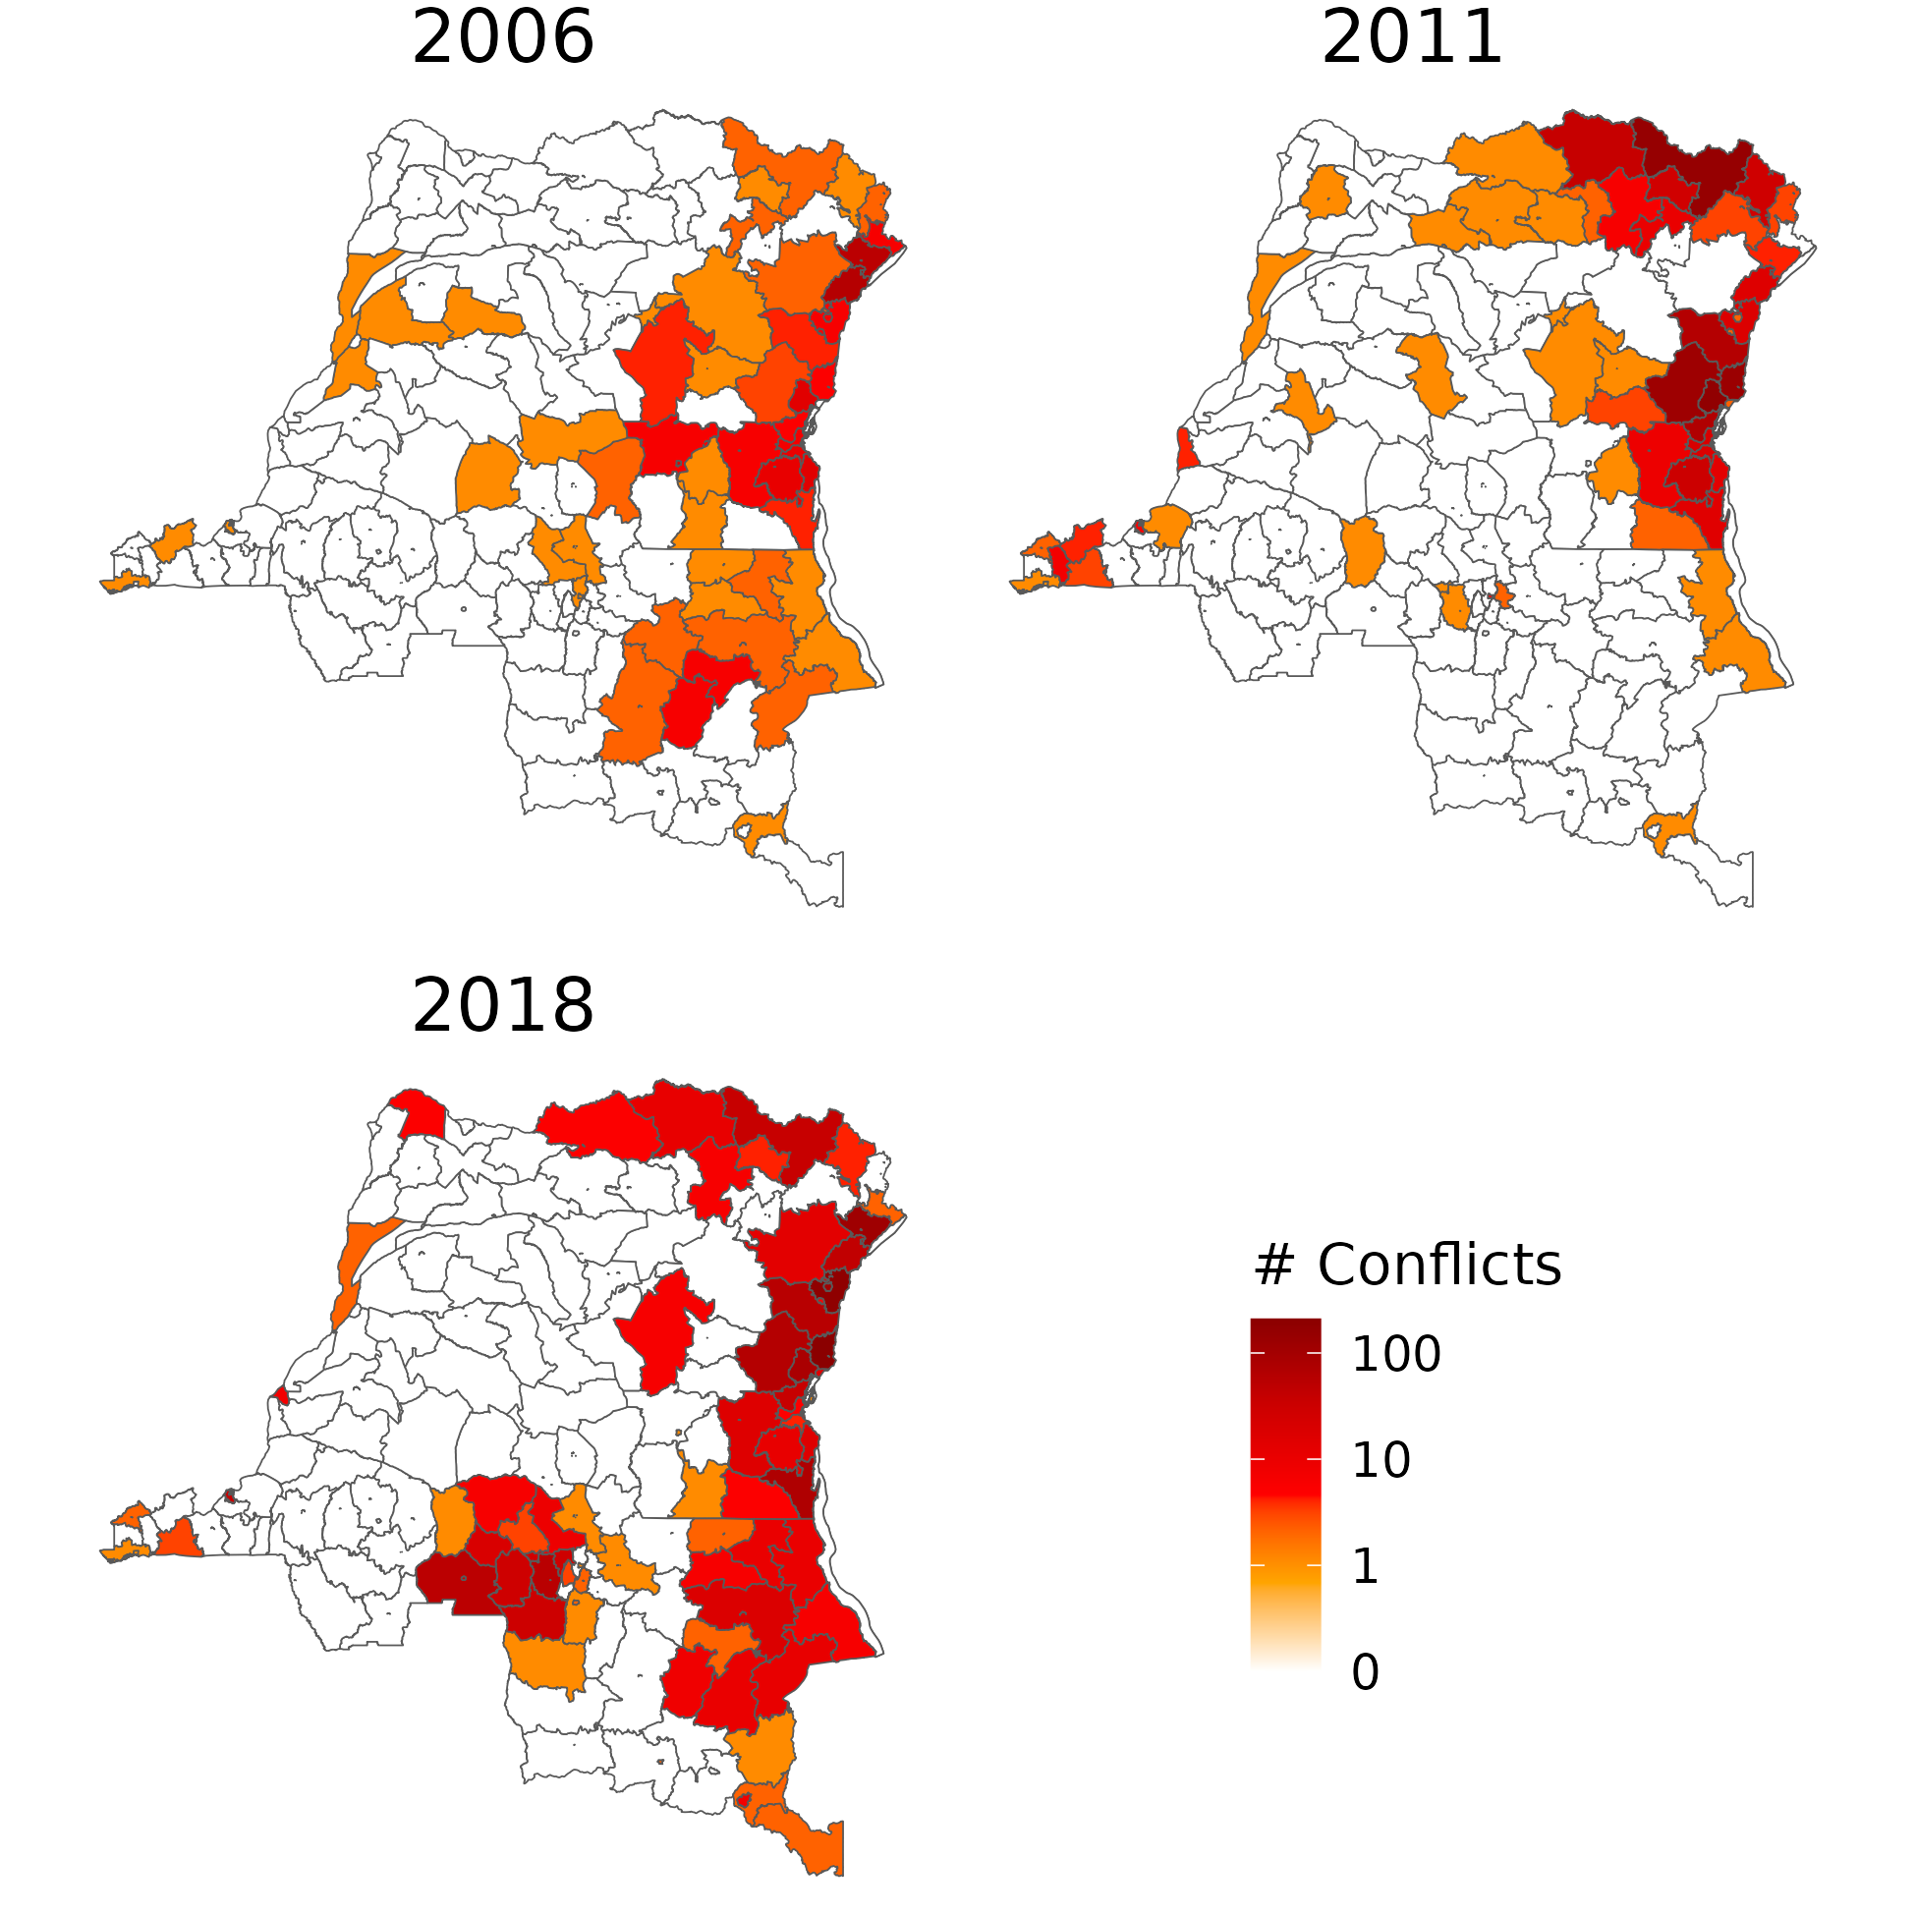

Figure . Deaths maps

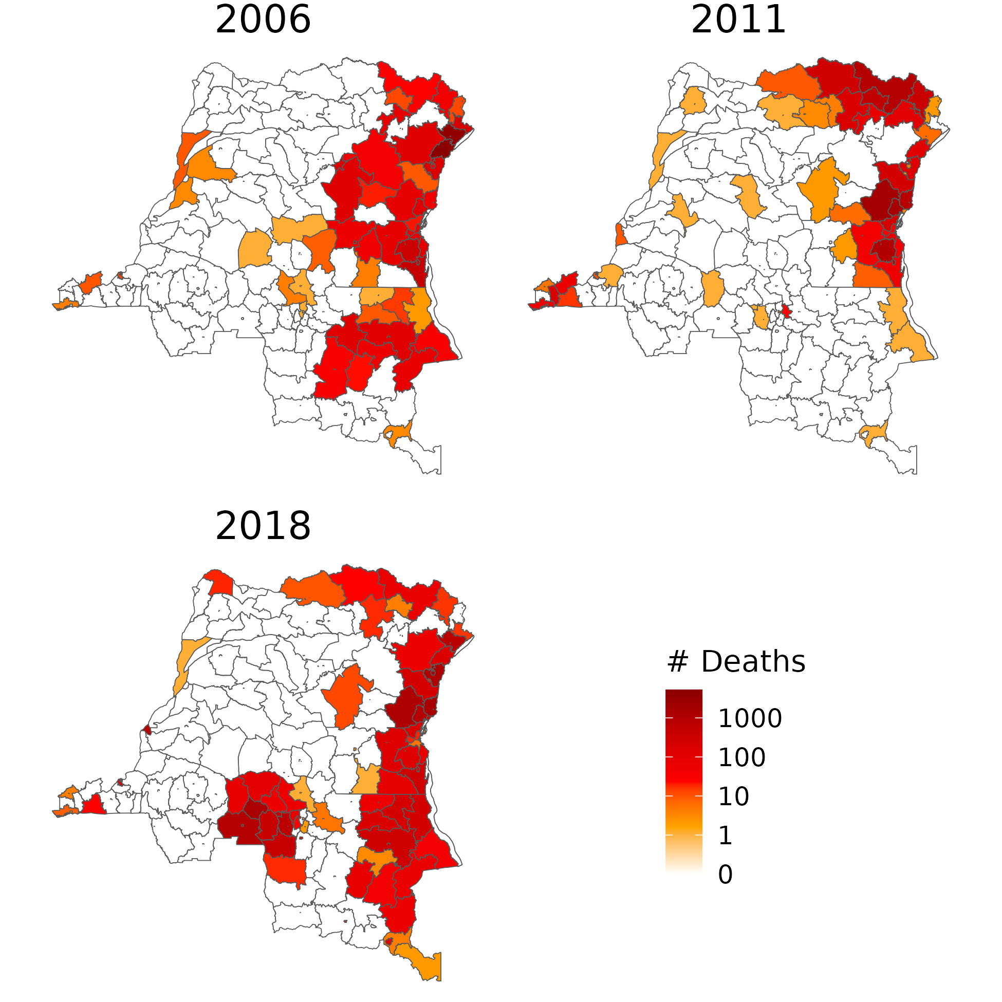

Figure . Monthly conflicts and deaths

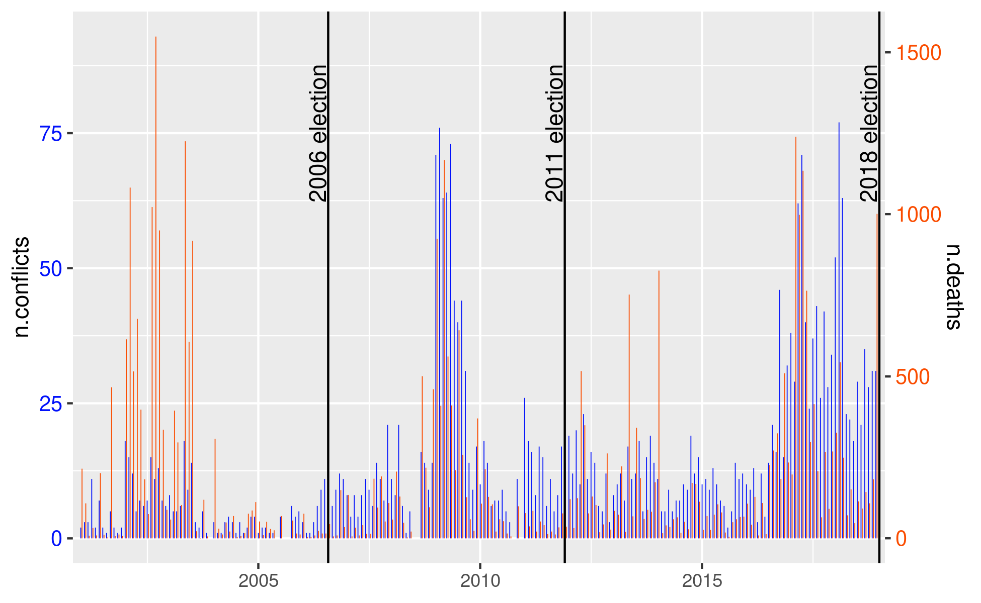

Figure . Difference in vote share associated with 10% more deaths before each election, by combatant dyad. Tables 11, 12, 13.

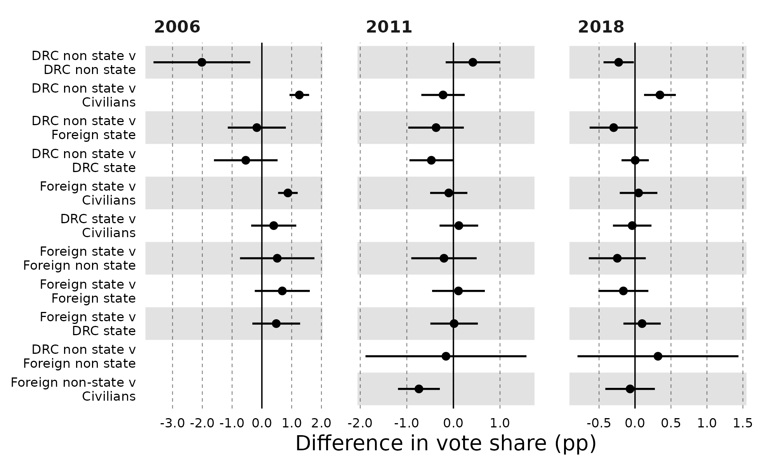

Figure . Difference in incumbent vote share associated with 10% more deaths before each election, by combatant dyad. Tables 11, 15, 16.

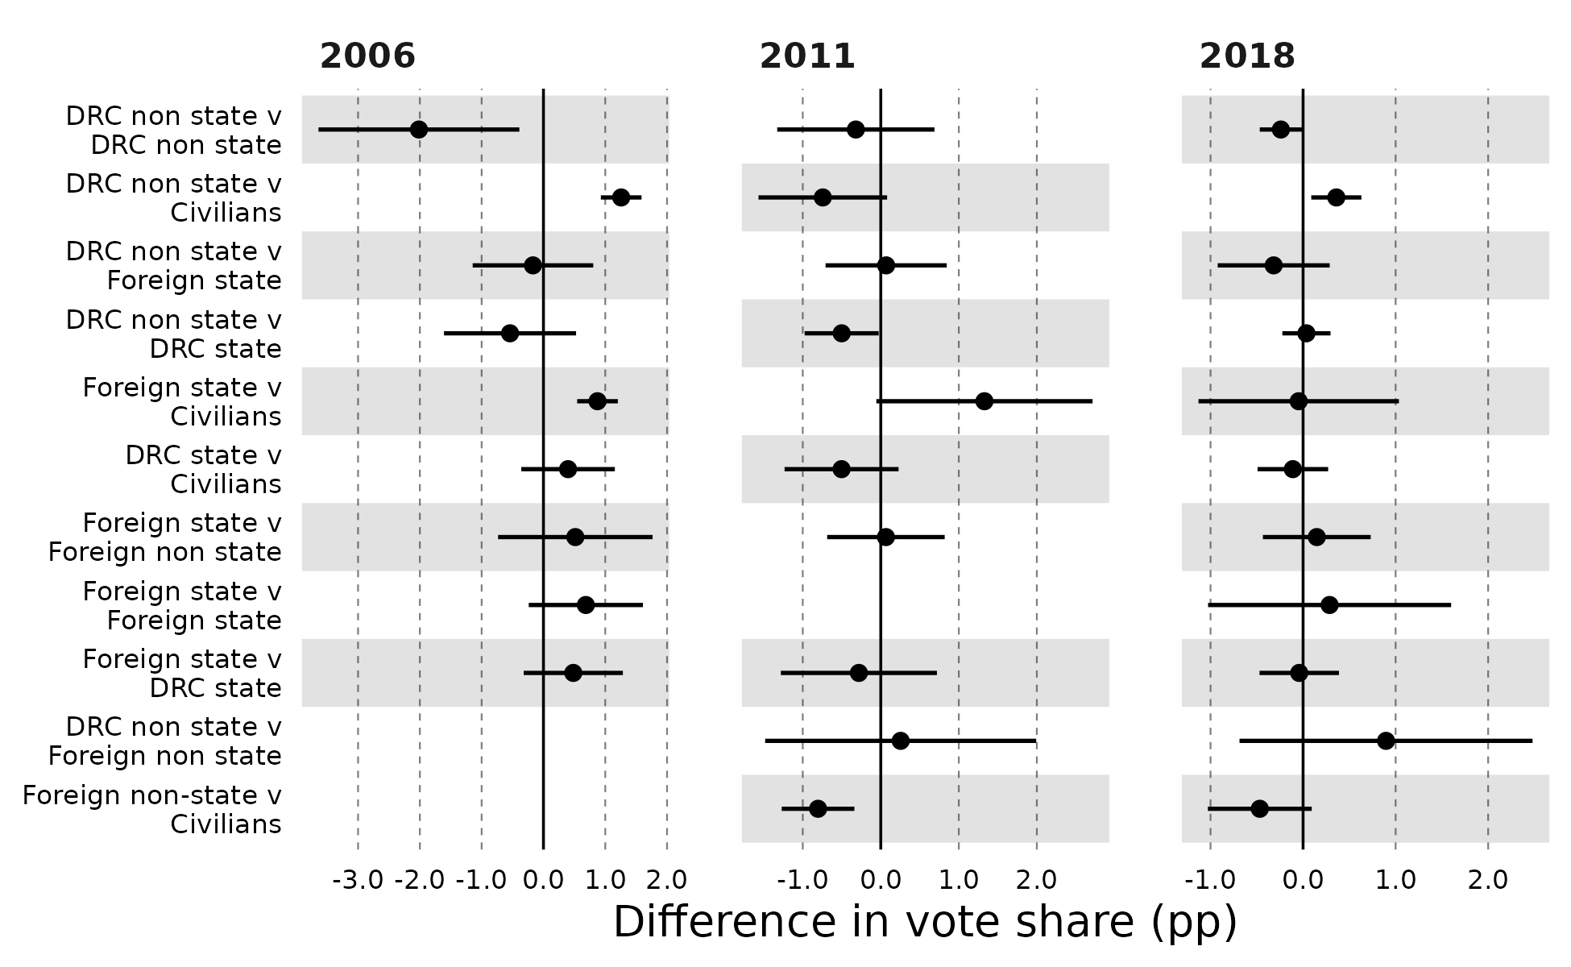

Table . Association between incumbent vote share and conflict, 2006, 2011, and 2018 DRC presidential elections, UCDP data

|  | Conflicts 2006 | Conflicts 2011 | Conflicts 2018 | Log Conflicts 2006 | Log Conflicts 2011 | Log Conflicts 2018 | Deaths 2006 | Deaths 2011 | Deaths 2018 | Log Deaths 2006 | Log Deaths 2011 | Log Deaths 2018 |
| --- | --- | --- | --- | --- | --- | --- | --- | --- | --- | --- | --- | --- |
| n.conflicts | 0.015 | -0.0005 | -0.0001 |  |  |  |  |  |  |  |  |  |
|  | (0.012) | (0.001) | (0.001) |  |  |  |  |  |  |  |  |  |
| log_n.conflicts |  |  |  | 0.581*** | -0.071* | -0.001 |  |  |  |  |  |  |
|  |  |  |  | (0.112) | (0.040) | (0.026) |  |  |  |  |  |  |
| n.deaths |  |  |  |  |  |  | 0.0001 | -0.00001 | 0.0001 |  |  |  |
|  |  |  |  |  |  |  | (0.0001) | (0.0001) | (0.0001) |  |  |  |
| log_n.deaths |  |  |  |  |  |  |  |  |  | 0.260*** | -0.059** | 0.010 |
|  |  |  |  |  |  |  |  |  |  | (0.031) | (0.025) | (0.017) |
| Constant | 0.367*** | 0.465*** | 0.195*** | 0.307*** | 0.478*** | 0.194*** | 0.389*** | 0.462*** | 0.189*** | 0.267*** | 0.484*** | 0.187*** |
|  | (0.031) | (0.028) | (0.017) | (0.029) | (0.030) | (0.018) | (0.029) | (0.027) | (0.017) | (0.029) | (0.031) | (0.018) |
| F Statistic | 12.398*** | 0.182 | 0.013 | 59.872*** | 1.842 | 0.002 | 2.164 | 0.010 | 0.675 | 90.069*** | 3.497* | 0.390 |
| Df | 1;167 | 1;162 | 1;163 | 1;167 | 1;162 | 1;163 | 1;167 | 1;162 | 1;163 | 1;167 | 1;162 | 1;163 |
| Observations | 169 | 164 | 165 | 169 | 164 | 165 | 169 | 164 | 165 | 169 | 164 | 165 |
| R2 | 0.069 | 0.001 | 0.0001 | 0.264 | 0.011 | 0.00001 | 0.013 | 0.0001 | 0.004 | 0.350 | 0.021 | 0.002 |
| Adjusted R2 | 0.064 | -0.005 | -0.006 | 0.259 | 0.005 | -0.006 | 0.007 | -0.006 | -0.002 | 0.346 | 0.015 | -0.004 |
| Residual Std. Error | 0.364 (df = 167) | 0.335 (df = 162) | 0.208 (df = 163) | 0.324 (df = 167) | 0.333 (df = 162) | 0.208 (df = 163) | 0.375 (df = 167) | 0.335 (df = 162) | 0.207 (df = 163) | 0.304 (df = 167) | 0.331 (df = 162) | 0.207 (df = 163) |
| Note: | *p<0.1; **p<0.05; ***p<0.01 | | | | | | | | | | | |

Table . Association between incumbent vote share and conflict, 2006, 2011, and 2018 DRC presidential elections, ACLED data

|  | Conflicts 2006 | Conflicts 2011 | Conflicts 2018 | Log Conflicts 2006 | Log Conflicts 2011 | Log Conflicts 2018 | Deaths 2006 | Deaths 2011 | Deaths 2018 | Log Deaths 2006 | Log Deaths 2011 | Log Deaths 2018 |
| --- | --- | --- | --- | --- | --- | --- | --- | --- | --- | --- | --- | --- |
| n.conflicts | 0.004 | -0.001 | -0.0001 |  |  |  |  |  |  |  |  |  |
|  | (0.005) | (0.0005) | (0.0002) |  |  |  |  |  |  |  |  |  |
| log_n.conflicts |  |  |  | 0.307*** | -0.027 | -0.008 |  |  |  |  |  |  |
|  |  |  |  | (0.036) | (0.031) | (0.018) |  |  |  |  |  |  |
| n.deaths |  |  |  |  |  |  | 0.0002 | -0.0002** | -0.00005 |  |  |  |
|  |  |  |  |  |  |  | (0.0002) | (0.0001) | (0.0001) |  |  |  |
| log_n.deaths |  |  |  |  |  |  |  |  |  | 0.096*** | -0.032 | 0.010 |
|  |  |  |  |  |  |  |  |  |  | (0.026) | (0.020) | (0.012) |
| Constant | 0.356*** | 0.469*** | 0.199*** | 0.269*** | 0.474*** | 0.201*** | 0.381*** | 0.472*** | 0.198*** | 0.354*** | 0.475*** | 0.185*** |
|  | (0.042) | (0.028) | (0.018) | (0.031) | (0.034) | (0.022) | (0.031) | (0.028) | (0.018) | (0.032) | (0.030) | (0.017) |
| F Statistic | 17.093*** | 0.743 | 0.482 | 53.539*** | 0.466 | 0.124 | 5.643** | 1.774 | 0.337 | 14.444*** | 1.735 | 0.493 |
| df | 1;167 | 1;162 | 1;163 | 1;167 | 1;162 | 1;163 | 1;167 | 1;162 | 1;163 | 1;167 | 1;162 | 1;163 |
| Observations | 169 | 164 | 165 | 169 | 164 | 165 | 169 | 164 | 165 | 169 | 164 | 165 |
| R2 | 0.093 | 0.005 | 0.003 | 0.243 | 0.003 | 0.001 | 0.033 | 0.011 | 0.002 | 0.080 | 0.011 | 0.003 |
| Adjusted R2 | 0.087 | -0.002 | -0.003 | 0.238 | -0.003 | -0.005 | 0.027 | 0.005 | -0.004 | 0.074 | 0.004 | -0.003 |
| Residual Std. Error | 0.360 (df = 167) | 0.334 (df = 162) | 0.207 (df = 163) | 0.329 (df = 167) | 0.334 (df = 162) | 0.208 (df = 163) | 0.371 (df = 167) | 0.333 (df = 162) | 0.207 (df = 163) | 0.362 (df = 167) | 0.333 (df = 162) | 0.207 (df = 163) |
| Note: | *p<0.1; **p<0.05; ***p<0.01 | | | | | | | | | | | |

Table . Association between incumbent vote share and conflict, 2006, 2011, and 2018 DRC presidential elections, UCDP data, encompassed territories (n=8) merged with surrounding territories

|  | Conflicts 2006 | Conflicts 2011 | Conflicts 2018 | Log Conflicts 2006 | Log Conflicts 2011 | Log Conflicts 2018 | Deaths 2006 | Deaths 2011 | Deaths 2018 | Log Deaths 2006 | Log Deaths 2011 | Log Deaths 2018 |
| --- | --- | --- | --- | --- | --- | --- | --- | --- | --- | --- | --- | --- |
| n.conflicts | 0.015 | -0.0005 | -0.0001 |  |  |  |  |  |  |  |  |  |
|  | (0.011) | (0.001) | (0.001) |  |  |  |  |  |  |  |  |  |
| log_n.conflicts |  |  |  | 0.556*** | -0.066* | -0.002 |  |  |  |  |  |  |
|  |  |  |  | (0.107) | (0.039) | (0.026) |  |  |  |  |  |  |
| n.deaths |  |  |  |  |  |  | 0.0001 | -0.00001 | 0.0001 |  |  |  |
|  |  |  |  |  |  |  | (0.0001) | (0.0001) | (0.0001) |  |  |  |
| log_n.deaths |  |  |  |  |  |  |  |  |  | 0.259*** | -0.054** | 0.010 |
|  |  |  |  |  |  |  |  |  |  | (0.032) | (0.024) | (0.018) |
| Constant | 0.363*** | 0.464*** | 0.196*** | 0.306*** | 0.477*** | 0.196*** | 0.385*** | 0.462*** | 0.191*** | 0.262*** | 0.483*** | 0.188*** |
|  | (0.031) | (0.028) | (0.018) | (0.029) | (0.031) | (0.018) | (0.030) | (0.028) | (0.017) | (0.029) | (0.031) | (0.019) |
| F Statistic | 12.351*** | 0.177 | 0.021 | 54.007*** | 1.638 | 0.007 | 2.232 | 0.008 | 0.643 | 86.697*** | 2.978* | 0.397 |
| df | 1;159 | 1;154 | 1;156 | 1;159 | 1;154 | 1;156 | 1;159 | 1;154 | 1;156 | 1;159 | 1;154 | 1;156 |
| Observations | 161 | 156 | 158 | 161 | 156 | 158 | 161 | 156 | 158 | 161 | 156 | 158 |
| R2 | 0.072 | 0.001 | 0.0001 | 0.254 | 0.011 | 0.00005 | 0.014 | 0.00005 | 0.004 | 0.353 | 0.019 | 0.003 |
| Adjusted R2 | 0.066 | -0.005 | -0.006 | 0.249 | 0.004 | -0.006 | 0.008 | -0.006 | -0.002 | 0.349 | 0.013 | -0.004 |
| Residual Std. Error | 0.363 (df = 159) | 0.332 (df = 154) | 0.207 (df = 156) | 0.326 (df = 159) | 0.331 (df = 154) | 0.207 (df = 156) | 0.374 (df = 159) | 0.332 (df = 154) | 0.207 (df = 156) | 0.303 (df = 159) | 0.329 (df = 154) | 0.207 (df = 156) |
| Note: | *p<0.1; **p<0.05; ***p<0.01 | | | | | | | | | | | |

Table . Association between incumbent vote share and conflict, 2006, 2011, and 2018 DRC presidential elections, UCDP data, spatial X model

|  | Conflicts 2006 | Conflicts 2011 | Conflicts 2018 | Log Conflicts 2006 | Log Conflicts 2011 | Log Conflicts 2018 | Deaths 2006 | Deaths 2011 | Deaths 2018 | Log Deaths 2006 | Log Deaths 2011 | Log Deaths 2018 |
| --- | --- | --- | --- | --- | --- | --- | --- | --- | --- | --- | --- | --- |
| n.conflicts | -0.00004 | -0.001 | 0.0003 |  |  |  |  |  |  |  |  |  |
|  | (0.009) | (0.001) | (0.001) |  |  |  |  |  |  |  |  |  |
| lag.n.conflicts | 0.055*** | 0.0002 | -0.001 |  |  |  |  |  |  |  |  |  |
|  | (0.011) | (0.002) | (0.001) |  |  |  |  |  |  |  |  |  |
| log_n.conflicts |  |  |  | 0.026 | -0.115* | -0.003 |  |  |  |  |  |  |
|  |  |  |  | (0.130) | (0.068) | (0.037) |  |  |  |  |  |  |
| lag.log_n.conflicts |  |  |  | 0.976*** | 0.072 | 0.003 |  |  |  |  |  |  |
|  |  |  |  | (0.126) | (0.088) | (0.052) |  |  |  |  |  |  |
| n.deaths |  |  |  |  |  |  | -0.00001 | -0.00001 | 0.0001 |  |  |  |
|  |  |  |  |  |  |  | (0.00005) | (0.0001) | (0.0001) |  |  |  |
| lag.n.deaths |  |  |  |  |  |  | 0.001*** | -0.00000 | -0.00001 |  |  |  |
|  |  |  |  |  |  |  | (0.0001) | (0.0002) | (0.0002) |  |  |  |
| log_n.deaths |  |  |  |  |  |  |  |  |  | 0.020 | -0.072* | -0.004 |
|  |  |  |  |  |  |  |  |  |  | (0.045) | (0.042) | (0.026) |
| lag.log_n.deaths |  |  |  |  |  |  |  |  |  | 0.422*** | 0.022 | 0.027 |
|  |  |  |  |  |  |  |  |  |  | (0.047) | (0.053) | (0.036) |
| Constant | 0.293*** | 0.464*** | 0.200*** | 0.241*** | 0.471*** | 0.194*** | 0.357*** | 0.462*** | 0.190*** | 0.183*** | 0.481*** | 0.179*** |
|  | (0.028) | (0.030) | (0.018) | (0.024) | (0.032) | (0.019) | (0.029) | (0.030) | (0.018) | (0.022) | (0.032) | (0.019) |
| Direct effect | -0.0000386 (0.00434) | -0.000552 (0.00135) | 0.000281 (0.000822) | 0.026 (0.0959) | -0.115 (0.083) | -0.00255 (0.0394) | -0.00000536 (0.0000597) | -0.0000113 (0.000135) | 0.0000616 (0.0000886) | 0.0204 (0.0333) | -0.072 (0.0489) | -0.00425 (0.0244) |
| Indirect effect | 0.0547*** (0.00769) | 0.000207 (0.00206) | -0.00113 (0.00128) | 0.976*** (0.125) | 0.072 (0.104) | 0.0027 (0.0572) | 0.000515*** (0.000123) | -0.00000119 (0.000251) | -0.00000789 (0.000132) | 0.422*** (0.0439) | 0.0221 (0.0617) | 0.027 (0.0342) |
| Total effect | 0.0547*** (0.00672) | -0.000345 (0.00171) | -0.000851 (0.00112) | 1*** (0.084) | -0.0434 (0.0654) | 0.000156 (0.0406) | 0.00051*** (0.000115) | -0.0000125 (0.000215) | 0.0000537 (0.000107) | 0.442*** (0.0291) | -0.0499 (0.0396) | 0.0228 (0.0228) |
| F Statistic | 33.402*** | 0.095 | 0.398 | 71.121*** | 1.158 | 0.002 | 10.023*** | 0.005 | 0.337 | 115.733*** | 1.804 | 0.507 |
| df | 2;166 | 2;161 | 2;162 | 2;166 | 2;161 | 2;162 | 2;166 | 2;161 | 2;162 | 2;166 | 2;161 | 2;162 |
| Observations | 169 | 164 | 165 | 169 | 164 | 165 | 169 | 164 | 165 | 169 | 164 | 165 |
| R2 | 0.287 | 0.001 | 0.005 | 0.461 | 0.014 | 0.00003 | 0.108 | 0.0001 | 0.004 | 0.582 | 0.022 | 0.006 |
| Adjusted R2 | 0.278 | -0.011 | -0.007 | 0.455 | 0.002 | -0.012 | 0.097 | -0.012 | -0.008 | 0.577 | 0.010 | -0.006 |
| Residual Std. Error | 0.320 (df = 166) | 0.336 (df = 161) | 0.208 (df = 162) | 0.278 (df = 166) | 0.333 (df = 161) | 0.208 (df = 162) | 0.358 (df = 166) | 0.336 (df = 161) | 0.208 (df = 162) | 0.245 (df = 166) | 0.332 (df = 161) | 0.208 (df = 162) |
| Note: | *p<0.1; **p<0.05; ***p<0.01 | | | | | | | | | | | |

Table . Association between incumbent vote share and conflict, 2011 DRC presidential elections, 2001-2011 conflict.

|  | Conflicts | Log Conflicts | Deaths | Log Deaths | ACLED Conflicts | ACLED Log Conflicts | ACLED Deaths | ACLED Log Deaths |
| --- | --- | --- | --- | --- | --- | --- | --- | --- |
| n.conflicts | -0.003** |  |  |  | -0.001** |  |  |  |
|  | (0.001) |  |  |  | (0.001) |  |  |  |
| log_n.conflicts |  | -0.249*** |  |  |  | -0.167*** |  |  |
|  |  | (0.033) |  |  |  | (0.028) |  |  |
| n.deaths |  |  | -0.0001 |  |  |  | -0.0001 |  |
|  |  |  | (0.0001) |  |  |  | (0.0001) |  |
| log_n.deaths |  |  |  | -0.110*** |  |  |  | -0.066*** |
|  |  |  |  | (0.019) |  |  |  | (0.014) |
| election_2006 | 0.615*** | 0.735*** | 0.568*** | 0.714*** | 0.630*** | 0.714*** | 0.592*** | 0.630*** |
|  | (0.053) | (0.044) | (0.055) | (0.047) | (0.052) | (0.049) | (0.055) | (0.048) |
| Constant | 0.247*** | 0.256*** | 0.249*** | 0.260*** | 0.252*** | 0.292*** | 0.251*** | 0.262*** |
|  | (0.031) | (0.030) | (0.031) | (0.031) | (0.031) | (0.032) | (0.031) | (0.032) |
| F Statistic | 61.457*** | 83.716*** | 52.493*** | 68.616*** | 66.039*** | 75.898*** | 58.663*** | 62.526*** |
| df | 2;161 | 2;161 | 2;161 | 2;161 | 2;161 | 2;161 | 2;161 | 2;161 |
| Observations | 164 | 164 | 164 | 164 | 164 | 164 | 164 | 164 |
| R2 | 0.433 | 0.510 | 0.395 | 0.460 | 0.451 | 0.485 | 0.422 | 0.437 |
| Adjusted R2 | 0.426 | 0.504 | 0.387 | 0.453 | 0.444 | 0.479 | 0.414 | 0.430 |
| Residual Std. Error (df = 161) | 0.253 | 0.235 | 0.261 | 0.247 | 0.249 | 0.241 | 0.255 | 0.252 |
| Note: | *p<0.1; **p<0.05; ***p<0.01 | | | | | | | |

Table . Association between incumbent vote share and conflict, 2018 DRC presidential elections, 2001-2018 conflict.

|  | Conflicts | Log Conflicts | Deaths | Log Deaths | ACLED Conflicts | ACLED Log Conflicts | ACLED Deaths | ACLED Log Deaths |
| --- | --- | --- | --- | --- | --- | --- | --- | --- |
| n.conflicts | -0.001 |  |  |  | -0.0003** |  |  |  |
|  | (0.0005) |  |  |  | (0.0002) |  |  |  |
| log_n.conflicts |  | -0.050** |  |  |  | -0.088*** |  |  |
|  |  | (0.024) |  |  |  | (0.021) |  |  |
| n.deaths |  |  | -0.00004*** |  |  |  | -0.0001*** |  |
|  |  |  | (0.00001) |  |  |  | (0.00003) |  |
| log_n.deaths |  |  |  | -0.018 |  |  |  | -0.038*** |
|  |  |  |  | (0.015) |  |  |  | (0.012) |
| election_2006 | 0.240*** | 0.257*** | 0.233*** | 0.246*** | 0.260*** | 0.315*** | 0.249*** | 0.275*** |
|  | (0.053) | (0.056) | (0.051) | (0.056) | (0.054) | (0.060) | (0.051) | (0.054) |
| Constant | 0.111*** | 0.121*** | 0.111*** | 0.117*** | 0.113*** | 0.166*** | 0.114*** | 0.134*** |
|  | (0.014) | (0.014) | (0.014) | (0.014) | (0.014) | (0.018) | (0.014) | (0.015) |
| F Statistic | 17.516*** | 17.994*** | 17.037*** | 16.335*** | 20.728*** | 24.519*** | 20.531*** | 20.223*** |
| df | 2;162 | 2;162 | 2;162 | 2;162 | 2;162 | 2;162 | 2;162 | 2;162 |
| Observations | 165 | 165 | 165 | 165 | 165 | 165 | 165 | 165 |
| R2 | 0.178 | 0.182 | 0.174 | 0.168 | 0.204 | 0.232 | 0.202 | 0.200 |
| Adjusted R2 | 0.168 | 0.172 | 0.164 | 0.158 | 0.194 | 0.223 | 0.192 | 0.190 |
| Residual Std. Error (df = 162) | 0.189 | 0.188 | 0.189 | 0.190 | 0.186 | 0.182 | 0.186 | 0.186 |
| Note: | *p<0.1; **p<0.05; ***p<0.01 | | | | | | | |

Table . Association between incumbent vote share and conflict, 2006 DRC presidential elections, 2001-2006 conflict

|  | Conflicts | Log Conflicts | Deaths | Log Deaths | ACLED Conflicts | ACLED Log Conflicts | ACLED Deaths | ACLED Log Deaths |
| --- | --- | --- | --- | --- | --- | --- | --- | --- |
| n.conflicts_2006 | 0.015 |  |  |  | 0.004 |  |  |  |
|  | (0.012) |  |  |  | (0.005) |  |  |  |
| log_n.conflicts_2006 |  | 0.581*** |  |  |  | 0.307*** |  |  |
|  |  | (0.112) |  |  |  | (0.036) |  |  |
| n.deaths_2006 |  |  | 0.0001 |  |  |  | 0.0002 |  |
|  |  |  | (0.0001) |  |  |  | (0.0002) |  |
| log_n.deaths_2006 |  |  |  | 0.260*** |  |  |  | 0.096*** |
|  |  |  |  | (0.031) |  |  |  | (0.026) |
| Constant | 0.367*** | 0.307*** | 0.389*** | 0.267*** | 0.356*** | 0.269*** | 0.381*** | 0.354*** |
|  | (0.031) | (0.029) | (0.029) | (0.029) | (0.042) | (0.031) | (0.031) | (0.032) |
| F Statistic | 12.398*** | 59.872*** | 2.164 | 90.069*** | 17.093*** | 53.539*** | 5.643** | 14.444*** |
| df | 1;167 | 1;167 | 1;167 | 1;167 | 1;167 | 1;167 | 1;167 | 1;167 |
| Observations | 169 | 169 | 169 | 169 | 169 | 169 | 169 | 169 |
| R2 | 0.069 | 0.264 | 0.013 | 0.350 | 0.093 | 0.243 | 0.033 | 0.080 |
| Adjusted R2 | 0.064 | 0.259 | 0.007 | 0.346 | 0.087 | 0.238 | 0.027 | 0.074 |
| Residual Std. Error (df = 167) | 0.364 | 0.324 | 0.375 | 0.304 | 0.360 | 0.329 | 0.371 | 0.362 |
| Note: | *p<0.1; **p<0.05; ***p<0.01 | | | | | | | |

Table . Association between incumbent vote share and conflict, 2011 DRC presidential elections, 2001-2006 and 2006-2011 conflict

|  | Conflicts | Log Conflicts | Deaths | Log Deaths | ACLED Conflicts | ACLED Log Conflicts | ACLED Deaths | ACLED Log Deaths |
| --- | --- | --- | --- | --- | --- | --- | --- | --- |
| election_2006 | 0.618*** | 0.702*** | 0.591*** | 0.679*** | 0.628*** | 0.691*** | 0.614*** | 0.627*** |
|  | (0.053) | (0.045) | (0.054) | (0.048) | (0.060) | (0.049) | (0.051) | (0.046) |
| n.conflicts_2006 | -0.004 |  |  |  | -0.001 |  |  |  |
|  | (0.003) |  |  |  | (0.003) |  |  |  |
| n.conflicts_2011 | -0.003** |  |  |  | -0.002** |  |  |  |
|  | (0.001) |  |  |  | (0.001) |  |  |  |
| log_n.conflicts_2006 |  | -0.063 |  |  |  | -0.001 |  |  |
|  |  | (0.061) |  |  |  | (0.048) |  |  |
| log_n.conflicts_2011 |  | -0.247*** |  |  |  | -0.191*** |  |  |
|  |  | (0.039) |  |  |  | (0.037) |  |  |
| n.deaths_2006 |  |  | -0.00003* |  |  |  | -0.00001 |  |
|  |  |  | (0.00001) |  |  |  | (0.00003) |  |
| n.deaths_2011 |  |  | -0.0003** |  |  |  | -0.0005*** |  |
|  |  |  | (0.0001) |  |  |  | (0.0001) |  |
| log_n.deaths_2006 |  |  |  | -0.026 |  |  |  | -0.013 |
|  |  |  |  | (0.024) |  |  |  | (0.020) |
| log_n.deaths_2011 |  |  |  | -0.141*** |  |  |  | -0.086*** |
|  |  |  |  | (0.020) |  |  |  | (0.019) |
| Constant | 0.247*** | 0.255*** | 0.247*** | 0.265*** | 0.252*** | 0.283*** | 0.251*** | 0.258*** |
|  | (0.031) | (0.031) | (0.031) | (0.031) | (0.031) | (0.032) | (0.031) | (0.032) |
| F Statistic | 40.775*** | 58.046*** | 37.548*** | 55.516*** | 44.193*** | 54.033*** | 45.054*** | 46.438*** |
| df | 3;160 | 3;160 | 3;160 | 3;160 | 3;160 | 3;160 | 3;160 | 3;160 |
| Observations | 164 | 164 | 164 | 164 | 164 | 164 | 164 | 164 |
| R2 | 0.433 | 0.521 | 0.413 | 0.510 | 0.453 | 0.503 | 0.458 | 0.465 |
| Adjusted R2 | 0.423 | 0.512 | 0.402 | 0.501 | 0.443 | 0.494 | 0.448 | 0.455 |
| Residual Std. Error (df = 160) | 0.254 | 0.233 | 0.258 | 0.236 | 0.249 | 0.237 | 0.248 | 0.246 |
| Note: | *p<0.1; **p<0.05; ***p<0.01 | | | | | | | |

Table . Association between incumbent vote share and conflict, 2018 DRC presidential elections, 2001-2006, 2006-2011, and 2011-2018 conflict

|  | Conflicts | Log Conflicts | Deaths | Log Deaths | ACLED Conflicts | ACLED Log Conflicts | ACLED Deaths | ACLED Log Deaths |
| --- | --- | --- | --- | --- | --- | --- | --- | --- |
| election_2006 | 0.178*** | 0.219*** | 0.164*** | 0.190*** | 0.194*** | 0.255*** | 0.191*** | 0.211*** |
|  | (0.058) | (0.070) | (0.054) | (0.070) | (0.058) | (0.062) | (0.056) | (0.056) |
| election_2011 | 0.144*** | 0.084* | 0.156*** | 0.100* | 0.130*** | 0.085* | 0.123** | 0.100** |
|  | (0.051) | (0.051) | (0.049) | (0.052) | (0.049) | (0.044) | (0.048) | (0.047) |
| n.conflicts_2006 | -0.003 |  |  |  | -0.001 |  |  |  |
|  | (0.002) |  |  |  | (0.001) |  |  |  |
| n.conflicts_2011 | -0.001 |  |  |  | -0.0002 |  |  |  |
|  | (0.001) |  |  |  | (0.001) |  |  |  |
| n.conflicts_2018 | 0.0005 |  |  |  | -0.0002 |  |  |  |
|  | (0.001) |  |  |  | (0.001) |  |  |  |
| log_n.conflicts_2006 |  | 0.057 |  |  |  | 0.040 |  |  |
|  |  | (0.082) |  |  |  | (0.046) |  |  |
| log_n.conflicts_2011 |  | -0.127*** |  |  |  | -0.076 |  |  |
|  |  | (0.046) |  |  |  | (0.051) |  |  |
| log_n.conflicts_2018 |  | 0.010 |  |  |  | -0.048 |  |  |
|  |  | (0.037) |  |  |  | (0.041) |  |  |
| n.deaths_2006 |  |  | -0.00005** |  |  |  | -0.00004** |  |
|  |  |  | (0.00002) |  |  |  | (0.00002) |  |
| n.deaths_2011 |  |  | -0.0001* |  |  |  | -0.0001** |  |
|  |  |  | (0.0001) |  |  |  | (0.0001) |  |
| n.deaths_2018 |  |  | 0.0001* |  |  |  | -0.00005 |  |
|  |  |  | (0.0001) |  |  |  | (0.0001) |  |
| log_n.deaths_2006 |  |  |  | 0.018 |  |  |  | 0.018 |
|  |  |  |  | (0.033) |  |  |  | (0.019) |
| log_n.deaths_2011 |  |  |  | -0.059*** |  |  |  | -0.058*** |
|  |  |  |  | (0.022) |  |  |  | (0.017) |
| log_n.deaths_2018 |  |  |  | 0.002 |  |  |  | -0.005 |
|  |  |  |  | (0.021) |  |  |  | (0.015) |
| Constant | 0.069*** | 0.090*** | 0.063*** | 0.090*** | 0.078*** | 0.121*** | 0.080*** | 0.089*** |
|  | (0.017) | (0.019) | (0.017) | (0.019) | (0.018) | (0.022) | (0.017) | (0.018) |
| F Statistic | 9.579*** | 11.431*** | 10.296*** | 10.669*** | 10.221*** | 12.222*** | 10.217*** | 12.231*** |
| df | 5;154 | 5;154 | 5;154 | 5;154 | 5;154 | 5;154 | 5;154 | 5;154 |
| Observations | 160 | 160 | 160 | 160 | 160 | 160 | 160 | 160 |
| R2 | 0.237 | 0.271 | 0.251 | 0.257 | 0.249 | 0.284 | 0.249 | 0.284 |
| Adjusted R2 | 0.212 | 0.247 | 0.226 | 0.233 | 0.225 | 0.261 | 0.225 | 0.261 |
| Residual Std. Error (df = 154) | 0.186 | 0.181 | 0.184 | 0.183 | 0.184 | 0.180 | 0.184 | 0.180 |
| Note: | *p<0.1; **p<0.05; ***p<0.01 | | | | | | | |

Table . Conflict events and deaths in DRC, 2001-01-17 to 2018-12-30, dyads

|  | **UDCP** | | | | | | | | **ACLED** | | | | | | | |
| --- | --- | --- | --- | --- | --- | --- | --- | --- | --- | --- | --- | --- | --- | --- | --- | --- |
|  | **2006 election** | | **2011 election** | | **2018 election** | | **Total** | | **2006 election** | | **2011 election** | | **2018 election** | | **Total** | |
| **Actors** | **Conflict events** | **Deaths** | **Conflict events** | **Deaths** | **Conflict events** | **Deaths** | **Conflict events** | **Deaths** | **Conflict events** | **Deaths** | **Conflict events** | **Deaths** | **Conflict events** | **Deaths** | **Conflict events** | **Deaths** |
| **DRC non state v Civilians** | 96 | 4,731 | 305 | 1,281 | 308 | 2,357 | **709** | **8,369** | 267 | 1,998 | 509 | 912 | 1,672 | 4,613 | **2,448** | **7,523** |
| **DRC non state v DRC non state** | 36 | 2,155 | 10 | 55 | 267 | 3,616 | **313** | **5,826** | 43 | 1,110 | 61 | 256 | 513 | 1,573 | **617** | **2,939** |
| **DRC non state v DRC state** | 3 | 48 | 26 | 418 | 358 | 4,919 | **387** | **5,385** | 199 | 390 | 395 | 1,707 | 930 | 1,876 | **1,524** | **3,973** |
| **DRC non state v Foreign non state** | 0 | 0 | 1 | 27 | 2 | 10 | **3** | **37** | 0 | 0 | 4 | 0 | 6 | 2 | **10** | **2** |
| **DRC non state v Foreign non state** | 0 | 0 | 0 | 0 | 0 | 0 | **0** | **0** | 0 | 0 | 0 | 0 | 6 | 10 | **6** | **10** |
| **DRC non state v Foreign state** | 43 | 1,118 | 127 | 2,227 | 39 | 327 | **209** | **3,672** | 205 | 1,843 | 24 | 105 | 30 | 57 | **259** | **2,005** |
| **DRC state v Civilians** | 41 | 401 | 225 | 1,123 | 224 | 1,029 | **490** | **2,553** | 60 | 280 | 78 | 217 | 391 | 808 | **529** | **1,305** |
| **DRC state v Foreign non state** | 0 | 0 | 0 | 0 | 0 | 0 | **0** | **0** | 0 | 0 | 41 | 101 | 158 | 384 | **199** | **485** |
| **Foreign non state v Foreign non state** | 0 | 0 | 0 | 0 | 1 | 2 | **1** | **2** | 0 | 0 | 1 | 9 | 0 | 0 | **1** | **9** |
| **Foreign non-state v Civilians** | 0 | 0 | 200 | 2,235 | 172 | 1,181 | **372** | **3,416** | 6 | 15 | 448 | 4,065 | 399 | 1,196 | **853** | **5,276** |
| **Foreign state v Civilians** | 79 | 3,863 | 33 | 358 | 25 | 78 | **137** | **4,299** | 100 | 1,138 | 25 | 56 | 158 | 240 | **283** | **1,434** |
| **Foreign state v DRC state** | 7 | 460 | 36 | 1,169 | 59 | 1,833 | **102** | **3,462** | 79 | 77 | 191 | 172 | 141 | 494 | **411** | **743** |
| **Foreign state v Foreign non state** | **11** | **113** | **80** | **408** | **175** | **1,951** | **266** | **2,472** | **12** | **77** | **65** | **65** | **16** | **61** | **93** | **203** |
| **Foreign state v Foreign state** | 13 | 676 | 0 | 0 | 6 | 41 | **19** | **717** | 178 | 4,179 | 4 | 0 | 16 | 13 | **198** | **4,192** |
| **Total** | 329 | 13,565 | 1,043 | 9,301 | 1,636 | 17,344 | **3,008** | **40,210** | 1,466 | 12,934 | 2,260 | 10,138 | 5,887 | 14,624 | **9,613** | **37,696** |

Table . Association between incumbent vote share and conflict, 2006 DRC presidential elections, differentiating combatants

|  | Conflicts | Log Conflicts | Deaths | Log Deaths | ACLED Conflicts | ACLED Log Conflicts | ACLED Deaths | ACLED Log Deaths |
| --- | --- | --- | --- | --- | --- | --- | --- | --- |
| DRC non state v DRC non state | -0.182*** | -1.264*** | -0.001 | -0.487** | 0.033 | 0.078 | -0.001 | 0.073 |
|  | (0.049) | (0.388) | (0.023) | (0.200) | (0.043) | (0.388) | (0.010) | (0.158) |
| DRC non state v Civilians | 0.097*** | 0.780*** | -0.00002 | 0.304*** | 0.039* | 0.372* | -0.0001 | 0.054 |
|  | (0.019) | (0.116) | (0.009) | (0.041) | (0.020) | (0.206) | (0.003) | (0.072) |
| DRC non state v Foreign state | 0.005 | 0.045 | 0.007 | -0.041 | -0.001 | 0.175 | 0.001 | 0.076 |
|  | (0.071) | (0.513) | (0.007) | (0.120) | (0.014) | (0.154) | (0.003) | (0.082) |
| DRC non state v DRC state | -0.126 | -3.787** | -0.018 | -0.131 | -0.009 | 0.120 | -0.001 | -0.060 |
|  | (0.114) | (1.878) | (0.022) | (0.132) | (0.030) | (0.217) | (0.013) | (0.099) |
| Civilians v Civilians |  |  |  |  | 0.024 | 0.212 | 0.001 | 0.058 |
|  |  |  |  |  | (0.135) | (1.626) | (0.021) | (0.205) |
| Foreign non-state v Civilians |  |  |  |  | 0.087 | 1.686 | -0.114 | -0.285 |
|  |  |  |  |  | (0.213) | (4.050) | (0.327) | (0.916) |
| Foreign state v Civilians | 0.081* | 0.555 | -0.001 | 0.211*** | -0.002 | -0.206 | 0.002 | 0.091 |
|  | (0.048) | (0.438) | (0.004) | (0.041) | (0.055) | (0.423) | (0.002) | (0.075) |
| DRC state v Civilians | 0.071 | 0.482 | 0.004 | 0.096 | 0.014 | 0.135 | 0.007 | 0.061 |
|  | (0.050) | (0.402) | (0.003) | (0.093) | (0.054) | (0.516) | (0.009) | (0.101) |
| Foreign state v Foreign non state | 0.100 | 0.821*** | 0.014 | 0.125 | 0.137 | -0.735 | -0.015 | -0.020 |
|  | (0.069) | (0.252) | (0.010) | (0.154) | (0.137) | (1.316) | (0.115) | (0.246) |
| DRC state v Foreign non state |  |  |  |  | -0.045 | 0.550 | 0.092 | 0.324 |
|  |  |  |  |  | (0.159) | (1.872) | (0.172) | (0.740) |
| Foreign state v Foreign state | 0.185 | 0.889 | 0.002* | 0.166 | -0.008 | 0.159 | 0.0003 | 0.011 |
|  | (0.132) | (1.011) | (0.001) | (0.114) | (0.024) | (0.221) | (0.001) | (0.100) |
| Foreign state v DRC state | 0.035 | 1.102 | 0.001 | 0.117 | 0.002 | -0.146 | -0.002 | -0.067 |
|  | (0.181) | (4.571) | (0.028) | (0.099) | (0.029) | (0.219) | (0.035) | (0.110) |
| DRC state v DRC State |  |  |  |  | 0.008 | -0.105 | 0.023 | 0.006 |
|  |  |  |  |  | (0.062) | (0.439) | (0.058) | (0.188) |
| Constant | 0.303*** | 0.318*** | 0.365*** | 0.284*** | 0.324*** | 0.309*** | 0.352*** | 0.365*** |
|  | (0.030) | (0.030) | (0.064) | (0.030) | (0.033) | (0.031) | (0.035) | (0.033) |
| F Statistic | 7.378*** | 6.216*** | 1.747* | 10.155*** | 2.934*** | 3.617*** | 1.892** | 1.079 |
| df | 9;159 | 9;159 | 9;159 | 9;159 | 13;155 | 13;155 | 13;155 | 13;155 |
| Observations | 169 | 169 | 169 | 169 | 169 | 169 | 169 | 169 |
| R2 | 0.295 | 0.260 | 0.090 | 0.365 | 0.197 | 0.233 | 0.137 | 0.083 |
| Adjusted R2 | 0.255 | 0.218 | 0.039 | 0.329 | 0.130 | 0.168 | 0.065 | 0.006 |
| Residual Std. Error | 0.325 (df = 159) | 0.333 (df = 159) | 0.369 (df = 159) | 0.308 (df = 159) | 0.351 (df = 155) | 0.343 (df = 155) | 0.364 (df = 155) | 0.375 (df = 155) |
| Note: | *p<0.1; **p<0.05; ***p<0.01 | | | | | | | |

Table . Association between incumbent vote share and conflict, 2011 DRC presidential elections, 2001-2011 conflict, differentiating combatants

|  | Conflicts | Log Conflicts | Deaths | Log Deaths |
| --- | --- | --- | --- | --- |
| election_2006 | 0.603*** | 0.633*** | 0.578*** | 0.644*** |
|  | (0.058) | (0.059) | (0.058) | (0.065) |
| DRC non state v DRC non state | -0.005 | 0.073 | 0.001* | 0.101 |
|  | (0.021) | (0.195) | (0.001) | (0.072) |
| DRC non state v Civilians | -0.001 | -0.051 | -0.001* | -0.054 |
|  | (0.006) | (0.140) | (0.001) | (0.057) |
| DRC non state v Foreign non state | 1.879*** | 10.233 | 0.026* | -0.039 |
|  | (0.711) | (8.225) | (0.015) | (0.213) |
| DRC non state v Foreign state | -0.003 | -0.170 | -0.001 | -0.090 |
|  | (0.014) | (0.208) | (0.0004) | (0.073) |
| DRC non state v DRC state | -0.064*** | -0.394** | -0.001 | -0.114** |
|  | (0.024) | (0.180) | (0.001) | (0.058) |
| Foreign non-state v Civilians | -0.015* | -0.310** | -0.001*** | -0.179*** |
|  | (0.008) | (0.146) | (0.0004) | (0.055) |
| Foreign state v Civilians | 0.017 | 0.106 | 0.0005 | -0.024 |
|  | (0.022) | (0.189) | (0.0004) | (0.049) |
| DRC state v Civilians | -0.030** | -0.230* | 0.002* | 0.028 |
|  | (0.013) | (0.117) | (0.001) | (0.051) |
| Foreign state v Foreign non state | -0.018 | -0.141 | -0.003** | -0.049 |
|  | (0.017) | (0.203) | (0.001) | (0.086) |
| Foreign state v Foreign state | -0.035 | 0.266 | 0.002 | 0.026 |
|  | (0.070) | (0.481) | (0.002) | (0.070) |
| Foreign state v DRC state | 0.070** | 0.344 | -0.001** | 0.004 |
|  | (0.030) | (0.214) | (0.0004) | (0.063) |
| Constant | 0.264*** | 0.258*** | 0.250*** | 0.251*** |
|  | (0.030) | (0.029) | (0.030) | (0.030) |
| F Statistic | 10.937*** | 11.469*** | 9.879*** | 10.753*** |
| df | 12;156 | 12;156 | 12;156 | 12;156 |
| Observations | 169 | 169 | 169 | 169 |
| R2 | 0.457 | 0.469 | 0.432 | 0.453 |
| Adjusted R2 | 0.415 | 0.428 | 0.388 | 0.411 |
| Residual Std. Error (df = 156) | 0.259 | 0.256 | 0.264 | 0.260 |
| Note: | *p<0.1; **p<0.05; ***p<0.01 | | | |

Table . Association between incumbent vote share and conflict, 2018 DRC presidential elections, 2001-2018 conflict, differentiating combatants

|  | Conflicts | Log Conflicts | Deaths | Log Deaths |
| --- | --- | --- | --- | --- |
| election_2006 | 0.157*** | 0.158*** | 0.156*** | 0.142** |
|  | (0.052) | (0.055) | (0.051) | (0.056) |
| election_2011 | 0.153*** | 0.154*** | 0.173*** | 0.164*** |
|  | (0.057) | (0.058) | (0.056) | (0.058) |
| DRC non state v DRC non state | -0.002 | -0.152** | -0.0003* | -0.055** |
|  | (0.002) | (0.070) | (0.0001) | (0.026) |
| DRC non state v Civilians | 0.001 | 0.119* | 0.0003 | 0.084*** |
|  | (0.003) | (0.063) | (0.0002) | (0.027) |
| DRC non state v Foreign non state | 0.389 | 4.113 | 0.003 | 0.077 |
|  | (0.422) | (4.993) | (0.009) | (0.138) |
| DRC non state v Foreign state | -0.008 | -0.155 | -0.0002 | -0.072* |
|  | (0.007) | (0.104) | (0.0002) | (0.041) |
| DRC non state v DRC state | 0.002 | 0.062 | 0.0001 | 0.001 |
|  | (0.002) | (0.051) | (0.0001) | (0.023) |
| Foreign non-state v Civilians | -0.004 | -0.060 | -0.0003 | -0.017 |
|  | (0.005) | (0.100) | (0.0002) | (0.042) |
| Foreign state v Civilians | 0.009 | 0.177 | -0.0002 | 0.012 |
|  | (0.010) | (0.123) | (0.0002) | (0.032) |
| DRC state v Civilians | -0.004 | -0.101* | 0.0004 | -0.009 |
|  | (0.003) | (0.057) | (0.001) | (0.033) |
| Foreign non state v Foreign non state | -0.749 | -31.406 | 0.006 | 0.157 |
|  | (0.862) | (39.105) | (0.102) | (0.709) |
| Foreign state v Foreign non state | 0.001 | -0.064 | -0.0001 | -0.059 |
|  | (0.004) | (0.114) | (0.0002) | (0.049) |
| Foreign state v Foreign state | -0.056 | -0.186 | -0.0004 | -0.039 |
|  | (0.041) | (0.245) | (0.001) | (0.043) |
| Foreign state v DRC state | 0.008 | 0.046 | -0.0002 | 0.024 |
|  | (0.007) | (0.088) | (0.0002) | (0.032) |
| Constant | 0.071*** | 0.070*** | 0.057** | 0.065** |
|  | (0.027) | (0.026) | (0.026) | (0.026) |
| F Statistic | 3.921*** | 4.818*** | 4.144*** | 5.241*** |
| df | 14;154 | 14;154 | 14;154 | 14;154 |
| Observations | 169 | 169 | 169 | 169 |
| R2 | 0.263 | 0.305 | 0.274 | 0.323 |
| Adjusted R2 | 0.196 | 0.241 | 0.208 | 0.261 |
| Residual Std. Error (df = 154) | 0.185 | 0.180 | 0.184 | 0.178 |
| Note: | *p<0.1; **p<0.05; ***p<0.01 | | | |

Table . ACLED data. Table of events by type and subtype for each time period.

| time_period | event_type | sub_event_type | n.events | fatalities |
| --- | --- | --- | --- | --- |
| 01-06 | Battles | Armed clash | 734 | 7,035 |
| Government regains territory | 96 | 419 |
| Non-state actor overtakes territory | 151 | 1,178 |
| Explosions/Remote violence | Air/drone strike | 5 | 6 |
| Grenade | 4 | 7 |
| Remote explosive/landmine/IED | 3 | 0 |
| Shelling/artillery/missile attack | 6 | 6 |
| Suicide bomb | 1 | 1 |
| Protests | Excessive force against protesters | 2 | 1 |
| Peaceful protest | 27 | 0 |
| Protest with intervention | 5 | 0 |
| Riots | Mob violence | 25 | 815 |
| Violent demonstration | 46 | 94 |
| Strategic developments | Agreement | 15 | 0 |
| Arrests | 2 | 0 |
| Change to group/activity | 79 | 0 |
| Disrupted weapons use | 1 | 0 |
| Headquarters or base established | 10 | 0 |
| Looting/property destruction | 22 | 0 |
| Non-violent transfer of territory | 37 | 0 |
| Other | 11 | 0 |
| Violence against civilians | Abduction/forced disappearance | 39 | 0 |
| Attack | 336 | 3,255 |
| Sexual violence | 39 | 118 |
| 06-11 | Battles | Armed clash | 952 | 4,358 |
| Government regains territory | 166 | 436 |
| Non-state actor overtakes territory | 40 | 8 |
| Explosions/Remote violence | Air/drone strike | 2 | 47 |
| Remote explosive/landmine/IED | 3 | 31 |
| Shelling/artillery/missile attack | 5 | 8 |
| Protests | Excessive force against protesters | 2 | 0 |
| Peaceful protest | 54 | 0 |
| Protest with intervention | 9 | 0 |
| Riots | Mob violence | 8 | 0 |
| Violent demonstration | 67 | 31 |
| Strategic developments | Agreement | 21 | 0 |
| Arrests | 3 | 0 |
| Change to group/activity | 72 | 0 |
| Headquarters or base established | 19 | 0 |
| Looting/property destruction | 45 | 0 |
| Non-violent transfer of territory | 47 | 0 |
| Other | 14 | 0 |
| Violence against civilians | Abduction/forced disappearance | 152 | 0 |
| Attack | 815 | 5,102 |
| Sexual violence | 83 | 117 |
| 11-18 | Battles | Armed clash | 2,435 | 6,534 |
| Government regains territory | 290 | 552 |
| Non-state actor overtakes territory | 126 | 222 |
| Explosions/Remote violence | Air/drone strike | 14 | 102 |
| Grenade | 22 | 48 |
| Remote explosive/landmine/IED | 14 | 18 |
| Shelling/artillery/missile attack | 29 | 91 |
| Protests | Excessive force against protesters | 76 | 23 |
| Peaceful protest | 509 | 0 |
| Protest with intervention | 181 | 0 |
| Riots | Mob violence | 187 | 146 |
| Violent demonstration | 381 | 270 |
| Strategic developments | Agreement | 105 | 0 |
| Arrests | 55 | 0 |
| Change to group/activity | 188 | 0 |
| Disrupted weapons use | 9 | 0 |
| Headquarters or base established | 73 | 0 |
| Looting/property destruction | 250 | 0 |
| Non-violent transfer of territory | 153 | 0 |
| Other | 38 | 0 |
| Violence against civilians | Abduction/forced disappearance | 539 | 0 |
| Attack | 1,696 | 5,868 |
| Sexual violence | 285 | 773 |

Table . Model vote share ~ type 2 dyads. 2011 vote share as a function of 2006 vote share, and 2006-2011 conflicts.

|  | Conflicts | Log Conflicts | Deaths | Log Deaths | ACLED Conflicts | ACLED Log Conflicts | ACLED Deaths | ACLED Log Deaths |
| --- | --- | --- | --- | --- | --- | --- | --- | --- |
| election_2006 | 0.607*** | 0.623*** | 0.587*** | 0.622*** | 0.640*** | 0.658*** | 0.636*** | 0.620*** |
|  | (0.056) | (0.057) | (0.057) | (0.057) | (0.059) | (0.060) | (0.056) | (0.057) |
| DRC non state v DRC non state | -0.048 | -0.209 | -0.009 | -0.077 | -0.021 | -0.132 | -0.007*** | -0.091* |
|  | (0.052) | (0.327) | (0.008) | (0.124) | (0.033) | (0.205) | (0.002) | (0.053) |
| DRC non state v Civilians | -0.003 | -0.233 | -0.004*** | -0.179* | -0.011* | -0.181 | -0.002 | -0.111** |
|  | (0.008) | (0.213) | (0.001) | (0.102) | (0.006) | (0.110) | (0.001) | (0.043) |
| DRC non state v Foreign non state | 2.002*** | 9.365 | 0.032* | 0.062 | -0.544*** | -11.961** |  |  |
|  | (0.701) | (8.420) | (0.017) | (0.214) | (0.207) | (5.051) |  |  |
| DRC non state v Foreign state | 0.003 | 0.156 | -0.00002 | 0.017 | -0.047 | 0.027 | 0.0003 | 0.031 |
|  | (0.015) | (0.277) | (0.0003) | (0.096) | (0.050) | (0.307) | (0.002) | (0.083) |
| DRC non state v DRC state | -0.063** | -0.453** | -0.002 | -0.121** | 0.002 | 0.010 | -0.0003 | 0.003 |
|  | (0.025) | (0.189) | (0.001) | (0.058) | (0.006) | (0.108) | (0.0003) | (0.036) |
| Civilians v Civilians |  |  |  |  | -0.146 | -3.050 | -0.044 | 0.158 |
|  |  |  |  |  | (0.142) | (3.418) | (0.051) | (0.153) |
| Foreign non-state v Civilians | -0.018** | -0.394** | -0.001*** | -0.194*** | -0.005 | -0.193* | -0.001*** | -0.157*** |
|  | (0.009) | (0.165) | (0.0004) | (0.057) | (0.004) | (0.111) | (0.0003) | (0.036) |
| Foreign state v Civilians | 0.141 | 0.436 | 0.013** | 0.321* | 0.058 | 0.237 | 0.037 | -0.128 |
|  | (0.086) | (0.487) | (0.006) | (0.171) | (0.079) | (0.422) | (0.030) | (0.132) |
| DRC state v Civilians | -0.048*** | -0.320** | 0.001 | -0.121 | -0.024 | -0.206 | -0.0003 | 0.021 |
|  | (0.015) | (0.140) | (0.001) | (0.090) | (0.024) | (0.201) | (0.005) | (0.055) |
| Foreign non state v Foreign non state |  |  |  |  | 5.467** | 96.507** | 0.137 | -0.196 |
|  |  |  |  |  | (2.621) | (42.971) | (0.325) | (0.375) |
| Foreign state v Foreign non state | -0.011 | 0.042 | -0.004** | 0.016 | -0.061 | -0.218 | -0.003 | 0.077 |
|  | (0.022) | (0.250) | (0.002) | (0.093) | (0.052) | (0.339) | (0.051) | (0.111) |
| DRC state v Foreign non state |  |  |  |  | -0.008 | 0.065 | -0.002 | -0.014 |
|  |  |  |  |  | (0.011) | (0.155) | (0.004) | (0.070) |
| Foreign state v Foreign state |  |  |  |  | -0.158 | -0.026 |  |  |
|  |  |  |  |  | (0.167) | (0.756) |  |  |
| Foreign state v DRC state | 0.029 | 0.077 | -0.002* | -0.068 | 0.009 | -0.042 | -0.008 | 0.123* |
|  | (0.054) | (0.349) | (0.001) | (0.123) | (0.014) | (0.172) | (0.009) | (0.074) |
| DRC state v DRC State |  |  |  |  | 0.084 | 0.388 | -0.139 | -0.079 |
|  |  |  |  |  | (0.076) | (0.399) | (0.120) | (0.125) |
| Constant | 0.269*** | 0.262*** | 0.256*** | 0.259*** | 0.262*** | 0.258*** | 0.249*** | 0.247*** |
|  | (0.029) | (0.029) | (0.030) | (0.029) | (0.029) | (0.030) | (0.029) | (0.030) |
| F Statistic | 12.457*** | 12.823*** | 11.086*** | 12.790*** | 9.125*** | 8.909*** | 10.323*** | 9.811*** |
| df | 11;157 | 11;157 | 11;157 | 11;157 | 16;152 | 16;152 | 14;154 | 14;154 |
| Observations | 169 | 169 | 169 | 169 | 169 | 169 | 169 | 169 |
| R2 | 0.466 | 0.473 | 0.437 | 0.473 | 0.490 | 0.484 | 0.484 | 0.471 |
| Adjusted R2 | 0.429 | 0.436 | 0.398 | 0.436 | 0.436 | 0.430 | 0.437 | 0.423 |
| Residual Std. Error | 0.256 (df = 157) | 0.254 (df = 157) | 0.262 (df = 157) | 0.254 (df = 157) | 0.254 (df = 152) | 0.255 (df = 152) | 0.254 (df = 154) | 0.257 (df = 154) |
| Note: | *p<0.1; **p<0.05; ***p<0.01 | | | | | | | |

Table . Model vote share ~ type 2 dyads. 2018 vote share as a function of 2006 vote share, 2011 vote share, and 2011-2018 conflicts.

|  | Conflicts | Log Conflicts | Deaths | Log Deaths | ACLED Conflicts | ACLED Log Conflicts | ACLED Deaths | ACLED Log Deaths |
| --- | --- | --- | --- | --- | --- | --- | --- | --- |
| election_2006 | 0.148*** | 0.149*** | 0.133*** | 0.149*** | 0.194*** | 0.203*** | 0.178*** | 0.139** |
|  | (0.051) | (0.051) | (0.048) | (0.051) | (0.056) | (0.057) | (0.053) | (0.054) |
| election_2011 | 0.156*** | 0.157*** | 0.186*** | 0.164*** | 0.128** | 0.114** | 0.139** | 0.165*** |
|  | (0.056) | (0.056) | (0.053) | (0.056) | (0.058) | (0.056) | (0.056) | (0.056) |
| DRC non state v DRC non state | -0.002 | -0.089 | -0.0003 | -0.058** | -0.0001 | -0.034 | -0.001 | 0.017 |
|  | (0.002) | (0.062) | (0.0002) | (0.028) | (0.003) | (0.064) | (0.001) | (0.028) |
| DRC non state v Civilians | 0.008* | 0.122* | 0.001** | 0.087** | 0.001 | 0.057 | 0.0004 | 0.009 |
|  | (0.004) | (0.073) | (0.0003) | (0.033) | (0.002) | (0.069) | (0.0003) | (0.023) |
| DRC non state v Foreign non state | 0.028 | 0.100 | 0.004 | 0.217 | -0.012 | -0.089 | -0.059 | -0.017 |
|  | (0.093) | (0.568) | (0.018) | (0.195) | (0.039) | (0.302) | (0.063) | (0.117) |
| DRC non state v Foreign state | -0.038 | -0.194 | -0.002 | -0.077 | -0.023 | -0.052 | 0.007 | 0.032 |
|  | (0.028) | (0.201) | (0.002) | (0.075) | (0.039) | (0.163) | (0.016) | (0.055) |
| DRC non state v DRC state | 0.0004 | 0.055 | 0.0001 | 0.009 | -0.001 | -0.010 | -0.00000 | -0.012 |
|  | (0.003) | (0.067) | (0.0002) | (0.032) | (0.002) | (0.062) | (0.001) | (0.023) |
| Civilians v Civilians |  |  |  |  | 0.009 | 0.089 | -0.002 | -0.026 |
|  |  |  |  |  | (0.020) | (0.125) | (0.017) | (0.037) |
| Foreign non-state v Civilians | -0.035* | -0.186 | -0.0004 | -0.113 | -0.005 | -0.194** | -0.006* | -0.046 |
|  | (0.018) | (0.135) | (0.001) | (0.069) | (0.003) | (0.079) | (0.003) | (0.042) |
| Foreign state v Civilians | -0.036 | -0.365 | -0.002 | -0.011 | 0.002 | 0.005 | -0.005 | 0.006 |
|  | (0.056) | (0.524) | (0.011) | (0.133) | (0.006) | (0.132) | (0.008) | (0.054) |
| DRC state v Civilians | -0.004 | -0.109 | -0.001 | -0.027 | -0.007* | -0.145** | -0.001 | -0.039 |
|  | (0.004) | (0.070) | (0.001) | (0.047) | (0.004) | (0.058) | (0.001) | (0.026) |
| Foreign non state v Foreign non state |  |  |  |  |  |  |  |  |
| Foreign state v Foreign non state | 0.028* | 0.080 | 0.00001 | 0.036 | -0.019 | 0.040 | 0.093 | 0.072 |
|  | (0.016) | (0.144) | (0.0003) | (0.072) | (0.108) | (0.303) | (0.067) | (0.069) |
| DRC state v Foreign non state |  |  |  |  | 0.005 | 0.126 | -0.0005 | 0.022 |
|  |  |  |  |  | (0.010) | (0.168) | (0.004) | (0.056) |
| Foreign state v Foreign state | 0.265 | 1.027 | 0.007 | 0.069 | -0.017 | 0.027 | 0.065 | 0.018 |
|  | (0.197) | (0.929) | (0.017) | (0.162) | (0.040) | (0.264) | (0.123) | (0.163) |
| Foreign state v DRC state | -0.010 | -0.051 | -0.0001 | -0.010 | 0.005 | 0.020 | -0.0003 | -0.034 |
|  | (0.012) | (0.120) | (0.0003) | (0.053) | (0.006) | (0.123) | (0.001) | (0.051) |
| DRC state v DRC State |  |  |  |  | -0.022 | -0.138 | -0.009 | -0.036 |
|  |  |  |  |  | (0.031) | (0.197) | (0.012) | (0.065) |
| Constant | 0.068*** | 0.067** | 0.054** | 0.061** | 0.083*** | 0.101*** | 0.076*** | 0.067** |
|  | (0.026) | (0.026) | (0.026) | (0.026) | (0.026) | (0.026) | (0.026) | (0.026) |
| F Statistic | 4.298*** | 4.793*** | 4.554*** | 4.902*** | 3.477*** | 4.004*** | 3.531*** | 3.323*** |
| df | 13;155 | 13;155 | 13;155 | 13;155 | 16;152 | 16;152 | 16;152 | 16;152 |
| Observations | 169 | 169 | 169 | 169 | 169 | 169 | 169 | 169 |
| R2 | 0.265 | 0.287 | 0.276 | 0.291 | 0.268 | 0.297 | 0.271 | 0.259 |
| Adjusted R2 | 0.203 | 0.227 | 0.216 | 0.232 | 0.191 | 0.222 | 0.194 | 0.181 |
| Residual Std. Error | 0.184 (df = 155) | 0.182 (df = 155) | 0.183 (df = 155) | 0.181 (df = 155) | 0.186 (df = 152) | 0.182 (df = 152) | 0.185 (df = 152) | 0.187 (df = 152) |
| Note: | *p<0.1; **p<0.05; ***p<0.01 | | | | | | | |

Table . Association between incumbent vote share and civilian or non-civilian deaths 2006 DRC presidential elections

|  | Deaths | Log Deaths |
| --- | --- | --- |
| n.deaths_non_civilian_2006 | 0.0001 |  |
|  | (0.002) |  |
| n.deaths_civilian_2006 | 0.0001 |  |
|  | (0.002) |  |
| log_n.deaths_non_civilian_2006 |  | 0.033 |
|  |  | (0.042) |
| log_n.deaths_civilian_2006 |  | 0.228*** |
|  |  | (0.038) |
| Constant | 0.389*** | 0.320*** |
|  | (0.034) | (0.029) |
| F Statistic | 1.087 | 29.278*** |
| df | 2;166 | 2;166 |
| Observations | 169 | 169 |
| R2 | 0.013 | 0.261 |
| Adjusted R2 | 0.001 | 0.252 |
| Residual Std. Error (df = 166) | 0.376 | 0.326 |
| Note: | *p<0.1; **p<0.05; ***p<0.01 | |

Table . Model vote share ~ civilian and non-civilian deaths. 2011 vote share as a function of 2006 vote share, 2001-2006 conflicts, and 2006-2011 conflicts

|  | Deaths | Log Deaths |
| --- | --- | --- |
| election_2006 | 0.596*** | 0.642*** |
|  | (0.075) | (0.052) |
| n.deaths_non_civilian_2006 | -0.0001 |  |
|  | (0.002) |  |
| n.deaths_civilian_2006 | 0.00001 |  |
|  | (0.001) |  |
| n.deaths_non_civilian_2011 | 0.0001 |  |
|  | (0.001) |  |
| n.deaths_civilian_2011 | -0.001 |  |
|  | (0.0005) |  |
| log_n.deaths_non_civilian_2006 |  | -0.051** |
|  |  | (0.023) |
| log_n.deaths_civilian_2006 |  | 0.015 |
|  |  | (0.021) |
| log_n.deaths_non_civilian_2011 |  | -0.027 |
|  |  | (0.025) |
| log_n.deaths_civilian_2011 |  | -0.125*** |
|  |  | (0.026) |
| Constant | 0.248*** | 0.242*** |
|  | (0.031) | (0.032) |
| F Statistic | 23.464*** | 31.668*** |
| df | 5;158 | 5;158 |
| Observations | 164 | 164 |
| R2 | 0.426 | 0.501 |
| Adjusted R2 | 0.408 | 0.485 |
| Residual Std. Error (df = 158) | 0.257 | 0.240 |
| Note: | *p<0.1; **p<0.05; ***p<0.01 | |

Table . Model vote share ~ civilian and non-civilian deaths. 2018 vote share as a function of 2006 vote share, 2011 vote share, 2001-2006 conflicts, 2006-2011 conflicts, and 2011-2018 conflicts

|  | Deaths | Log Deaths |
| --- | --- | --- |
| election_2006 | 0.180*** | 0.218*** |
|  | (0.060) | (0.066) |
| election_2011 | 0.140** | 0.081* |
|  | (0.065) | (0.048) |
| n.deaths_non_civilian_2006 | -0.0001 |  |
|  | (0.001) |  |
| n.deaths_civilian_2006 | -0.00002 |  |
|  | (0.001) |  |
| n.deaths_non_civilian_2011 | 0.00001 |  |
|  | (0.0002) |  |
| n.deaths_civilian_2011 | -0.0003* |  |
|  | (0.0002) |  |
| n.deaths_non_civilian_2018 | -0.00002 |  |
|  | (0.0001) |  |
| n.deaths_civilian_2018 | 0.001** |  |
|  | (0.0002) |  |
| log_n.deaths_non_civilian_2006 |  | -0.045** |
|  |  | (0.020) |
| log_n.deaths_civilian_2006 |  | 0.025 |
|  |  | (0.029) |
| log_n.deaths_non_civilian_2011 |  | 0.024 |
|  |  | (0.019) |
| log_n.deaths_civilian_2011 |  | -0.093*** |
|  |  | (0.029) |
| log_n.deaths_non_civilian_2018 |  | -0.017 |
|  |  | (0.023) |
| log_n.deaths_civilian_2018 |  | 0.034 |
|  |  | (0.030) |
| Constant | 0.064*** | 0.080*** |
|  | (0.022) | (0.019) |
| F Statistic | 7.003*** | 8.865*** |
| df | 8;151 | 8;151 |
| Observations | 160 | 160 |
| R2 | 0.271 | 0.320 |
| Adjusted R2 | 0.232 | 0.284 |
| Residual Std. Error (df = 151) | 0.183 | 0.177 |
| Note: | *p<0.1; **p<0.05; ***p<0.01 | |

Table . Associations between conflict and vote share, two-way fixed effects models

|  | Total Deaths | Log Total Deaths | Total Conflicts | Log Total Conflicts | Total Deaths no NL | Log Total Deaths no NL | Total Conflicts no NL | Log Total Conflicts no NL | ACLED Total Deaths | ACLED Log Total Deaths | ACLED Total Conflicts | ACLED Log Total Conflicts | ACLED Total Deaths no NL | ACLED Log Total Deaths no NL | ACLED Total Conflicts no NL | ACLED Log Total Conflicts no NL |
| --- | --- | --- | --- | --- | --- | --- | --- | --- | --- | --- | --- | --- | --- | --- | --- | --- |
| nightlight_mean | -0.031** | -0.030** | -0.030** | -0.031** |  |  |  |  | -0.029* | -0.031** | -0.024* | -0.029* |  |  |  |  |
|  | (0.015) | (0.015) | (0.015) | (0.015) |  |  |  |  | (0.015) | (0.015) | (0.014) | (0.016) |  |  |  |  |
| n.deaths | 0.00004 |  |  |  | 0.00003 |  |  |  | 0.00004 |  |  |  | 0.0001 |  |  |  |
|  | (0.00004) |  |  |  | (0.00004) |  |  |  | (0.0001) |  |  |  | (0.0001) |  |  |  |
| log_n.deaths |  | 0.012 |  |  |  | 0.011 |  |  |  | -0.032** |  |  |  | -0.032* |  |  |
|  |  | (0.020) |  |  |  | (0.020) |  |  |  | (0.016) |  |  |  | (0.016) |  |  |
| n.conflicts |  |  | -0.002*** |  |  |  | -0.002*** |  |  |  | -0.001*** |  |  |  | -0.001*** |  |
|  |  |  | (0.001) |  |  |  | (0.001) |  |  |  | (0.0003) |  |  |  | (0.0003) |  |
| log_n.conflicts |  |  |  | -0.069 |  |  |  | -0.068 |  |  |  | -0.138*** |  |  |  | -0.144*** |
|  |  |  |  | (0.045) |  |  |  | (0.046) |  |  |  | (0.039) |  |  |  | (0.039) |
| F Statistic | 2.507* | 2.282 | 5.765*** | 3.773** | 0.742 | 0.329 | 7.141*** | 3.148* | 2.374* | 4.133** | 10.336*** | 8.592*** | 0.888 | 3.880** | 17.777*** | 13.930*** |
| df | 2;325 | 2;325 | 2;325 | 2;325 | 1;326 | 1;326 | 1;326 | 1;326 | 2;325 | 2;325 | 2;325 | 2;325 | 1;326 | 1;326 | 1;326 | 1;326 |
| Observations | 498 | 498 | 498 | 498 | 498 | 498 | 498 | 498 | 498 | 498 | 498 | 498 | 498 | 498 | 498 | 498 |
| R2 | 0.015 | 0.014 | 0.034 | 0.023 | 0.002 | 0.001 | 0.021 | 0.010 | 0.014 | 0.025 | 0.060 | 0.050 | 0.003 | 0.012 | 0.052 | 0.041 |
| Adjusted R2 | -0.506 | -0.508 | -0.477 | -0.495 | -0.521 | -0.523 | -0.492 | -0.510 | -0.507 | -0.491 | -0.438 | -0.452 | -0.520 | -0.507 | -0.446 | -0.462 |
| Note: | *p<0.1; **p<0.05; ***p<0.01 | | | | | | | | | | | | | | | |

Table . Associations between conflict and vote share: state actors, non-state actors, and civilians

|  | (1) | (2) | (3) |
| --- | --- | --- | --- |
| Non.state.vs.non.state_deaths | -0.0003 |  |  |
|  | (0.0002) |  |  |
| Foreign.vs.non.state_deaths | -0.0005 |  |  |
|  | (0.0004) |  |  |
| Non.state.vs.civilians_deaths | 0.0002** |  |  |
|  | (0.0001) |  |  |
| DRC.vs.non.state_deaths | 0.0001 |  |  |
|  | (0.0002) |  |  |
| DRC.vs.civilians_deaths | 0.0005 |  |  |
|  | (0.001) |  |  |
| Foreign.vs.civilians_deaths | -0.002 |  |  |
|  | (0.003) |  |  |
| Non.state.vs.non.state_events |  | -0.003 |  |
|  |  | (0.002) |  |
| Foreign.vs.non.state_events |  | -0.033*** |  |
|  |  | (0.012) |  |
| Non.state.vs.civilians_events |  | 0.004 |  |
|  |  | (0.004) |  |
| DRC.vs.non.state_events |  | -0.001 |  |
|  |  | (0.003) |  |
| DRC.vs.civilians_events |  | 0.002 |  |
|  |  | (0.005) |  |
| Foreign.vs.civilians_events |  | 0.020 |  |
|  |  | (0.035) |  |
| n.deaths_DRC_milit |  |  | -0.001 |
|  |  |  | (0.001) |
| n.deaths_foreign_milit |  |  | -0.004 |
|  |  |  | (0.005) |
| n.deaths_non_state |  |  | -0.0001 |
|  |  |  | (0.0004) |
| n.deaths_civilians |  |  | 0.00004 |
|  |  |  | (0.0001) |
| n.deaths_unknow |  |  | 0.0002 |
|  |  |  | (0.0003) |
| F Statistic | 1.083 | 3.104*** | 1.992* |
| df | 6;321 | 6;321 | 5;322 |
| Observations | 498 | 498 | 498 |
| R2 | 0.020 | 0.055 | 0.030 |
| Adjusted R2 | -0.518 | -0.463 | -0.497 |
| Note: | *p<0.1; **p<0.05; ***p<0.01 | | |

Table . Conflict events and deaths in DRC, 2001-01-17 to 2018-12-30: state actors, non-state actors, and civilians

| Conflict category |  | Conflict events | Deaths |
| --- | --- | --- | --- |
| Non-state vs civilians |  | 1,193 | 15,837 |
| Non-state vs non-state |  | 393 | 7,855 |
| State vs civilians |  | 515 | 2,800 |
|  | Government of DR Congo (Zaire) | 490 | 2,553 |
|  | Government of Rwanda | 20 | 228 |
|  | Government of Uganda | 5 | 19 |
| State vs non-state |  | 907 | 13,718 |
|  | Government of Angola | 4 | 9 |
|  | Government of Burundi | 5 | 26 |
|  | Government of DR Congo (Zaire) | 489 | 8,847 |
|  | Government of Rwanda | 151 | 2,396 |
|  | Government of Uganda | 258 | 2,440 |
| Total |  | 3,008 | 40,210 |

Table . Conflict events and deaths in DRC, 2001-01-17 to 2018-12-30, state actors, non-state actors, and civilians

|  | | 2006 election | | 2011 election | | 2018 election | |
| --- | --- | --- | --- | --- | --- | --- | --- |
| Conflict category |  | Conflict events | Deaths | Conflict events | Deaths | Conflict events | Deaths |
| Non-state vs civilians |  | 170 | 8562 | 521 | 3673 | 502 | 3602 |
| Non-state vs non-state |  | 91 | 3946 | 21 | 161 | 281 | 3748 |
| State vs civilians |  | 46 | 433 | 242 | 1324 | 227 | 1043 |
|  | Government of DR Congo (Zaire) | 41 | 401 | 225 | 1123 | 224 | 1029 |
|  | Government of Rwanda | 2 | 26 | 17 | 201 | 1 | 1 |
|  | Government of Uganda | 3 | 6 | - | - | 2 | 13 |
| State vs non-state |  | 22 | 624 | 259 | 4143 | 626 | 8951 |
|  | Government of Burundi | 1 | 3 | - | - | 4 | 23 |
|  | Government of DR Congo (Zaire) | 10 | 508 | 62 | 1587 | 417 | 6752 |
|  | Government of Uganda | 11 | 113 | 78 | 403 | 169 | 1924 |
|  | Government of Angola | - | - | 2 | 5 | 2 | 4 |
|  | Government of Rwanda | - | - | 117 | 2148 | 34 | 248 |
| Total |  | 329 | 13565 | 1043 | 9301 | 1636 | 17344 |

Table . Events and deaths, all groups.

|  | 2006 election | | 2011 election | | 2018 election | |
| --- | --- | --- | --- | --- | --- | --- |
| group | Conflict events | Deaths | Conflict events | Deaths | Conflict events | Deaths |
| ADF | 9 | 102 | 18 | 110 | 265 | 1,113 |
| ALiR, CNDD-FDD , Mayi Mayi | 1 | 3 | 0 | 0 | 0 | 0 |
| Alur | 1 | 0 | 0 | 0 | 0 | 0 |
| Baraka group | 1 | 32 | 1 | 0 | 1 | 9 |
| Baraka group, Mayi Mayi Luwotu | 1 | 0 | 0 | 0 | 0 | 0 |
| BDK | 2 | 0 | 17 | 212 | 10 | 31 |
| Civilians | 216 | 7,129 | 763 | 4,921 | 729 | 4,255 |
| CNDD-FDD | 3 | 3 | 0 | 0 | 0 | 0 |
| CNDP | 1 | 6 | 61 | 553 | 0 | 0 |
| FAPC | 6 | 19 | 0 | 0 | 0 | 0 |
| FAPC, FNI | 1 | 0 | 0 | 0 | 0 | 0 |
| FDLR | 27 | 0 | 406 | 1,822 | 110 | 220 |
| FLC | 2 | 0 | 0 | 0 | 0 | 0 |
| FNI | 35 | 31 | 2 | 0 | 0 | 0 |
| FNI, FRPI | 3 | 0 | 0 | 0 | 0 | 0 |
| FNI, FRPI, RCD-K-ML | 1 | 0 | 0 | 0 | 0 | 0 |
| FRF | 3 | 0 | 0 | 0 | 0 | 0 |
| FRPI | 8 | 0 | 4 | 0 | 27 | 0 |
| FRPI, RCD-K-ML | 1 | 0 | 0 | 0 | 0 | 0 |
| Government of Burundi | 1 | 0 | 0 | 0 | 4 | 10 |
| Government of DR Congo (Zaire) | 51 | 10 | 287 | 473 | 641 | 942 |
| Government of Rwanda | 2 | 0 | 134 | 267 | 35 | 38 |
| Government of Uganda | 14 | 3 | 78 | 41 | 171 | 593 |
| Hema | 35 | 535 | 0 | 0 | 117 | 34 |
| Lendu | 36 | 1 | 0 | 0 | 117 | 17 |
| LRA | 2 | 8 | 261 | 216 | 69 | 19 |
| Mayi Mayi | 38 | 185 | 0 | 0 | 0 | 0 |
| Mayi Mayi - Chinja Chinja | 4 | 0 | 0 | 0 | 0 | 0 |
| Mayi Mayi - Makabe | 8 | 0 | 0 | 0 | 0 | 0 |
| MLC | 3 | 0 | 0 | 0 | 0 | 0 |
| MLC, RCD-N | 10 | 1 | 0 | 0 | 0 | 0 |
| MLC, RCD-N, UPC | 1 | 0 | 0 | 0 | 0 | 0 |
| Palipehutu-FNL | 4 | 0 | 0 | 0 | 0 | 0 |
| PUSIC | 2 | 20 | 0 | 0 | 0 | 0 |
| Rastas | 6 | 0 | 2 | 0 | 0 | 0 |
| RCD | 67 | 127 | 0 | 0 | 0 | 0 |
| RCD - CP | 1 | 0 | 0 | 0 | 0 | 0 |
| RCD - LN | 6 | 0 | 0 | 0 | 0 | 0 |
| RCD-K-ML | 11 | 58 | 0 | 0 | 0 | 0 |
| RCD-N | 1 | 0 | 0 | 0 | 0 | 0 |
| UPC | 33 | 1 | 0 | 0 | 0 | 0 |
| APCLS | 0 | 0 | 1 | 0 | 51 | 123 |
| Bafulero, Bavira | 0 | 0 | 1 | 3 | 0 | 0 |
| Bangadi Militia | 0 | 0 | 1 | 0 | 0 | 0 |
| Banyamulenge | 0 | 0 | 1 | 1 | 0 | 0 |
| Bena Kapuya | 0 | 0 | 2 | 0 | 0 | 0 |
| Bena Nsimba | 0 | 0 | 2 | 0 | 0 | 0 |
| CNPSC | 0 | 0 | 11 | 10 | 90 | 255 |
| FDC | 0 | 0 | 1 | 0 | 10 | 4 |
| FLEC-FAC | 0 | 0 | 2 | 3 | 1 | 0 |
| Government of Angola | 0 | 0 | 2 | 2 | 2 | 2 |
| Mayi Mayi Complet | 0 | 0 | 1 | 0 | 0 | 0 |
| NDC | 0 | 0 | 1 | 0 | 18 | 5 |
| Nunu | 0 | 0 | 2 | 0 | 7 | 283 |
| PARECO | 0 | 0 | 18 | 8 | 0 | 0 |
| Raia Mutomboki | 0 | 0 | 4 | 2 | 15 | 6 |
| Tende | 0 | 0 | 2 | 0 | 7 | 5 |
| ADF, Mayi Mayi Mayangose | 0 | 0 | 0 | 0 | 3 | 0 |
| ADF, Vuba militia | 0 | 0 | 0 | 0 | 3 | 0 |
| anti-Balaka | 0 | 0 | 0 | 0 | 3 | 0 |
| APCLS-R, NDC-R | 0 | 0 | 0 | 0 | 6 | 12 |
| APCLS, CMC | 0 | 0 | 0 | 0 | 1 | 0 |
| APCLS, FDLR, Nyatura Love | 0 | 0 | 0 | 0 | 1 | 0 |
| Bafulero | 0 | 0 | 0 | 0 | 3 | 2 |
| Bahemba | 0 | 0 | 0 | 0 | 4 | 0 |
| Baluba | 0 | 0 | 0 | 0 | 31 | 30 |
| Baluba, Lulua | 0 | 0 | 0 | 0 | 2 | 0 |
| Bambuti | 0 | 0 | 0 | 0 | 4 | 0 |
| Bambuti, Batwa | 0 | 0 | 0 | 0 | 2 | 0 |
| Bana Mura | 0 | 0 | 0 | 0 | 12 | 0 |
| Banyamulenge, Barundi | 0 | 0 | 0 | 0 | 3 | 0 |
| Batabwa | 0 | 0 | 0 | 0 | 2 | 0 |
| Batwa | 0 | 0 | 0 | 0 | 31 | 208 |
| Chokwe, Pende | 0 | 0 | 0 | 0 | 2 | 20 |
| Christians (CAR) | 0 | 0 | 0 | 0 | 1 | 0 |
| CMC | 0 | 0 | 0 | 0 | 67 | 14 |
| CMC, NDC-R | 0 | 0 | 0 | 0 | 2 | 1 |
| CNRD | 0 | 0 | 0 | 0 | 12 | 5 |
| Elements (Luba militia) | 0 | 0 | 0 | 0 | 3 | 0 |
| FLEC-FAC-TN | 0 | 0 | 0 | 0 | 1 | 2 |
| Forces of Paul Joseph Mukungubila | 0 | 0 | 0 | 0 | 4 | 84 |
| Groupe de Sécurité (Nyatura Kasongo) | 0 | 0 | 0 | 0 | 12 | 33 |
| Hunde | 0 | 0 | 0 | 0 | 1 | 0 |
| Hutu | 0 | 0 | 0 | 0 | 12 | 6 |
| Kamuina Nsapu | 0 | 0 | 0 | 0 | 225 | 1,496 |
| Kata Katanga | 0 | 0 | 0 | 0 | 42 | 122 |
| M23 | 0 | 0 | 0 | 0 | 88 | 1,124 |
| M23-R | 0 | 0 | 0 | 0 | 6 | 2 |
| Mayi Mayi Kifuafua, Raia Mutomboki | 0 | 0 | 0 | 0 | 3 | 0 |
| Mayi Mayi Mazembe | 0 | 0 | 0 | 0 | 62 | 42 |
| Mayi Mayi Mazembe, NDC-R | 0 | 0 | 0 | 0 | 2 | 0 |
| Mayi Mayi Simba | 0 | 0 | 0 | 0 | 10 | 0 |
| MNR | 0 | 0 | 0 | 0 | 4 | 45 |
| Muslims (CAR) | 0 | 0 | 0 | 0 | 1 | 0 |
| Nande | 0 | 0 | 0 | 0 | 11 | 18 |
| NDC-R | 0 | 0 | 0 | 0 | 49 | 94 |
| Ngumino | 0 | 0 | 0 | 0 | 1 | 0 |
| Nyatura | 0 | 0 | 0 | 0 | 11 | 0 |
| Perci (Batwa militia) | 0 | 0 | 0 | 0 | 8 | 0 |
| Raia Mutomboki - Bravo | 0 | 0 | 0 | 0 | 1 | 0 |
| Raia Mutomboki - Makombo | 0 | 0 | 0 | 0 | 1 | 0 |
| RED-TABARA | 0 | 0 | 0 | 0 | 4 | 11 |
| UPC (Ali Darass Fulani supporters) | 0 | 0 | 0 | 0 | 3 | 0 |
| UPLC | 0 | 0 | 0 | 0 | 15 | 27 |
| Total | 658 | 8,274 | 2,086 | 8,644 | 3,272 | 11,362 |

Table . ACLED data. Actors involved in at least one event between Jan 2001 and Dec 2018

| actor | inter | n.events | fatalities | first_event_date | last_event_date |
| --- | --- | --- | --- | --- | --- |
| (Empty) | 0 | 1,489 | 0 | 2001-01-27 | 2018-12-27 |
| ADD: Alliance for Democratic Development | 3 | 1 | 0 | 2011-12-18 | 2011-12-18 |
| ADF-NALU: Allied Democratic Forces-National Army for the Liberation of Uganda | 2 | 388 | 1,786 | 2001-03-03 | 2018-09-03 |
| ADF: Allied Democratic Forces | 2 | 235 | 818 | 2004-11-25 | 2018-12-24 |
| ADFL: Alliance of Democratic Forces for Liberation | 2 | 2 | 0 | 2002-03-14 | 2002-03-14 |
| AFDC: Alliance of Democratic Forces of Congo | 3 | 2 | 0 | 2017-04-12 | 2017-04-13 |
| Akara Communal Militia (Democratic Republic of Congo) | 4 | 1 | 4 | 2017-04-26 | 2017-04-26 |
| ALIR: Army for the Liberation of Rwanda | 2 | 2 | 0 | 2001-06-08 | 2001-08-02 |
| Alliance for Democratic Change | 2 | 1 | 0 | 2010-07-08 | 2010-07-08 |
| ALPC: Alliance for the Liberation of Congolese People | 3 | 3 | 1 | 2013-11-09 | 2018-01-10 |
| ALPCU: Armed Liberation United Congolese people | 3 | 1 | 0 | 2013-11-27 | 2013-11-27 |
| Alur Ethnic Militia (Democratic Republic of Congo) | 4 | 2 | 50 | 2002-01-04 | 2002-05-05 |
| Anti-Balaka | 3 | 6 | 0 | 2015-10-13 | 2018-05-16 |
| APCLS-M: Alliance of Patriots for a Free and Sovereign Congo (Mapenzi) | 3 | 1 | 0 | 2017-12-15 | 2017-12-15 |
| APCLS: Alliance of Patriots for a Free and Sovereign Congo | 3 | 161 | 447 | 2009-08-13 | 2018-12-28 |
| APRDC: Alliance of Patriots for the Restoration of Democracy in Congo | 3 | 1 | 0 | 2018-01-24 | 2018-01-24 |
| Aru Communal Militia (Democratic Republic of Congo) | 4 | 6 | 16 | 2018-02-14 | 2018-02-16 |
| Bafulero Ethnic Militia (Democratic Republic of Congo) | 4 | 9 | 15 | 2012-07-28 | 2018-05-06 |
| Bafuliru Ethnic Militia (Democratic Republic of Congo) | 4 | 11 | 17 | 2012-12-06 | 2018-06-18 |
| Bakabeya Communal Militia (Democratic Republic of Congo) | 4 | 1 | 0 | 2016-07-15 | 2016-07-15 |
| Bakata Katanga Communal Militia (Democratic Republic of Congo) | 4 | 1 | 0 | 2013-01-27 | 2013-01-27 |
| Bakwa Kanjinga Communal Militia (Democratic Republic of Congo) | 4 | 2 | 0 | 2013-03-12 | 2013-03-13 |
| Bakwa Katulayi Ethnic Militia (Democratic Republic of Congo) | 4 | 2 | 1 | 2011-12-24 | 2011-12-28 |
| Bakwa Mfika Communal Militia (Democratic Republic of Congo) | 4 | 2 | 0 | 2013-03-12 | 2013-03-13 |
| Bakwa Ndaye Ethnic Militia (Democratic Republic of Congo) | 4 | 1 | 0 | 2018-09-09 | 2018-09-09 |
| Bakwa Yidu Communal Militia (Democratic Republic of Congo) | 4 | 1 | 1 | 2012-10-30 | 2012-10-30 |
| Bakwamputus Ethnic Militia (Democratic Republic of Congo) | 4 | 1 | 0 | 2011-12-17 | 2011-12-17 |
| Balala Rondo | 3 | 1 | 0 | 2016-03-14 | 2016-03-14 |
| Balubakat: Association of the Baluba People of Katanga | 3 | 2 | 3 | 2014-07-15 | 2014-08-07 |
| Bamate Ethnic Militia (Democratic Republic of Congo) | 4 | 4 | 6 | 2013-05-23 | 2013-05-26 |
| Bamboma Ethnic Militia (Democratic Republic of Congo) | 4 | 2 | 110 | 2009-11-17 | 2009-11-20 |
| Bana Mura | 3 | 8 | 161 | 2017-04-15 | 2017-05-15 |
| Bangadi Communal Militia (Democratic Republic of Congo) | 4 | 1 | 0 | 2009-05-12 | 2009-05-12 |
| Bangubangu Ethnic Militia (Democratic Republic of Congo) | 4 | 1 | 0 | 2017-03-07 | 2017-03-07 |
| Bantu Clan Militia (Somalia) | 4 | 1 | 3 | 2017-10-07 | 2017-10-07 |
| Bantu Ethnic Militia (Democratic Republic of Congo) | 4 | 25 | 136 | 2014-03-22 | 2017-12-29 |
| Banunu Ethnic Militia (Democratic Republic of Congo) | 4 | 3 | 173 | 2018-11-22 | 2018-12-23 |
| Banyamulenge Ethnic Militia (Democratic Republic of Congo) | 4 | 19 | 50 | 2001-03-21 | 2018-12-09 |
| Barundi Ethnic Militia (Democratic Republic of Congo) | 4 | 2 | 5 | 2012-07-28 | 2014-06-06 |
| Basengele Communal Militia (Democratic Republic of Congo) | 4 | 1 | 0 | 2018-11-22 | 2018-11-22 |
| Batangi Ethnic Militia (Democratic Republic of Congo) | 4 | 4 | 6 | 2013-05-23 | 2013-05-26 |
| Batende Ethnic Militia (Democratic Republic of Congo) | 4 | 6 | 539 | 2018-12-16 | 2018-12-23 |
| Batetelas Ethnic Militia (Democratic Republic of Congo) | 4 | 1 | 0 | 2011-12-17 | 2011-12-17 |
| Batwa Ethnic Militia (Burundi) | 4 | 2 | 3 | 2017-12-29 | 2018-01-16 |
| Batwa Ethnic Militia (Democratic Republic of Congo) | 4 | 97 | 332 | 2011-03-18 | 2018-10-22 |
| Baye Communal Militia (Democratic Republic of Congo) | 4 | 1 | 1 | 2015-11-06 | 2015-11-06 |
| BDK: Bundu dia Kongo | 3 | 20 | 244 | 2006-01-19 | 2017-06-09 |
| BDM: Bundu Dia Mayala | 3 | 5 | 17 | 2017-08-07 | 2017-08-09 |
| Bena Dipumba Communal Militia (Democratic Republic of Congo) | 4 | 1 | 0 | 2014-06-17 | 2014-06-17 |
| Bena Kalombo Communal Militia (Democratic Republic of Congo) | 4 | 1 | 1 | 2012-10-30 | 2012-10-30 |
| Bena Kambombo Communal Militia (Democratic Republic of Congo) | 4 | 1 | 9 | 2012-12-15 | 2012-12-15 |
| Bena Kelende Communal Militia (Democratic Republic of Congo) | 4 | 5 | 8 | 2011-07-16 | 2013-10-18 |
| Bena Nyoka Communal Militia (Democratic Republic of Congo) | 4 | 1 | 3 | 2011-07-16 | 2011-07-16 |
| Bena Nzemba Communal Militia (Democratic Republic of Congo) | 4 | 1 | 0 | 2014-06-17 | 2014-06-17 |
| Bena Tshilabo Communal Militia (Democratic Republic of Congo) | 4 | 1 | 9 | 2012-12-15 | 2012-12-15 |
| Biakatu Communal Militia (Democratic Republic of Congo) | 4 | 1 | 1 | 2016-01-18 | 2016-01-18 |
| Bijombo Communal Militia (Democratic Republic of Congo) | 4 | 2 | 20 | 2018-07-08 | 2018-07-08 |
| Bila Ethnic Militia (Democratic Republic of Congo) | 4 | 1 | 0 | 2011-03-18 | 2011-03-18 |
| Blukwa Communal Militia (Democratic Republic of Congo) | 4 | 1 | 2 | 2014-05-20 | 2014-05-20 |
| Bobala Communal Militia (Democratic Republic of Congo) | 4 | 1 | 2 | 2014-08-02 | 2014-08-02 |
| Bobandu Communal Militia (Democratic Republic of Congo) | 4 | 2 | 5 | 2015-08-18 | 2016-02-24 |
| Bogbaka Communal Militia (Democratic Republic of Congo) | 4 | 3 | 0 | 2013-04-06 | 2013-05-07 |
| Bogbonga Communal Militia (Democratic Republic of Congo) | 4 | 2 | 2 | 2015-05-18 | 2015-05-18 |
| Bokalakiti Communal Militia (Democratic Republic of Congo) | 4 | 1 | 0 | 2017-10-29 | 2017-10-29 |
| Bokenge Communal Militia (Democratic Republic of Congo) | 4 | 1 | 4 | 2015-08-18 | 2015-08-18 |
| Bokuto Communal Militia (Democratic Republic of Congo) | 4 | 1 | 3 | 2014-02-07 | 2014-02-07 |
| Bolambi Communal Militia (Democratic Republic of Congo) | 4 | 1 | 1 | 2017-03-18 | 2017-03-18 |
| Bomboma Communal Militia (Democratic Republic of Congo) | 4 | 1 | 1 | 2018-03-07 | 2018-03-07 |
| Bomboma Ethnic Militia (Democratic Republic of Congo) | 4 | 1 | 0 | 2009-12-14 | 2009-12-14 |
| Bongandanga Communal Militia (Democratic Republic of Congo) | 4 | 2 | 4 | 2013-09-23 | 2013-09-23 |
| Bongwele Communal Militia (Democratic Republic of Congo) | 4 | 1 | 0 | 2016-01-12 | 2016-01-12 |
| Budjala Ethnic Militia (Democratic Republic of Congo) | 4 | 2 | 2 | 2013-07-20 | 2013-07-20 |
| Bulana Communal Militia (Democratic Republic of Congo) | 4 | 2 | 2 | 2016-03-21 | 2016-03-22 |
| Bulo Communal Militia (Democratic Republic of Congo) | 4 | 2 | 0 | 2011-09-15 | 2013-03-10 |
| Butembo Communal Militia (Democratic Republic of Congo) | 4 | 2 | 2 | 2016-08-24 | 2018-02-10 |
| Bwena Muntu Communal Militia (Democratic Republic of Congo) | 4 | 1 | 4 | 2013-10-18 | 2013-10-18 |
| CDF: Congolese Defence Forces | 2 | 12 | 33 | 2012-08-13 | 2016-12-01 |
| Chokwe Ethnic Militia (Democratic Republic of Congo) | 4 | 1 | 100 | 2017-04-15 | 2017-04-15 |
| Christian Militia (Democratic Republic of Congo) | 4 | 2 | 0 | 2015-03-31 | 2018-03-30 |
| Civilians (Angola) | 7 | 2 | 0 | 2004-04-18 | 2004-04-19 |
| Civilians (Burundi) | 7 | 1 | 10 | 2002-10-25 | 2002-10-25 |
| Civilians (Central African Republic) | 7 | 6 | 0 | 2013-08-29 | 2018-03-20 |
| Civilians (Democratic Republic of Congo) | 7 | 4,374 | 16,097 | 2001-01-20 | 2018-12-30 |
| Civilians (International) | 7 | 39 | 25 | 2001-05-18 | 2018-12-27 |
| Civilians (Mozambique) | 7 | 1 | 9 | 2017-10-10 | 2017-10-10 |
| Civilians (Rwanda) | 7 | 13 | 107 | 2001-08-22 | 2018-06-21 |
| Civilians (South Africa) | 7 | 1 | 0 | 2011-02-16 | 2011-02-16 |
| Civilians (Tanzania) | 7 | 2 | 0 | 2015-08-02 | 2016-09-14 |
| Civilians (Thailand) | 7 | 3 | 0 | 2001-06-13 | 2001-07-29 |
| Civilians (Uganda) | 7 | 6 | 10 | 2001-05-01 | 2018-05-19 |
| CMC: Coalition of Movements of Change of the Congo | 3 | 1 | 0 | 2018-12-14 | 2018-12-14 |
| CNDD-FDD: National Council for the Defence of Democracy-Forces for the Defence of Democracy | 3 | 36 | 58 | 2001-01-29 | 2003-10-04 |
| CNDP: National Congress for the Defence of the People | 2 | 299 | 165 | 2006-01-15 | 2012-04-30 |
| CNPSC: National Coalition of the People for Congo's Sovereignty | 3 | 7 | 8 | 2017-06-29 | 2018-10-04 |
| CNRD: National Council for Renewal and Democracy | 3 | 22 | 112 | 2017-04-26 | 2018-12-15 |
| COGAI: Coalition of Armed Group of Ituri | 3 | 1 | 0 | 2012-05-24 | 2012-05-24 |
| CRC: Congolese Revolutionary Council | 2 | 3 | 0 | 2011-07-01 | 2011-09-10 |
| Dekese Communal Militia (Democratic Republic of Congo) | 4 | 2 | 8 | 2018-03-05 | 2018-03-05 |
| Diabaka Communal Militia (Democratic Republic of Congo) | 4 | 1 | 0 | 2017-06-19 | 2017-06-19 |
| Dibaya Communal Militia (Democratic Republic of Congo) | 4 | 3 | 4 | 2015-07-10 | 2017-01-07 |
| Djeshi ya Yesu | 3 | 1 | 0 | 2016-06-22 | 2016-06-22 |
| Djugu Communal Militia (Democratic Republic of Congo) | 4 | 3 | 10 | 2015-07-03 | 2018-11-28 |
| Djumia Communal Militia (Democratic Republic of Congo) | 4 | 1 | 2 | 2013-01-31 | 2013-01-31 |
| Djupagasa Ethnic Militia (Democratic Republic of Congo) | 4 | 1 | 1 | 2013-01-22 | 2013-01-22 |
| Djupagiju Communal Militia (Democratic Republic of Congo) | 4 | 1 | 1 | 2017-10-25 | 2017-10-25 |
| Djupajalafuru Communal Militia (Democratic Republic of Congo) | 4 | 1 | 1 | 2017-10-25 | 2017-10-25 |
| Djupamula Ethnic Militia (Democratic Republic of Congo) | 4 | 1 | 0 | 2011-01-22 | 2011-01-22 |
| Djupazunguru Ethnic Militia (Democratic Republic of Congo) | 4 | 1 | 0 | 2011-01-22 | 2011-01-22 |
| Djupio Ethnic Militia (Democratic Republic of Congo) | 4 | 1 | 1 | 2013-01-22 | 2013-01-22 |
| Doruma Communal Militia (Democratic Republic of Congo) | 4 | 1 | 0 | 2009-05-10 | 2009-05-10 |
| Drakpa Communal Militia (Democratic Republic of Congo) | 4 | 1 | 1 | 2016-02-25 | 2016-02-25 |
| Dungu Communal Militia (Democratic Republic of Congo) | 4 | 2 | 1 | 2016-03-23 | 2017-08-04 |
| Ebengo Ethnic Militia (Democratic Republic of Congo) | 4 | 1 | 0 | 2012-02-06 | 2012-02-06 |
| EFLC: Ecumenical Forces for the Liberation of the Congo | 2 | 1 | 0 | 2012-10-16 | 2012-10-16 |
| Enyele Ethnic Militia (Democratic Republic of Congo) | 4 | 12 | 54 | 2009-10-29 | 2018-04-23 |
| FAP: Popular Self-Defence Forces | 3 | 3 | 10 | 2013-08-17 | 2014-06-23 |
| FAPC: Peoples Armed Forces of Congo | 3 | 4 | 10 | 2004-11-30 | 2004-12-15 |
| FD-PLO: Defense Forces of the People of Orientale | 3 | 1 | 0 | 2013-01-07 | 2013-01-07 |
| FDC: Forces for Congolese Defence | 3 | 2 | 8 | 2014-02-15 | 2017-03-28 |
| FDDH: Human Rights Defence Forces | 2 | 7 | 17 | 2013-05-12 | 2013-09-28 |
| FDIPC: Force for the Defence of the Interests of the Congolese People | 3 | 3 | 12 | 2013-07-19 | 2013-07-19 |
| FDLR-FOCA: Democratic Forces for the Liberation of Rwanda- Forces fighting Abacunguzi | 2 | 11 | 9 | 2011-11-18 | 2018-12-15 |
| FDLR-RUD: Democratic Forces for the Liberation of Rwanda-Rally for Unity and Democracy | 2 | 26 | 20 | 2014-06-02 | 2018-11-08 |
| FDLR-Soki: Democratic Forces for the Liberation of Rwanda (Soki Faction) | 2 | 1 | 0 | 2011-08-16 | 2011-08-16 |
| FDLR: Democratic Forces for the Liberation of Rwanda | 2 | 1,093 | 4,706 | 2001-09-10 | 2018-12-17 |
| FLC: Congolese Liberation Front | 2 | 23 | 187 | 2001-03-11 | 2001-07-04 |
| FLEC-FAC: Front for the Liberation of the Enclave of Cabinda-Armed Forces of Cabinda | 2 | 1 | 0 | 2017-09-07 | 2017-09-07 |
| FLEC: Front for the Liberation and Emancipation of the Congo | 3 | 1 | 0 | 2009-11-25 | 2009-11-25 |
| FLEC: Front for the Liberation of the Enclave of Cabinda | 2 | 10 | 4 | 2011-05-02 | 2012-11-07 |
| FNI: Nationalist and Integrationist Front | 2 | 64 | 139 | 2003-08-22 | 2007-10-17 |
| FNL-N: National Forces of Liberation (Nzabampema Faction) | 2 | 2 | 6 | 2018-01-29 | 2018-08-11 |
| FNL: National Forces of Liberation | 3 | 53 | 71 | 2009-08-12 | 2018-11-14 |
| FOREBU: Republican Forces of Burundi | 2 | 6 | 13 | 2016-07-19 | 2018-12-14 |
| Former CNDP: National Congress for the Defence of the People | 2 | 15 | 57 | 2010-09-01 | 2012-05-19 |
| Former Military Forces of Rwanda (1973-1994) | 8 | 8 | 11 | 2001-02-04 | 2004-09-09 |
| Former Military Forces of the Democratic Republic of Congo (2001-2019) | 1 | 7 | 21 | 2004-09-10 | 2017-08-26 |
| Former Military Forces of the Democratic Republic of Congo / Zaire (1965-1997) | 1 | 1 | 0 | 2001-02-21 | 2001-02-21 |
| FPB: Popular Forces of Burundi | 2 | 2 | 5 | 2018-12-14 | 2018-12-14 |
| FPC: Forces of Congolese Patriots | 2 | 2 | 12 | 2013-05-14 | 2013-05-14 |
| FPD: Popular Force for Democracy | 2 | 5 | 0 | 2012-09-11 | 2012-09-15 |
| FPDC: Popular Front for Democracy in Congo | 3 | 2 | 1 | 2017-12-25 | 2018-12-10 |
| FPJC: Popular Front for Justice in Congo | 3 | 68 | 44 | 2008-10-06 | 2012-01-24 |
| FPLC: Patriotic Front for the Liberation of the Congo | 2 | 1 | 0 | 2011-11-18 | 2011-11-18 |
| FPPH: Popular Forces for the Protection of the Hutu | 3 | 1 | 0 | 2014-05-07 | 2014-05-07 |
| FRF: Federal Republican Forces | 3 | 5 | 12 | 2008-11-15 | 2011-01-31 |
| FROLINA: National Liberation Front | 2 | 1 | 2 | 2002-08-17 | 2002-08-17 |
| FRPI-Cobra Matata: Front for Patriotic Resistance of Ituri (Cobra Matata Faction) | 3 | 7 | 3 | 2014-08-09 | 2014-12-03 |
| FRPI-R: Front for Patriotic Resistance of Ituri-Rambo | 3 | 1 | 0 | 2015-07-24 | 2015-07-24 |
| FRPI: Front for Patriotic Resistance of Ituri | 3 | 371 | 367 | 2005-04-19 | 2018-12-09 |
| Gini Lau Communal Militia (Democratic Republic of Congo) | 4 | 1 | 2 | 2015-04-11 | 2015-04-11 |
| Government of Angola (1975-) | 8 | 2 | 0 | 2018-01-17 | 2018-10-12 |
| Government of Rwanda (1994-) | 8 | 2 | 0 | 2012-07-14 | 2015-09-26 |
| Government of Tanzania (1964-) | 8 | 1 | 0 | 2018-02-05 | 2018-02-05 |
| Government of the Democratic Republic of Congo (2001-2019) | 1 | 24 | 0 | 2002-09-06 | 2018-12-27 |
| Government of the United States (2017-2021) | 8 | 1 | 0 | 2018-11-26 | 2018-11-26 |
| Government of Uganda (1986-) | 8 | 2 | 0 | 2002-09-06 | 2012-11-14 |
| Group of 47 | 3 | 3 | 2 | 2007-01-28 | 2008-06-05 |
| Haut-Uele Communal Militia (Democratic Republic of Congo) | 4 | 4 | 0 | 2009-05-10 | 2009-05-11 |
| Hema Ethnic Militia (Democratic Republic of Congo) | 4 | 24 | 1,754 | 2001-02-17 | 2018-08-03 |
| Hunde Ethnic Militia (Democratic Republic of Congo) | 4 | 4 | 2 | 2004-12-02 | 2013-04-21 |
| Hutu Ethnic Militia (Democratic Republic of Congo) | 4 | 17 | 22 | 2004-12-05 | 2018-07-16 |
| Ibobi Communal Militia (Democratic Republic of Congo) | 4 | 1 | 3 | 2014-02-07 | 2014-02-07 |
| Idjwi Communal Militia (Democratic Republic of Congo) | 4 | 1 | 3 | 2018-05-22 | 2018-05-22 |
| Ifiti Communal Militia (Democratic Republic of Congo) | 4 | 1 | 1 | 2017-03-18 | 2017-03-18 |
| Imbokolo Ethnic Militia (Democratic Republic of Congo) | 4 | 1 | 3 | 2012-12-11 | 2012-12-11 |
| Ingobokagihugu Militia | 3 | 1 | 0 | 2014-05-14 | 2014-05-14 |
| Interahamwe Militia | 3 | 148 | 318 | 2001-02-10 | 2009-08-14 |
| Irivo Communal Militia (Democratic Republic of Congo) | 4 | 1 | 0 | 2017-04-28 | 2017-04-28 |
| JUNAFEC: Union of Nationalist Federalists of Congo Youth | 3 | 3 | 3 | 2014-04-19 | 2016-07-15 |
| Jupafoyo Communal Militia (Democratic Republic of Congo) | 4 | 1 | 0 | 2017-04-30 | 2017-04-30 |
| Jupanyar Unore Communal Militia (Democratic Republic of Congo) | 4 | 1 | 0 | 2017-04-30 | 2017-04-30 |
| Kabare Communal Militia (Democratic Republic of Congo) | 4 | 1 | 0 | 2018-05-14 | 2018-05-14 |
| Kabeya Lumbu Communal Militia (Democratic Republic of Congo) | 4 | 1 | 0 | 2018-10-08 | 2018-10-08 |
| Kabeya Mayi 1 Communal Militia (Democratic Republic of Congo) | 4 | 2 | 7 | 2013-01-19 | 2013-01-19 |
| Kabeya Mayi 2 Communal Militia (Democratic Republic of Congo) | 4 | 1 | 7 | 2013-01-19 | 2013-01-19 |
| Kabongo Communal Militia (Democratic Republic of Congo) | 4 | 1 | 30 | 2011-08-08 | 2011-08-08 |
| Kahesha Communal Militia (Democratic Republic of Congo) | 4 | 2 | 0 | 2015-06-24 | 2015-06-24 |
| Kalambo Communal Militia (Democratic Republic of Congo) | 4 | 1 | 0 | 2010-02-01 | 2010-02-01 |
| Kalehe Communal Militia (Democratic Republic of Congo) | 4 | 3 | 3 | 2016-12-03 | 2018-05-09 |
| Kalemie Ethnic Militia (Democratic Republic of Congo) | 4 | 1 | 1 | 2013-07-09 | 2013-07-09 |
| Kaliki Communal Militia (Democratic Republic of Congo) | 4 | 1 | 3 | 2011-07-31 | 2011-07-31 |
| Kamaka Communal Militia (Democratic Republic of Congo) | 4 | 1 | 0 | 2017-04-28 | 2017-04-28 |
| Kamalu Communal Militia (Democratic Republic of Congo) | 4 | 1 | 1 | 2016-06-20 | 2016-06-20 |
| Kamanda Ethnic Militia (Democratic Republic of Congo) | 4 | 1 | 1 | 2012-05-26 | 2012-05-26 |
| Kampala Communal Militia (Democratic Republic of Congo) | 4 | 1 | 0 | 2015-07-11 | 2015-07-11 |
| Kande Communal Militia (Democratic Republic of Congo) | 4 | 1 | 2 | 2014-07-01 | 2014-07-01 |
| Kaniola Communal Militia (Democratic Republic of Congo) | 4 | 1 | 1 | 2011-08-29 | 2011-08-29 |
| Kanunga Communal Militia (Democratic Republic of Congo) | 4 | 2 | 7 | 2015-07-18 | 2015-07-23 |
| Kasenga Communal Militia (Democratic Republic of Congo) | 4 | 1 | 2 | 2013-05-06 | 2013-05-06 |
| Katanga Communal Militia (Democratic Republic of Congo) | 4 | 1 | 0 | 2017-01-09 | 2017-01-09 |
| Katenda Communal Militia (Democratic Republic of Congo) | 4 | 3 | 10 | 2013-05-12 | 2013-05-15 |
| Kawangu Communal Militia (Democratic Republic of Congo) | 4 | 1 | 0 | 2016-04-17 | 2016-04-17 |
| Kebange Communal Militia (Democratic Republic of Congo) | 4 | 1 | 7 | 2015-07-23 | 2015-07-23 |
| Kelela Communal Militia (Democratic Republic of Congo) | 4 | 1 | 0 | 2013-01-01 | 2013-01-01 |
| Kete Communal Militia (Democratic Republic of Congo) | 4 | 1 | 8 | 2018-05-21 | 2018-05-21 |
| Kibanga Communal Militia (Democratic Republic of Congo) | 4 | 1 | 0 | 2018-05-03 | 2018-05-03 |
| Kibombo Communal Militia (Democratic Republic of Congo) | 4 | 1 | 0 | 2018-08-05 | 2018-08-05 |
| Kigogo Communal Militia (Democratic Republic of Congo) | 4 | 1 | 0 | 2015-11-21 | 2015-11-21 |
| Kigombet Communal Militia (Democratic Republic of Congo) | 4 | 2 | 1 | 2013-07-26 | 2013-07-27 |
| Kintobongo Communal Militia (Democratic Republic of Congo) | 4 | 1 | 2 | 2016-10-19 | 2016-10-19 |
| Kioka Communal Militia (Democratic Republic of Congo) | 4 | 1 | 2 | 2013-03-17 | 2013-03-17 |
| Kitembo Communal Militia (Democratic Republic of Congo) | 4 | 1 | 2 | 2013-02-21 | 2013-02-21 |
| Kiwanja Communal Militia (Democratic Republic of Congo) | 4 | 1 | 0 | 2018-10-21 | 2018-10-21 |
| Kuluna Communal Militia (Democratic Republic of Congo) | 4 | 8 | 10 | 2011-11-28 | 2018-12-08 |
| Kumu Communal Militia (Democratic Republic of Congo) | 4 | 1 | 3 | 2015-10-21 | 2015-10-21 |
| Kunda Communal Militia (Democratic Republic of Congo) | 4 | 1 | 1 | 2015-01-01 | 2015-01-01 |
| Lemera Communal Militia (Democratic Republic of Congo) | 4 | 1 | 0 | 2018-11-07 | 2018-11-07 |
| Lendu Ethnic Militia (Democratic Republic of Congo) | 4 | 157 | 3,718 | 2001-01-19 | 2018-11-09 |
| Lijoba Clan Militia (Democratic Republic of Congo) | 4 | 1 | 0 | 2016-05-15 | 2016-05-15 |
| Lingotebe Communal Militia (Democratic Republic of Congo) | 4 | 1 | 5 | 2015-01-21 | 2015-01-21 |
| Lobala Ethnic Militia (Democratic Republic of Congo) | 4 | 5 | 129 | 2009-11-17 | 2010-04-05 |
| Lobilo Communal Militia (Democratic Republic of Congo) | 4 | 1 | 0 | 2013-02-20 | 2013-02-20 |
| Lodjo Communal Militia (Democratic Republic of Congo) | 4 | 2 | 1 | 2017-03-20 | 2017-03-20 |
| Lokele Ethnic Militia (Democratic Republic of Congo) | 4 | 4 | 9 | 2014-01-01 | 2014-01-04 |
| Lokenye Communal Militia (Democratic Republic of Congo) | 4 | 1 | 1 | 2014-03-25 | 2014-03-25 |
| Lokutu Communal Militia (Democratic Republic of Congo) | 4 | 1 | 0 | 2014-10-03 | 2014-10-03 |
| Longonya Dive Communal Militia (Democratic Republic of Congo) | 4 | 2 | 4 | 2015-04-19 | 2015-04-19 |
| Loshundu Communal Militia (Democratic Republic of Congo) | 4 | 1 | 0 | 2014-05-27 | 2014-05-27 |
| Lotelama Communal Militia (Democratic Republic of Congo) | 4 | 1 | 15 | 2016-08-12 | 2016-08-12 |
| LRA: Lords Resistance Army | 2 | 974 | 4,493 | 2005-09-11 | 2018-12-21 |
| Luba Dragon | 4 | 1 | 0 | 2015-06-04 | 2015-06-04 |
| Luba Ethnic Militia (Democratic Republic of Congo) | 4 | 12 | 21 | 2014-06-03 | 2018-01-14 |
| Lubangula Communal Militia (Democratic Republic of Congo) | 4 | 1 | 30 | 2011-08-08 | 2011-08-08 |
| Lubumbashi Communal Militia (Democratic Republic of Congo) | 4 | 2 | 2 | 2018-04-21 | 2018-04-22 |
| Lugaba Communal Militia (Democratic Republic of Congo) | 4 | 1 | 0 | 2015-06-24 | 2015-06-24 |
| Lulua Ethnic Militia (Democratic Republic of Congo) | 4 | 1 | 20 | 2017-04-19 | 2017-04-19 |
| Lulunga Communal Militia (Democratic Republic of Congo) | 4 | 1 | 0 | 2012-12-24 | 2012-12-24 |
| Lunda Communal Militia (Democratic Republic of Congo) | 4 | 1 | 0 | 2011-07-01 | 2011-07-01 |
| M23: March 23 Movement | 2 | 396 | 617 | 2012-05-07 | 2017-10-17 |
| M26 | 2 | 3 | 0 | 2013-01-15 | 2013-04-29 |
| M27 | 2 | 1 | 0 | 2014-08-13 | 2014-08-13 |
| Mabeka Communal Militia (Democratic Republic of Congo) | 4 | 2 | 0 | 2015-11-28 | 2015-11-28 |
| MAC: Action Movement for Change | 3 | 8 | 0 | 2013-08-18 | 2013-09-08 |
| Makpelengo Ethnic Militia (Democratic Republic of Congo) | 4 | 2 | 4 | 2013-07-11 | 2013-07-11 |
| Mambasa Communal Militia (Democratic Republic of Congo) | 4 | 1 | 0 | 2018-04-17 | 2018-04-17 |
| Mapenzi Ethnic Militia (Democratic Republic of Congo) | 4 | 1 | 4 | 2018-06-26 | 2018-06-26 |
| Mayi Mayi Militia | 3 | 788 | 1,492 | 2001-01-29 | 2018-12-21 |
| Mayi Mayi Militia (Aigle rouge) | 3 | 2 | 7 | 2013-04-11 | 2013-04-11 |
| Mayi Mayi Militia (Akilimali) | 3 | 2 | 0 | 2011-04-05 | 2012-08-04 |
| Mayi Mayi Militia (Augustin) | 3 | 1 | 0 | 2012-08-24 | 2012-08-24 |
| Mayi Mayi Militia (Bakata Katanga) | 3 | 102 | 214 | 2013-02-08 | 2017-07-19 |
| Mayi Mayi Militia (Bakwanga) | 3 | 2 | 9 | 2014-06-03 | 2014-06-04 |
| Mayi Mayi Militia (Bede) | 3 | 6 | 2 | 2013-08-17 | 2016-01-13 |
| Mayi Mayi Militia (Biloze Bishambuke) | 3 | 3 | 4 | 2018-07-01 | 2018-08-18 |
| Mayi Mayi Militia (Body of Christ) | 3 | 6 | 16 | 2016-10-15 | 2017-02-07 |
| Mayi Mayi Militia (Buhirwa) | 3 | 1 | 0 | 2017-12-01 | 2017-12-01 |
| Mayi Mayi Militia (Bwasakala) | 3 | 3 | 6 | 2011-12-07 | 2012-12-05 |
| Mayi Mayi Militia (Charles) | 3 | 27 | 62 | 2015-02-11 | 2018-11-16 |
| Mayi Mayi Militia (Cheka) | 3 | 61 | 203 | 2011-05-19 | 2015-01-14 |
| Mayi Mayi Militia (Cmdt Jackson) | 3 | 4 | 2 | 2007-05-23 | 2007-08-02 |
| Mayi Mayi Militia (Cmdt La Fontaine) | 3 | 18 | 10 | 2007-05-23 | 2016-03-09 |
| Mayi Mayi Militia (Fimbo) | 3 | 1 | 0 | 2018-12-28 | 2018-12-28 |
| Mayi Mayi Militia (Fuliiru) | 3 | 6 | 25 | 2017-05-28 | 2017-06-21 |
| Mayi Mayi Militia (Gashumba) | 3 | 1 | 1 | 2018-12-14 | 2018-12-14 |
| Mayi Mayi Militia (Gedeon Kyungu Mutanda) | 3 | 10 | 11 | 2012-02-20 | 2017-06-18 |
| Mayi Mayi Militia (Guides) | 3 | 9 | 15 | 2011-12-04 | 2012-01-06 |
| Mayi Mayi Militia (Handlebar) | 3 | 2 | 16 | 2015-07-04 | 2015-07-26 |
| Mayi Mayi Militia (Hapa na pale) | 3 | 11 | 10 | 2018-01-01 | 2018-08-19 |
| Mayi Mayi Militia (Kalakala) | 3 | 1 | 0 | 2017-05-24 | 2017-05-24 |
| Mayi Mayi Militia (Karakara) | 3 | 4 | 14 | 2015-08-19 | 2018-04-23 |
| Mayi Mayi Militia (Kashumba) | 3 | 1 | 3 | 2018-12-14 | 2018-12-14 |
| Mayi Mayi Militia (Kifuafua-Mbaenda) | 3 | 2 | 2 | 2018-08-21 | 2018-10-21 |
| Mayi Mayi Militia (Kifuafua-Ngendo) | 3 | 8 | 9 | 2018-06-10 | 2018-06-20 |
| Mayi Mayi Militia (Kifuafua) | 3 | 41 | 77 | 2009-02-26 | 2018-10-23 |
| Mayi Mayi Militia (Kihebe) | 3 | 2 | 0 | 2018-12-09 | 2018-12-09 |
| Mayi Mayi Militia (Kijangala) | 3 | 2 | 0 | 2018-06-27 | 2018-11-02 |
| Mayi Mayi Militia (Kikurukuku) | 3 | 1 | 0 | 2011-10-01 | 2011-10-01 |
| Mayi Mayi Militia (Kirikicho) | 3 | 16 | 19 | 2011-05-14 | 2018-11-03 |
| Mayi Mayi Militia (Kiyandayira) | 3 | 2 | 0 | 2015-11-22 | 2015-11-22 |
| Mayi Mayi Militia (Leopard) | 3 | 2 | 0 | 2017-12-28 | 2018-01-06 |
| Mayi Mayi Militia (Lofombo) | 3 | 1 | 1 | 2015-12-31 | 2015-12-31 |
| Mayi Mayi Militia (Luc Yabili) | 3 | 2 | 0 | 2017-11-30 | 2017-12-10 |
| Mayi Mayi Militia (Mahoro) | 3 | 4 | 2 | 2014-11-01 | 2016-04-30 |
| Mayi Mayi Militia (Makabe) | 3 | 1 | 2 | 2018-06-09 | 2018-06-09 |
| Mayi Mayi Militia (Makenga Sultani) | 3 | 2 | 8 | 2013-02-25 | 2013-03-16 |
| Mayi Mayi Militia (Makucha-Makucha) | 3 | 1 | 0 | 2015-06-03 | 2015-06-03 |
| Mayi Mayi Militia (Malaika-Sheikh Assan) | 3 | 3 | 4 | 2018-04-02 | 2018-08-09 |
| Mayi Mayi Militia (Malaika) | 3 | 23 | 59 | 2017-08-07 | 2018-07-21 |
| Mayi Mayi Militia (Manu) | 3 | 9 | 9 | 2012-10-08 | 2016-11-19 |
| Mayi Mayi Militia (Marungu) | 3 | 3 | 4 | 2015-09-15 | 2015-11-10 |
| Mayi Mayi Militia (Mazembe) | 3 | 98 | 281 | 2016-07-15 | 2018-12-16 |
| Mayi Mayi Militia (Mazimano) | 3 | 1 | 0 | 2018-03-25 | 2018-03-25 |
| Mayi Mayi Militia (Mbuayi) | 3 | 1 | 0 | 2007-04-21 | 2007-04-21 |
| Mayi Mayi Militia (Mesandu) | 3 | 5 | 0 | 2017-09-15 | 2018-05-08 |
| Mayi Mayi Militia (Morgan Ekasambaza) | 3 | 42 | 104 | 2012-05-14 | 2014-02-24 |
| Mayi Mayi Militia (Mupekenya) | 3 | 1 | 0 | 2011-06-15 | 2011-06-15 |
| Mayi Mayi Militia (Mutchoma) | 3 | 2 | 0 | 2013-02-04 | 2013-02-04 |
| Mayi Mayi Militia (Mwenyemali) | 3 | 9 | 2 | 2016-11-05 | 2018-12-29 |
| Mayi Mayi Militia (Nyakiliba) | 3 | 2 | 0 | 2015-11-22 | 2015-11-23 |
| Mayi Mayi Militia (Nyumba-Isha) | 3 | 1 | 0 | 2015-09-25 | 2015-09-25 |
| Mayi Mayi Militia (PARECO) | 3 | 57 | 49 | 2006-10-21 | 2016-07-17 |
| Mayi Mayi Militia (Raia Mukombozi) | 3 | 2 | 5 | 2013-06-17 | 2013-06-18 |
| Mayi Mayi Militia (Raia Mutomboki-Binakwa) | 3 | 3 | 1 | 2015-02-28 | 2018-09-07 |
| Mayi Mayi Militia (Raia Mutomboki-Bravo) | 3 | 11 | 31 | 2014-10-20 | 2014-11-05 |
| Mayi Mayi Militia (Raia Mutomboki-Butachibera) | 3 | 2 | 0 | 2015-11-14 | 2017-06-05 |
| Mayi Mayi Militia (Raia Mutomboki-Cynthia) | 3 | 1 | 0 | 2014-08-08 | 2014-08-08 |
| Mayi Mayi Militia (Raia Mutomboki-Donat) | 3 | 1 | 0 | 2018-04-16 | 2018-04-16 |
| Mayi Mayi Militia (Raia Mutomboki-Hamakombo) | 3 | 6 | 12 | 2015-11-14 | 2018-12-26 |
| Mayi Mayi Militia (Raia Mutomboki-Kabazimiya) | 3 | 4 | 4 | 2016-01-30 | 2017-12-30 |
| Mayi Mayi Militia (Raia Mutomboki-Kikuni Jurist) | 3 | 5 | 4 | 2014-11-09 | 2014-12-07 |
| Mayi Mayi Militia (Raia Mutomboki-Kisekelwa) | 3 | 1 | 4 | 2017-12-30 | 2017-12-30 |
| Mayi Mayi Militia (Raia Mutomboki-Kizamoto) | 3 | 15 | 14 | 2016-02-17 | 2018-11-19 |
| Mayi Mayi Militia (Raia Mutomboki-Kokodikoko) | 3 | 4 | 2 | 2017-01-31 | 2018-11-12 |
| Mayi Mayi Militia (Raia Mutomboki-Lukoba) | 3 | 2 | 3 | 2015-11-27 | 2017-06-06 |
| Mayi Mayi Militia (Raia Mutomboki-Mabala) | 3 | 13 | 18 | 2015-11-21 | 2018-10-20 |
| Mayi Mayi Militia (Raia Mutomboki-Maheshe) | 3 | 9 | 23 | 2016-10-29 | 2017-02-16 |
| Mayi Mayi Militia (Raia Mutomboki-Makombo) | 3 | 18 | 31 | 2014-10-20 | 2017-08-31 |
| Mayi Mayi Militia (Raia Mutomboki-Mambonde) | 3 | 1 | 0 | 2015-11-04 | 2015-11-04 |
| Mayi Mayi Militia (Raia Mutomboki-Mirage) | 3 | 1 | 0 | 2016-04-01 | 2016-04-01 |
| Mayi Mayi Militia (Raia Mutomboki-Ndarumanga) | 3 | 11 | 13 | 2015-11-27 | 2018-12-17 |
| Mayi Mayi Militia (Raia Mutomboki-Nsindo) | 3 | 1 | 9 | 2014-12-13 | 2014-12-13 |
| Mayi Mayi Militia (Raia Mutomboki-Ntoto) | 3 | 3 | 9 | 2014-12-13 | 2015-06-06 |
| Mayi Mayi Militia (Raia Mutomboki-Shabani) | 3 | 2 | 2 | 2018-08-18 | 2018-12-18 |
| Mayi Mayi Militia (Raia Mutomboki-Shukuru) | 3 | 7 | 12 | 2015-12-25 | 2016-12-07 |
| Mayi Mayi Militia (Raia Mutomboki-Sisawa) | 3 | 10 | 2 | 2014-09-12 | 2015-10-09 |
| Mayi Mayi Militia (Raia Mutomboki-Vikwazo) | 3 | 1 | 0 | 2018-06-22 | 2018-06-22 |
| Mayi Mayi Militia (Raia Mutomboki-Walike) | 3 | 1 | 0 | 2018-06-28 | 2018-06-28 |
| Mayi Mayi Militia (Raia Mutomboki) | 3 | 313 | 308 | 2011-06-13 | 2018-11-03 |
| Mayi Mayi Militia (Safisha Mabaya) | 3 | 3 | 12 | 2012-09-01 | 2012-09-01 |
| Mayi Mayi Militia (Shebi Muhisa) | 3 | 2 | 0 | 2015-06-06 | 2015-06-06 |
| Mayi Mayi Militia (Shetani) | 3 | 10 | 27 | 2012-10-10 | 2015-10-07 |
| Mayi Mayi Militia (Simba-Mangalibi) | 3 | 2 | 9 | 2014-07-02 | 2014-07-07 |
| Mayi Mayi Militia (Simba) | 3 | 79 | 119 | 2011-04-18 | 2018-09-02 |
| Mayi Mayi Militia (Sumbadede) | 3 | 2 | 0 | 2016-06-26 | 2016-06-27 |
| Mayi Mayi Militia (Tshandenga) | 3 | 1 | 6 | 2012-06-16 | 2012-06-16 |
| Mayi Mayi Militia (Union of Patriots for the Defense of the Innocents) | 3 | 6 | 29 | 2015-11-14 | 2016-05-26 |
| Mayi Mayi Militia (UPLC: Union of Patriots for the Liberation of Congo) | 2 | 14 | 19 | 2016-11-23 | 2018-12-08 |
| Mayi Mayi Militia (UPLC: Union of Patriots for the Liberation of Congo) | 3 | 1 | 0 | 2018-09-04 | 2018-09-04 |
| Mayi Mayi Militia (Vuende) | 3 | 1 | 0 | 2015-03-18 | 2015-03-18 |
| Mayi Mayi Militia (Werrason) | 3 | 2 | 5 | 2015-04-30 | 2015-05-25 |
| Mayi Mayi Militia (Yakutumba) | 3 | 193 | 440 | 2008-10-03 | 2018-12-03 |
| Mbandaka Communal Militia (Democratic Republic of Congo) | 4 | 1 | 0 | 2015-08-01 | 2015-08-01 |
| Mbingi Communal Militia (Democratic Republic of Congo) | 4 | 1 | 0 | 2009-07-02 | 2009-07-02 |
| Mbororo Ethnic Militia (Democratic Republic of Congo) | 4 | 12 | 34 | 2011-09-12 | 2017-01-12 |
| Mbuza Ethnic Militia (Democratic Republic of Congo) | 4 | 5 | 10 | 2013-12-30 | 2014-01-04 |
| Menga Otete Communal Militia (Democratic Republic of Congo) | 4 | 2 | 6 | 2015-06-06 | 2015-06-06 |
| Military Forces of Angola (1975-) | 8 | 18 | 15 | 2006-03-01 | 2018-08-25 |
| Military Forces of Burundi (1996-2005) | 8 | 5 | 6 | 2001-05-24 | 2002-01-07 |
| Military Forces of Burundi (2005-) | 8 | 15 | 27 | 2012-10-04 | 2018-12-15 |
| Military Forces of Namibia (1990-) | 8 | 1 | 0 | 2001-06-18 | 2001-06-18 |
| Military Forces of Rwanda (1994-) | 8 | 82 | 2,580 | 2001-02-28 | 2018-11-20 |
| Military Forces of South Sudan (2011-) | 8 | 6 | 10 | 2014-04-18 | 2017-04-26 |
| Military Forces of Southern Sudan (2005-2011) | 8 | 44 | 0 | 2008-01-22 | 2010-02-01 |
| Military Forces of Sudan (1989-2019) | 8 | 2 | 0 | 2007-05-03 | 2008-12-14 |
| Military Forces of the Central African Republic (2003-2013) | 8 | 1 | 0 | 2012-07-16 | 2012-07-16 |
| Military Forces of the Central African Republic (2013-2014) Bozize Faction | 8 | 1 | 0 | 2013-03-29 | 2013-03-29 |
| Military Forces of the Democratic Republic of Congo (1997-2001) | 1 | 65 | 223 | 2001-01-18 | 2018-11-30 |
| Military Forces of the Democratic Republic of Congo (2001-2019) | 1 | 4,000 | 10,724 | 2001-04-28 | 2018-12-30 |
| Military Forces of the Democratic Republic of Congo (2001-2019) (Nkunda Faction) | 1 | 2 | 0 | 2004-05-31 | 2004-06-08 |
| Military Forces of the Democratic Republic of Congo (2001-2019) National Intelligence Agency | 1 | 18 | 25 | 2011-05-19 | 2018-10-15 |
| Military Forces of the Democratic Republic of Congo (2001-2019) Naval Forces | 1 | 1 | 10 | 2018-12-17 | 2018-12-17 |
| Military Forces of the Democratic Republic of Congo (2001-2019) Presidential Security Unit | 1 | 1 | 10 | 2011-02-27 | 2011-02-27 |
| Military Forces of the Democratic Republic of Congo (2001-2019) Republican Guard | 1 | 6 | 5 | 2012-06-30 | 2016-03-11 |
| Military Forces of the Democratic Republic of Congo (2019-) | 1 | 13 | 77 | 2018-06-02 | 2018-11-15 |
| Military Forces of the Democratic Republic of Congo (2019-) National Intelligence Agency | 1 | 1 | 2 | 2018-06-25 | 2018-06-25 |
| Military Forces of Uganda (1986-) | 8 | 96 | 1,233 | 2001-01-19 | 2018-09-12 |
| Military Forces of Zambia (2002-2008) | 8 | 2 | 2 | 2003-06-29 | 2003-07-01 |
| Military Forces of Zambia (2008-2011) | 8 | 1 | 0 | 2009-07-31 | 2009-07-31 |
| Military Forces of Zimbabwe (1987-2017) | 8 | 3 | 0 | 2001-04-03 | 2001-05-11 |
| Militia (Adumi) | 3 | 1 | 2 | 2010-02-13 | 2010-02-13 |
| Militia (Alleluia) | 3 | 3 | 4 | 2013-08-08 | 2013-08-09 |
| Militia (Dominique) | 3 | 3 | 6 | 2015-10-06 | 2015-10-10 |
| Militia (Elements) | 3 | 18 | 71 | 2015-04-30 | 2017-10-14 |
| Militia (Faustin Munene) | 3 | 2 | 0 | 2011-10-08 | 2011-10-08 |
| Militia (Foka Mike) | 3 | 1 | 0 | 2013-04-24 | 2013-04-24 |
| Militia (Gedeon) | 3 | 2 | 0 | 2015-05-20 | 2015-05-20 |
| Militia (Hilaire Kombi) | 3 | 4 | 0 | 2013-03-22 | 2013-04-26 |
| Militia (Iki Tabani) | 3 | 1 | 0 | 2013-04-05 | 2013-04-05 |
| Militia (Kalamba Dilondo) | 3 | 1 | 0 | 2018-02-05 | 2018-02-05 |
| Militia (Kalenge Kabwa) | 3 | 2 | 0 | 2018-10-05 | 2018-10-07 |
| Militia (Kamwina Nsapu) | 3 | 156 | 859 | 2016-07-21 | 2018-12-07 |
| Militia (Kawai Dewayo) | 3 | 1 | 17 | 2018-11-07 | 2018-11-07 |
| Militia (Kem) | 3 | 6 | 1 | 2013-10-25 | 2013-11-11 |
| Militia (Miners) | 3 | 1 | 1 | 2018-10-02 | 2018-10-02 |
| Militia (Mumbere Kasauti) | 3 | 2 | 0 | 2014-03-15 | 2014-03-15 |
| Militia (Mweke) | 3 | 1 | 0 | 2015-11-14 | 2015-11-14 |
| Militia (Oudas) | 3 | 1 | 3 | 2016-09-30 | 2016-09-30 |
| Militia (Thoms) | 3 | 1 | 0 | 2014-02-01 | 2014-02-01 |
| Militia (Waminene) | 3 | 1 | 19 | 2016-12-20 | 2016-12-20 |
| Minda Communal Militia (Democratic Republic of Congo) | 4 | 4 | 3 | 2011-12-05 | 2011-12-08 |
| Minembwe Dissidents | 3 | 4 | 0 | 2007-03-27 | 2007-07-30 |
| MLC: Movement for the Liberation of Congo | 2 | 82 | 977 | 2001-01-19 | 2018-01-10 |
| Moba Communal Militia (Democratic Republic of Congo) | 4 | 1 | 12 | 2013-04-14 | 2013-04-14 |
| Mokonga Communal Militia (Democratic Republic of Congo) | 4 | 1 | 0 | 2011-10-01 | 2011-10-01 |
| Mono Ethnic Militia (Democratic Republic of Congo) | 4 | 1 | 0 | 2013-02-25 | 2013-02-25 |
| MONUC: United Nations Organization Mission in Democratic Republic of Congo (1999-2010) | 8 | 145 | 188 | 2001-08-16 | 2010-02-23 |
| MONUSCO: United Nations Organization Stabilization Mission in Democratic Republic of Congo (2010-) | 8 | 188 | 245 | 2001-03-15 | 2018-12-20 |
| Movement for Claiming the Truth of the Ballot Box | 2 | 2 | 0 | 2012-08-16 | 2012-08-20 |
| MPA: Popular Movement for Self-Defence | 3 | 6 | 14 | 2013-01-22 | 2013-03-01 |
| MPDC: People's Movement for the Defence of the Congo | 3 | 1 | 0 | 2014-04-09 | 2014-04-09 |
| MRC: Congolese Revolutionary Movement | 3 | 31 | 60 | 2005-09-05 | 2006-09-13 |
| MRDC: Movement for the Restoration of Democracy in the Congo | 2 | 1 | 0 | 2013-05-07 | 2013-05-07 |
| MRPC: Popular Resistance Movement of Congo | 3 | 2 | 10 | 2012-08-15 | 2012-09-04 |
| Mubake Communal Militia (Democratic Republic of Congo) | 4 | 1 | 2 | 2013-01-31 | 2013-01-31 |
| Mudikongo Ethnic Militia (Democratic Republic of Congo) | 4 | 1 | 1 | 2012-05-26 | 2012-05-26 |
| Mudundu 40 | 3 | 2 | 0 | 2002-11-01 | 2002-12-03 |
| Muhuzi Communal Militia (Democratic Republic of Congo) | 4 | 1 | 2 | 2014-11-01 | 2014-11-01 |
| Mukandila Communal Militia (Democratic Republic of Congo) | 4 | 1 | 0 | 2013-08-02 | 2013-08-02 |
| Mukemuna Communal Militia (Democratic Republic of Congo) | 4 | 1 | 0 | 2013-08-02 | 2013-08-02 |
| Mukungwe Communal Militia (Democratic Republic of Congo) | 4 | 4 | 0 | 2013-08-01 | 2013-08-04 |
| Munyenge Communal Militia (Democratic Republic of Congo) | 4 | 1 | 0 | 2010-02-01 | 2010-02-01 |
| Munzaya Ethnic Militia (Democratic Republic of Congo) | 4 | 4 | 6 | 2009-11-15 | 2012-11-13 |
| Mutanda Communal Militia (Democratic Republic of Congo) | 4 | 1 | 1 | 2018-02-20 | 2018-02-20 |
| Mutiny of LRA: Lords Resistance Army | 2 | 1 | 9 | 2008-04-02 | 2008-04-02 |
| Mutiny of Military Forces of the Democratic Republic of Congo (2001-2019) | 1 | 82 | 66 | 2002-05-18 | 2017-11-05 |
| Mutiny of Military Forces of the Democratic Republic of Congo (2001-2019) (Bemba Faction) | 1 | 2 | 0 | 2007-03-20 | 2007-03-21 |
| Mutiny of Military Forces of the Democratic Republic of Congo (2001-2019) (Nkunda Faction) | 1 | 31 | 43 | 2004-05-10 | 2004-09-08 |
| Mwanza Communal Militia (Democratic Republic of Congo) | 4 | 1 | 0 | 2017-01-07 | 2017-01-07 |
| NALU: National Army for the Liberation of Uganda | 2 | 3 | 12 | 2005-08-01 | 2010-07-12 |
| Nande Ethnic Militia (Democratic Republic of Congo) | 4 | 15 | 19 | 2011-09-30 | 2017-10-16 |
| NDC-C: Nduma Defense of Congo (Cheka) | 3 | 23 | 94 | 2015-03-07 | 2018-06-20 |
| NDC-G: Nduma Defence of Congo (Guidon) | 3 | 4 | 6 | 2018-09-30 | 2018-11-20 |
| NDC-M: Nduma Defence of Congo (Mandaima) | 3 | 3 | 1 | 2018-01-29 | 2018-02-05 |
| NDC-R: Nduma Defence of Congo (Renove) | 3 | 83 | 191 | 2015-02-16 | 2018-12-29 |
| NDC: Nduma Defence of Congo | 3 | 66 | 50 | 2013-09-06 | 2018-10-14 |
| NDRC: National Council for Democratic Renewal | 2 | 1 | 0 | 2016-06-24 | 2016-06-24 |
| Ndrungo Communal Militia (Democratic Republic of Congo) | 4 | 2 | 0 | 2011-10-05 | 2013-03-10 |
| Ngale Communal Militia (Democratic Republic of Congo) | 4 | 1 | 1 | 2014-08-02 | 2014-08-02 |
| Ngbaka Communal Militia (Democratic Republic of Congo) | 4 | 4 | 4 | 2013-11-18 | 2015-01-28 |
| Ngbanda Communal Militia (Democratic Republic of Congo) | 4 | 1 | 5 | 2015-01-21 | 2015-01-21 |
| Ngbandi Communal Militia (Democratic Republic of Congo) | 4 | 4 | 4 | 2013-11-18 | 2015-02-15 |
| Ngiti Ethnic Militia (Democratic Republic of Congo) | 4 | 1 | 0 | 2009-07-27 | 2009-07-27 |
| Ngobi-Mayi Communal Militia (Democratic Republic of Congo) | 4 | 1 | 0 | 2017-10-29 | 2017-10-29 |
| Ngombe Communal Militia (Democratic Republic of Congo) | 4 | 3 | 0 | 2011-11-28 | 2013-02-25 |
| Ngona Communal Militia (Democratic Republic of Congo) | 4 | 1 | 0 | 2011-10-01 | 2011-10-01 |
| Ngumino Ethnic Militia (Democratic Republic of Congo) | 3 | 19 | 18 | 2016-03-07 | 2017-08-13 |
| Ngumino Ethnic Militia (Democratic Republic of Congo) | 4 | 2 | 2 | 2018-07-08 | 2018-12-09 |
| Niangara Communal Militia (Democratic Republic of Congo) | 4 | 1 | 0 | 2009-05-10 | 2009-05-10 |
| Nombe Ovungu Communal Militia (Democratic Republic of Congo) | 4 | 2 | 2 | 2016-04-22 | 2016-04-22 |
| Nsapu Clan Militia (Democratic Republic of Congo) | 4 | 2 | 6 | 2018-04-30 | 2018-04-30 |
| Ntambwe Communal Militia (Democratic Republic of Congo) | 4 | 2 | 1 | 2016-06-20 | 2016-06-20 |
| Ntungulu Communal Militia (Democratic Republic of Congo) | 4 | 4 | 3 | 2011-12-05 | 2011-12-08 |
| Nyamilima Communal Militia (Democratic Republic of Congo) | 4 | 1 | 1 | 2016-04-08 | 2016-04-08 |
| Nyanzale Communal Militia (Democratic Republic of Congo) | 4 | 1 | 1 | 2016-02-27 | 2016-02-27 |
| Nyatura Militia Group | 4 | 169 | 345 | 2012-06-08 | 2018-10-16 |
| Nyatura Militia Group (Bavuga) | 4 | 2 | 1 | 2018-06-26 | 2018-06-26 |
| Nyatura Militia Group (Benjamin) | 4 | 1 | 0 | 2016-07-18 | 2016-07-18 |
| Nyatura Militia Group (Delta FDDH) | 4 | 2 | 0 | 2018-03-21 | 2018-03-21 |
| Nyatura Militia Group (Domi) | 4 | 11 | 20 | 2018-05-15 | 2018-12-12 |
| Nyatura Militia Group (FDP: People's Defense Forces) | 4 | 1 | 0 | 2018-11-06 | 2018-11-06 |
| Nyatura Militia Group (Kalume) | 4 | 1 | 0 | 2018-06-26 | 2018-06-26 |
| Nyatura Militia Group (Kasongo) | 4 | 4 | 2 | 2016-07-18 | 2018-01-01 |
| Nyatura Militia Group (Kavumbi) | 4 | 2 | 3 | 2017-12-28 | 2018-06-27 |
| Nyatura Militia Group (Love) | 4 | 8 | 62 | 2018-02-25 | 2018-12-15 |
| Nyatura Militia Group (Mudogo) | 4 | 1 | 0 | 2018-06-27 | 2018-06-27 |
| Nyatura Militia Group (Nduhuye) | 4 | 1 | 1 | 2018-08-18 | 2018-08-18 |
| Nyatura Militia Group (Nzayi) | 4 | 1 | 3 | 2017-12-28 | 2017-12-28 |
| Nyatura Militia Group (Raia Tujigemeye) | 4 | 2 | 3 | 2016-07-20 | 2016-07-22 |
| Nzaji Communal Militia (Democratic Republic of Congo) | 4 | 1 | 2 | 2014-07-01 | 2014-07-01 |
| Nzambe Lumumba Sect Militia (Democratic Republic of Congo) | 4 | 1 | 3 | 2011-07-27 | 2011-07-27 |
| Nzambe ya Bakoko | 3 | 2 | 0 | 2011-10-10 | 2011-10-10 |
| Okita Ndeke Communal Militia (Democratic Republic of Congo) | 4 | 1 | 1 | 2014-03-25 | 2014-03-25 |
| Okito Dimba Communal Militia (Democratic Republic of Congo) | 4 | 1 | 15 | 2016-08-12 | 2016-08-12 |
| Omahotshia Communal Militia (Democratic Republic of Congo) | 4 | 2 | 1 | 2013-07-26 | 2013-07-27 |
| Otso Communal Militia (Democratic Republic of Congo) | 4 | 1 | 1 | 2017-01-09 | 2017-01-09 |
| PALIPEHUTU-FNL: National Forces for Liberation-Party for the Liberation of the Hutu People | 2 | 10 | 100 | 2001-05-31 | 2005-12-03 |
| PALU: Unified Lumumbist Party | 3 | 5 | 1 | 2011-11-24 | 2013-11-30 |
| Panga Mulambo Communal Militia (Democratic Republic of Congo) | 4 | 1 | 0 | 2015-06-24 | 2015-06-24 |
| Panzi Communal Militia (Democratic Republic of Congo) | 4 | 1 | 0 | 2017-09-24 | 2017-09-24 |
| Pende Communal Militia (Democratic Republic of Congo) | 4 | 2 | 20 | 2017-04-12 | 2017-04-19 |
| PERCI: Civilian Personnel of the Military | 3 | 3 | 0 | 2016-07-20 | 2016-07-20 |
| Phende Ethnic Militia (Democratic Republic of Congo) | 4 | 2 | 0 | 2011-07-01 | 2011-07-12 |
| Police Forces of Rwanda (1994-) | 8 | 1 | 0 | 2013-09-15 | 2013-09-15 |
| Police Forces of the Democratic Republic of Congo (1997-2001) | 1 | 1 | 2 | 2001-08-15 | 2001-08-15 |
| Police Forces of the Democratic Republic of Congo (2001-2019) | 1 | 948 | 998 | 2003-12-08 | 2018-12-30 |
| Police Forces of the Democratic Republic of Congo (2001-2019) Eco-Guards | 1 | 6 | 22 | 2016-01-19 | 2018-11-28 |
| Police Forces of the Democratic Republic of Congo (2001-2019) Garamba National Park | 1 | 5 | 10 | 2012-06-06 | 2017-04-25 |
| Police Forces of the Democratic Republic of Congo (2001-2019) Kahuzi-Biega National Park | 1 | 3 | 1 | 2016-04-01 | 2018-03-04 |
| Police Forces of the Democratic Republic of Congo (2001-2019) Okapi National Park | 1 | 3 | 6 | 2015-11-13 | 2017-07-14 |
| Police Forces of the Democratic Republic of Congo (2001-2019) Prison Guards | 1 | 15 | 85 | 2009-09-04 | 2018-11-03 |
| Police Forces of the Democratic Republic of Congo (2019-) | 1 | 6 | 2 | 2018-06-02 | 2018-10-10 |
| Police Forces of the Democratic Republic of Congo (2019-) Virunga National Park | 1 | 1 | 2 | 2010-06-21 | 2010-06-21 |
| Police Forces of the Republic of Congo (1997-) | 8 | 1 | 0 | 2015-12-28 | 2015-12-28 |
| Police Forces of Uganda (1986-) | 8 | 1 | 4 | 2016-05-21 | 2016-05-21 |
| PPRD: People's Party for Reconstruction and Democracy | 3 | 15 | 66 | 2006-07-25 | 2018-12-19 |
| PRA: Peoples Redemption Army | 2 | 5 | 0 | 2001-10-15 | 2004-11-30 |
| PRFI: Patriotic Resistance Forces of Ituri | 3 | 2 | 0 | 2012-07-25 | 2016-10-21 |
| Private Security Forces (Democratic Republic of Congo) | 8 | 6 | 5 | 2012-02-02 | 2018-04-01 |
| Protesters (Burundi) | 6 | 4 | 0 | 2017-08-29 | 2018-02-19 |
| Protesters (Central African Republic) | 6 | 3 | 0 | 2015-04-08 | 2017-07-14 |
| Protesters (Democratic Republic of Congo) | 6 | 863 | 24 | 2001-03-04 | 2018-12-30 |
| PUSIC: Party for the Unity and Safekeeping of Congos Integrity | 3 | 23 | 5 | 2003-07-23 | 2004-02-16 |
| RCD-Goma: Rally for Congolese Democracy (Goma) | 2 | 294 | 1,976 | 2001-01-18 | 2005-08-04 |
| RCD-K-ML: Rally for Congolese Democracy-Kisangani-Liberation Movement | 2 | 99 | 743 | 2001-10-20 | 2003-08-15 |
| RCD: Rally for Congolese Democracy | 2 | 88 | 2,672 | 2001-04-10 | 2005-08-24 |
| RCD: Rally for Congolese Democracy (Masunzu Faction) | 2 | 2 | 10 | 2002-07-17 | 2002-08-03 |
| RED-TABARA: Resistance to the Rule of Law in Burundi | 2 | 9 | 10 | 2018-05-15 | 2018-11-02 |
| Resistance Patriots of Dongo | 2 | 14 | 310 | 2009-11-26 | 2010-01-01 |
| RFR: Republican Federalist Forces | 3 | 1 | 0 | 2009-01-22 | 2009-01-22 |
| Rioters (Burundi) | 5 | 2 | 39 | 2016-01-08 | 2017-09-15 |
| Rioters (Central African Republic) | 5 | 1 | 0 | 2014-10-21 | 2014-10-21 |
| Rioters (Democratic Republic of Congo) | 5 | 743 | 1,344 | 2001-03-27 | 2018-12-30 |
| Rioters (International) | 5 | 1 | 1 | 2013-06-10 | 2013-06-10 |
| Rioters (South Sudan) | 5 | 1 | 0 | 2018-01-31 | 2018-01-31 |
| RPR: Gathering of the Rwandan People | 2 | 1 | 0 | 2008-05-30 | 2008-05-30 |
| RUD: Gathering for Unity and Democracy | 2 | 11 | 3 | 2007-12-17 | 2015-03-07 |
| Rutshuru Communal Militia (Democratic Republic of Congo) | 4 | 2 | 1 | 2018-05-13 | 2018-05-14 |
| Shabunda Clan Militia (Democratic Republic of Congo) | 4 | 1 | 2 | 2018-06-18 | 2018-06-18 |
| Shari Communal Militia (Democratic Republic of Congo) | 4 | 1 | 1 | 2015-01-01 | 2015-01-01 |
| Sikilyamuba | 2 | 1 | 0 | 2014-10-15 | 2014-10-15 |
| Songo Communal Militia (Democratic Republic of Congo) | 4 | 1 | 1 | 2018-03-06 | 2018-03-06 |
| SPLM-In Opposition: Sudan People's Liberation Movement-In Opposition | 2 | 10 | 1 | 2016-09-26 | 2018-10-04 |
| SPLM/A: Sudan People's Liberation Movement/Army | 2 | 3 | 0 | 2003-11-27 | 2004-08-03 |
| Tchele Communal Militia (Democratic Republic of Congo) | 4 | 1 | 3 | 2018-02-26 | 2018-02-26 |
| Tchuru Communal Militia (Democratic Republic of Congo) | 4 | 1 | 1 | 2017-03-20 | 2017-03-20 |
| Tembo Communal Militia (Democratic Republic of Congo) | 4 | 2 | 0 | 2013-04-14 | 2013-04-15 |
| Tigers Militia | 3 | 3 | 13 | 2013-02-27 | 2013-03-03 |
| Tonkandjo Communal Militia (Democratic Republic of Congo) | 4 | 1 | 0 | 2013-02-20 | 2013-02-20 |
| Tshiyoyo Militia | 3 | 3 | 0 | 2018-09-15 | 2018-12-07 |
| Tutsi Ethnic Militia (Democratic Republic of Congo) | 4 | 2 | 0 | 2011-02-26 | 2014-08-12 |
| Twirwaneho Ethnic Militia (Democratic Republic of Congo) | 4 | 7 | 17 | 2018-05-04 | 2018-08-18 |
| UDPS: Union for Democracy and Social Progress | 3 | 11 | 4 | 2011-11-05 | 2018-12-30 |
| UFLKA: Union of Forces for the Liberation of Katanga | 3 | 1 | 0 | 2011-12-16 | 2011-12-16 |
| UFRC: Union of Revolutionary Forces of Congo | 2 | 1 | 0 | 2013-02-05 | 2013-02-05 |
| UN: United Nations | 8 | 1 | 0 | 2012-02-10 | 2012-02-10 |
| UNAFEC: Union of Nationalist Federalists of Congo Party | 3 | 3 | 0 | 2011-11-05 | 2017-06-08 |
| Unidentified Armed Group (Burundi) | 3 | 7 | 3 | 2009-07-15 | 2018-10-20 |
| Unidentified Armed Group (Central African Republic) | 3 | 1 | 13 | 2018-03-12 | 2018-03-12 |
| Unidentified Armed Group (Democratic Republic of Congo) | 3 | 1,349 | 3,068 | 2001-02-28 | 2018-12-30 |
| Unidentified Armed Group (Rwanda) | 3 | 2 | 1 | 2002-10-03 | 2011-01-22 |
| Unidentified Armed Group (South Sudan) | 3 | 2 | 2 | 2014-05-13 | 2016-03-25 |
| Unidentified Armed Group (Sudan) | 3 | 1 | 0 | 2013-02-14 | 2013-02-14 |
| Unidentified Armed Group (Uganda) | 3 | 3 | 16 | 2012-08-05 | 2018-05-11 |
| Unidentified Communal Militia (Democratic Republic of Congo) | 4 | 34 | 89 | 2007-09-18 | 2018-07-03 |
| Unidentified Ethnic Militia (Democratic Republic of Congo) | 4 | 10 | 57 | 2004-12-02 | 2017-02-04 |
| UNMAS: United Nations Mine Action Service | 8 | 1 | 0 | 2018-05-28 | 2018-05-28 |
| UPC: Union of Congolese Patriots | 3 | 171 | 2,335 | 2002-08-30 | 2016-11-04 |
| URDC: Union for the Rehabilitation of Democracy in the Congo | 3 | 1 | 0 | 2012-10-20 | 2012-10-20 |
| Vamangbi Communal Militia (Democratic Republic of Congo) | 4 | 1 | 2 | 2013-05-28 | 2013-05-28 |
| Vazanga Communal Militia (Democratic Republic of Congo) | 4 | 1 | 2 | 2013-05-28 | 2013-05-28 |
| Vitshumbi Communal Militia (Democratic Republic of Congo) | 4 | 1 | 3 | 2018-11-28 | 2018-11-28 |
| Watsa Communal Militia (Democratic Republic of Congo) | 4 | 1 | 0 | 2009-05-13 | 2009-05-13 |
| Waza Communal Militia (Democratic Republic of Congo) | 4 | 2 | 2 | 2016-03-21 | 2016-03-22 |
| West Lau Communal Militia (Democratic Republic of Congo) | 4 | 1 | 2 | 2015-04-11 | 2015-04-11 |
| Yaliseke Communal Militia (Democratic Republic of Congo) | 4 | 1 | 0 | 2013-12-16 | 2013-12-16 |
| Yamahenga Communal Militia (Democratic Republic of Congo) | 4 | 1 | 0 | 2013-12-16 | 2013-12-16 |
| Yaongowa Communal Militia (Democratic Republic of Congo) | 4 | 1 | 0 | 2013-02-12 | 2013-02-12 |
| Yatamba Communal Militia (Democratic Republic of Congo) | 4 | 1 | 0 | 2013-02-12 | 2013-02-12 |
| Yatota Communal Militia (Democratic Republic of Congo) | 4 | 1 | 3 | 2015-01-08 | 2015-01-08 |
| Yimbu Communal Militia (Democratic Republic of Congo) | 4 | 1 | 4 | 2017-04-26 | 2017-04-26 |
| Yoka Ethnic Militia (Democratic Republic of Congo) | 4 | 1 | 0 | 2012-02-06 | 2012-02-06 |
| Zambo Communal Militia (Democratic Republic of Congo) | 4 | 1 | 3 | 2015-01-08 | 2015-01-08 |
| Zaraguinas | 3 | 1 | 1 | 2013-04-01 | 2013-04-01 |
| Zegesia Communal Militia (Democratic Republic of Congo) | 4 | 2 | 0 | 2013-04-06 | 2013-04-11 |
| Zekefia Communal Militia (Democratic Republic of Congo) | 4 | 2 | 0 | 2013-05-07 | 2013-05-07 |
| Zengele Communal Militia (Democratic Republic of Congo) | 4 | 1 | 2 | 2014-05-20 | 2014-05-20 |
| Zimba Communal Militia (Democratic Republic of Congo) | 4 | 1 | 3 | 2015-10-21 | 2015-10-21 |

Table . Civilian deaths for each period.

| group | 2006 election | 2011 election | 2018 election |
| --- | --- | --- | --- |
| CNDD-FDD | 25 | 0 | 0 |
| FAPC | 42 | 0 | 0 |
| FAPC, FNI | 33 | 0 | 0 |
| FDLR | 146 | 1,130 | 417 |
| FNI | 1,881 | 3 | 0 |
| FNI, FRPI | 82 | 0 | 0 |
| FNI, FRPI, RCD-K-ML | 160 | 0 | 0 |
| FRPI | 193 | 11 | 65 |
| FRPI, RCD-K-ML | 1,200 | 0 | 0 |
| Government of DR Congo (Zaire) | 402 | 1,179 | 1,376 |
| Government of Rwanda | 26 | 256 | 30 |
| Government of Uganda | 6 | 30 | 170 |
| Hema | 837 | 0 | 79 |
| Lendu | 837 | 0 | 79 |
| Mayi Mayi | 246 | 0 | 0 |
| Mayi Mayi - Chinja Chinja | 167 | 0 | 0 |
| Mayi Mayi - Makabe | 50 | 0 | 0 |
| MLC, RCD-N | 249 | 0 | 0 |
| Palipehutu-FNL | 56 | 0 | 0 |
| PUSIC | 47 | 0 | 0 |
| Rastas | 130 | 29 | 0 |
| RCD | 779 | 0 | 0 |
| RCD - CP | 30 | 0 | 0 |
| RCD - LN | 139 | 0 | 0 |
| RCD-K-ML | 174 | 0 | 0 |
| UPC | 2,126 | 0 | 0 |
| ADF | 0 | 68 | 1,084 |
| BDK | 0 | 9 | 14 |
| CNDP | 0 | 239 | 0 |
| CNPSC | 0 | 16 | 66 |
| LRA | 0 | 2,197 | 94 |
| Mayi Mayi Complet | 0 | 27 | 0 |
| PARECO | 0 | 89 | 0 |
| ADF, Mayi Mayi Mayangose | 0 | 0 | 119 |
| ADF, Vuba militia | 0 | 0 | 31 |
| anti-Balaka | 0 | 0 | 2 |
| APCLS | 0 | 0 | 62 |
| APCLS-R, NDC-R | 0 | 0 | 18 |
| Bafulero | 0 | 0 | 45 |
| Baluba | 0 | 0 | 16 |
| Bambuti, Batwa | 0 | 0 | 24 |
| Bana Mura | 0 | 0 | 339 |
| Banyamulenge, Barundi | 0 | 0 | 45 |
| Baraka group | 0 | 0 | 1 |
| Batabwa | 0 | 0 | 24 |
| Batwa | 0 | 0 | 16 |
| CMC | 0 | 0 | 83 |
| CMC, NDC-R | 0 | 0 | 21 |
| CNRD | 0 | 0 | 42 |
| Elements (Luba militia) | 0 | 0 | 35 |
| FDC | 0 | 0 | 3 |
| Government of Burundi | 0 | 0 | 2 |
| Groupe de Sécurité (Nyatura Kasongo) | 0 | 0 | 21 |
| Hutu | 0 | 0 | 15 |
| Kamuina Nsapu | 0 | 0 | 764 |
| Kata Katanga | 0 | 0 | 198 |
| M23 | 0 | 0 | 163 |
| M23-R | 0 | 0 | 28 |
| Mayi Mayi Kifuafua, Raia Mutomboki | 0 | 0 | 5 |
| Mayi Mayi Mazembe | 0 | 0 | 181 |
| Mayi Mayi Mazembe, NDC-R | 0 | 0 | 27 |
| Mayi Mayi Simba | 0 | 0 | 16 |
| MNR | 0 | 0 | 3 |
| Nande | 0 | 0 | 15 |
| NDC | 0 | 0 | 111 |
| NDC-R | 0 | 0 | 63 |
| Nyatura | 0 | 0 | 63 |
| Perci (Batwa militia) | 0 | 0 | 49 |
| Raia Mutomboki | 0 | 0 | 156 |
| Raia Mutomboki - Bravo | 0 | 0 | 30 |
| Raia Mutomboki - Makombo | 0 | 0 | 30 |
| RED-TABARA | 0 | 0 | 2 |
| UPC (Ali Darass Fulani supporters) | 0 | 0 | 9 |
| UPLC | 0 | 0 | 2 |
| Total | 10,063 | 5,283 | 6,353 |

Table . Association between incumbent vote share and conflict, 2006 DRC presidential elections, differentiating combatants. Spatial lag of X model.

|  | Conflicts | Log Conflicts | Deaths | Log Deaths |
| --- | --- | --- | --- | --- |
| DRC non state v DRC non state | -0.183*** | -1.293*** | -0.001 | -0.482** |
|  | (0.048) | (0.393) | (0.023) | (0.211) |
| DRC non state v Civilians | 0.107*** | 0.863*** | -0.0001 | 0.322*** |
|  | (0.018) | (0.142) | (0.009) | (0.044) |
| DRC non state v Foreign state | 0.009 | 0.110 | 0.005 | -0.064 |
|  | (0.078) | (0.536) | (0.007) | (0.128) |
| DRC non state v DRC state | -0.261* | -7.355** | -0.017 | -0.177 |
|  | (0.136) | (3.091) | (0.026) | (0.153) |
| Foreign state v Civilians | 0.066 | 0.437 | -0.001 | 0.193*** |
|  | (0.048) | (0.415) | (0.004) | (0.043) |
| DRC state v Civilians | 0.076 | 0.564 | 0.003 | 0.109 |
|  | (0.047) | (0.354) | (0.002) | (0.094) |
| Foreign state v Foreign non state | 0.087 | 0.714*** | 0.015 | 0.148 |
|  | (0.058) | (0.149) | (0.011) | (0.157) |
| Foreign state v Foreign state | 0.205 | 0.982 | 0.003 | 0.162 |
|  | (0.145) | (1.120) | (0.002) | (0.114) |
| Foreign state v DRC state | -0.046 | -1.177 | 0.001 | 0.119 |
|  | (0.182) | (4.275) | (0.015) | (0.112) |
| lag DRC non state v DRC non state | -0.076 | -0.772 | 0.005 | 0.449 |
|  | (0.112) | (0.943) | (0.005) | (0.321) |
| lag DRC non state v Civilians | 0.011 | 0.265 | -0.007 | -0.081 |
|  | (0.064) | (0.572) | (0.004) | (0.180) |
| lag DRC non state v Foreign state | -0.127 | -0.973 | 0.005 | -0.247 |
|  | (0.104) | (0.702) | (0.013) | (0.252) |
| lag DRC non state v DRC state | -0.348 | -9.241 | 0.008 | -0.323 |
|  | (0.506) | (11.657) | (0.055) | (0.517) |
| lag Foreign state v Civilians | 0.157 | 1.792** | 0.004* | 0.070 |
|  | (0.095) | (0.746) | (0.002) | (0.131) |
| lag DRC state v Civilians | -0.019 | -0.286 | 0.011 | 0.280 |
|  | (0.096) | (0.640) | (0.009) | (0.195) |
| lag Foreign state v Foreign non state | 0.035 | -0.144 | 0.010 | 0.197 |
|  | (0.183) | (1.172) | (0.026) | (0.411) |
| lag Foreign state v Foreign state | -0.324 | -3.200** | -0.002 | -0.218 |
|  | (0.230) | (1.567) | (0.005) | (0.200) |
| lag Foreign state v DRC state | 0.663 | 15.072* | -0.002 | 0.167 |
|  | (0.408) | (8.662) | (0.003) | (0.294) |
| Constant | 0.272*** | 0.276*** | 0.335*** | 0.276*** |
|  | (0.052) | (0.046) | (0.050) | (0.051) |
| Total DRC non state v DRC non state | -0.259** (0.107) | -2.07** (0.923) | 0.0047 (0.00444) | -0.0327 (0.34) |
| Total DRC non state v Civilians | 0.118* (0.0694) | 1.13** (0.558) | -0.00657* (0.00362) | 0.241 (0.188) |
| Total DRC non state v Foreign state | -0.118 (0.126) | -0.863 (0.856) | 0.0105 (0.0118) | -0.311 (0.286) |
| Total DRC non state v DRC state | -0.609 (0.553) | -16.6 (12.9) | -0.00886 (0.0527) | -0.5 (0.557) |
| Total Foreign state v Civilians | 0.222** (0.0882) | 2.23*** (0.683) | 0.00332 (0.00227) | 0.263** (0.116) |
| Total DRC state v Civilians | 0.0566 (0.11) | 0.278 (0.698) | 0.0148* (0.00799) | 0.389* (0.202) |
| Total Foreign state v Foreign non state | 0.122 (0.17) | 0.57 (1.1) | 0.0256 (0.0258) | 0.345 (0.438) |
| Total Foreign state v Foreign state | -0.12 (0.241) | -2.22 (1.71) | 0.000523 (0.00436) | -0.0565 (0.214) |
| Total Foreign state v DRC state | 0.617 (0.393) | 13.9 (9.02) | -0.000569 (0.00262) | 0.286 (0.305) |
| F Statistic | 4.901*** | 4.702*** | 1.368 | 5.443*** |
| df | 18;150 | 18;150 | 18;150 | 18;150 |
| Observations | 169 | 169 | 169 | 169 |
| R2 | 0.370 | 0.361 | 0.141 | 0.395 |
| Adjusted R2 | 0.295 | 0.284 | 0.038 | 0.322 |
| Residual Std. Error (df = 150) | 0.316 | 0.319 | 0.369 | 0.310 |
| Note: | *p<0.1; **p<0.05; ***p<0.01 | | | |

Table . Association between incumbent vote share and conflict, 2011 DRC presidential elections, differentiating combatants. Spatial lag of X model.

|  | Conflicts | Log Conflicts | Deaths | Log Deaths |
| --- | --- | --- | --- | --- |
| election_2006 | 0.612*** | 0.636*** | 0.587*** | 0.626*** |
|  | (0.060) | (0.061) | (0.059) | (0.059) |
| DRC non state v DRC non state | -0.049 | -0.275 | -0.008 | -0.091 |
|  | (0.058) | (0.365) | (0.009) | (0.130) |
| DRC non state v Civilians | -0.004 | -0.233 | -0.004*** | -0.215** |
|  | (0.008) | (0.220) | (0.001) | (0.106) |
| DRC non state v Foreign non state | 2.127*** | 11.278 | 0.033* | 0.107 |
|  | (0.774) | (8.912) | (0.018) | (0.218) |
| DRC non state v Foreign state | 0.002 | 0.211 | 0.00004 | 0.055 |
|  | (0.016) | (0.290) | (0.0003) | (0.100) |
| DRC non state v DRC state | -0.064** | -0.474** | -0.002 | -0.152** |
|  | (0.025) | (0.198) | (0.001) | (0.060) |
| Foreign non-state v Civilians | -0.020** | -0.460** | -0.001*** | -0.229*** |
|  | (0.009) | (0.189) | (0.0004) | (0.062) |
| Foreign state v Civilians | 0.176* | 0.479 | 0.012* | 0.356** |
|  | (0.090) | (0.505) | (0.007) | (0.179) |
| DRC state v Civilians | -0.051*** | -0.387*** | 0.001 | -0.131 |
|  | (0.015) | (0.147) | (0.002) | (0.092) |
| Foreign state v Foreign non state | -0.008 | 0.106 | -0.004 | 0.039 |
|  | (0.024) | (0.268) | (0.002) | (0.099) |
| Foreign state v DRC state | 0.016 | 0.071 | -0.002* | -0.098 |
|  | (0.057) | (0.368) | (0.001) | (0.131) |
| lag DRC non state v DRC non state | 0.048 | 0.788 | 0.027 | 0.368 |
|  | (0.144) | (0.936) | (0.023) | (0.339) |
| lag DRC non state v Civilians | -0.042* | -0.230 | -0.002 | -0.602* |
|  | (0.024) | (0.641) | (0.004) | (0.340) |
| lag DRC non state v Foreign non state | 1.379 | 18.612 | 0.023 | 0.322 |
|  | (2.200) | (25.634) | (0.049) | (0.589) |
| lag DRC non state v Foreign state | 0.091** | 1.160 | 0.001* | 0.458 |
|  | (0.042) | (0.816) | (0.001) | (0.289) |
| lag DRC non state v DRC state | 0.029 | 0.152 | 0.002 | 0.269* |
|  | (0.063) | (0.462) | (0.003) | (0.143) |
| lag Foreign non-state v Civilians | 0.007 | 0.178 | -0.00000 | 0.148 |
|  | (0.026) | (0.450) | (0.001) | (0.155) |
| lag Foreign state v Civilians | 0.176 | -1.379 | 0.010 | -0.234 |
|  | (0.237) | (1.308) | (0.016) | (0.418) |
| lag DRC state v Civilians | -0.008 | -0.353 | -0.002 | 0.318 |
|  | (0.036) | (0.372) | (0.004) | (0.233) |
| lag Foreign state v Foreign non state | -0.040 | -0.249 | 0.001 | -0.347 |
|  | (0.079) | (0.765) | (0.007) | (0.311) |
| lag Foreign state v DRC state | -0.119 | 0.697 | -0.001 | -0.076 |
|  | (0.155) | (1.053) | (0.003) | (0.393) |
| Constant | 0.267*** | 0.251*** | 0.229*** | 0.226*** |
|  | (0.040) | (0.039) | (0.036) | (0.041) |
| Total election_2006 | 0.612*** (0.0596) | 0.636*** (0.0609) | 0.587*** (0.0588) | 0.626*** (0.0587) |
| Total DRC non state v DRC non state | -0.00186 (0.163) | 0.514 (1.04) | 0.0191 (0.0254) | 0.277 (0.376) |
| Total DRC non state v Civilians | -0.0459* (0.0259) | -0.463 (0.681) | -0.00619 (0.00447) | -0.817** (0.376) |
| Total DRC non state v Foreign non state | 3.51 (2.34) | 29.9 (28) | 0.0559 (0.0524) | 0.429 (0.642) |
| Total DRC non state v Foreign state | 0.0935** (0.0452) | 1.37 (0.904) | 0.00145* (0.000813) | 0.513 (0.329) |
| Total DRC non state v DRC state | -0.0346 (0.0659) | -0.321 (0.489) | 0.000178 (0.00352) | 0.117 (0.15) |
| Total Foreign non-state v Civilians | -0.0126 (0.0269) | -0.282 (0.459) | -0.00121 (0.000956) | -0.0808 (0.156) |
| Total Foreign state v Civilians | 0.352 (0.26) | -0.9 (1.37) | 0.0219 (0.0173) | 0.122 (0.434) |
| Total DRC state v Civilians | -0.0592 (0.0394) | -0.74* (0.415) | -0.00171 (0.00536) | 0.188 (0.255) |
| Total Foreign state v Foreign non state | -0.0487 (0.0874) | -0.142 (0.842) | -0.00245 (0.00778) | -0.308 (0.345) |
| Total Foreign state v DRC state | -0.103 (0.176) | 0.769 (1.17) | -0.00272 (0.00336) | -0.174 (0.445) |
| F Statistic | 6.769*** | 6.781*** | 6.014*** | 7.408*** |
| df | 21;147 | 21;147 | 21;147 | 21;147 |
| Observations | 169 | 169 | 169 | 169 |
| R2 | 0.492 | 0.492 | 0.462 | 0.514 |
| Adjusted R2 | 0.419 | 0.420 | 0.385 | 0.445 |
| Residual Std. Error (df = 147) | 0.258 | 0.258 | 0.265 | 0.252 |
| Note: | *p<0.1; **p<0.05; ***p<0.01 | | | |

Table . Association between incumbent vote share and conflict, 2018 DRC presidential elections, differentiating combatants. Spatial lag of X model.

|  | Conflicts | Log Conflicts | Deaths | Log Deaths |
| --- | --- | --- | --- | --- |
| election_2006 | 0.099* | 0.101* | 0.097** | 0.109** |
|  | (0.052) | (0.053) | (0.049) | (0.052) |
| election_2011 | 0.180*** | 0.189*** | 0.204*** | 0.191*** |
|  | (0.056) | (0.057) | (0.055) | (0.058) |
| DRC non state v DRC non state | -0.002 | -0.084 | -0.0002 | -0.055* |
|  | (0.002) | (0.063) | (0.0002) | (0.029) |
| DRC non state v Civilians | 0.009** | 0.151** | 0.001** | 0.082** |
|  | (0.004) | (0.075) | (0.0003) | (0.034) |
| DRC non state v Foreign non state | 0.032 | 0.175 | 0.005 | 0.246 |
|  | (0.092) | (0.564) | (0.018) | (0.195) |
| DRC non state v Foreign state | -0.025 | -0.115 | -0.002 | -0.061 |
|  | (0.028) | (0.204) | (0.002) | (0.075) |
| DRC non state v DRC state | -0.0002 | 0.022 | 0.00003 | 0.001 |
|  | (0.003) | (0.069) | (0.0002) | (0.033) |
| Foreign non-state v Civilians | -0.026 | -0.200 | -0.0004 | -0.128* |
|  | (0.019) | (0.138) | (0.001) | (0.070) |
| Foreign state v Civilians | -0.056 | -0.752 | -0.005 | -0.104 |
|  | (0.056) | (0.546) | (0.011) | (0.138) |
| DRC state v Civilians | -0.003 | -0.091 | 0.0002 | -0.010 |
|  | (0.004) | (0.072) | (0.001) | (0.049) |
| Foreign state v Foreign non state | 0.021 | 0.115 | 0.00003 | 0.058 |
|  | (0.017) | (0.146) | (0.0003) | (0.072) |
| Foreign state v Foreign state | 0.230 | 1.538 | 0.013 | 0.155 |
|  | (0.200) | (0.993) | (0.017) | (0.174) |
| Foreign state v DRC state | -0.003 | -0.027 | -0.0001 | -0.009 |
|  | (0.012) | (0.121) | (0.0003) | (0.055) |
| lag DRC non state v DRC non state | 0.008 | 0.314* | 0.001 | 0.127* |
|  | (0.006) | (0.188) | (0.0005) | (0.074) |
| lag DRC non state v Civilians | 0.032*** | 0.237 | 0.002** | 0.054 |
|  | (0.011) | (0.188) | (0.001) | (0.077) |
| lag DRC non state v Foreign non state | 0.033 | 0.573 | -0.004 | 0.096 |
|  | (0.238) | (1.469) | (0.053) | (0.523) |
| lag DRC non state v Foreign state | -0.192** | -1.052* | -0.021*** | -0.310 |
|  | (0.081) | (0.585) | (0.007) | (0.209) |
| lag DRC non state v DRC state | -0.010 | -0.041 | -0.001 | -0.007 |
|  | (0.008) | (0.179) | (0.001) | (0.093) |
| lag Foreign non-state v Civilians | -0.009 | 0.259 | 0.0003 | 0.240 |
|  | (0.038) | (0.306) | (0.002) | (0.164) |
| lag Foreign state v Civilians | -0.017 | -0.972 | 0.038 | -0.115 |
|  | (0.153) | (1.762) | (0.032) | (0.416) |
| lag DRC state v Civilians | 0.001 | -0.018 | 0.001 | -0.002 |
|  | (0.011) | (0.189) | (0.004) | (0.133) |
| lag Foreign state v Foreign non state | 0.008 | -0.344 | -0.00002 | -0.266 |
|  | (0.034) | (0.377) | (0.001) | (0.195) |
| lag Foreign state v Foreign state | 0.399 | 2.438 | -0.028 | 0.463 |
|  | (0.529) | (3.216) | (0.049) | (0.522) |
| lag Foreign state v DRC state | 0.017 | 0.168 | 0.001 | 0.006 |
|  | (0.032) | (0.322) | (0.001) | (0.159) |
| Constant | 0.045 | 0.037 | 0.042 | 0.035 |
|  | (0.029) | (0.031) | (0.029) | (0.034) |
| Total election_2006 | 0.0986* (0.0522) | 0.101* (0.0526) | 0.0973** (0.0488) | 0.109** (0.0519) |
| Total election_2011 | 0.18*** (0.0562) | 0.189*** (0.0573) | 0.204*** (0.0547) | 0.191*** (0.0578) |
| Total DRC non state v DRC non state | 0.00621 (0.00635) | 0.23 (0.201) | 0.000455 (0.000506) | 0.0727 (0.0809) |
| Total DRC non state v Civilians | 0.0416*** (0.0122) | 0.388* (0.209) | 0.00278*** (0.000899) | 0.136* (0.0821) |
| Total DRC non state v Foreign non state | 0.0649 (0.258) | 0.748 (1.59) | 0.00124 (0.0563) | 0.342 (0.564) |
| Total DRC non state v Foreign state | -0.218** (0.0849) | -1.17* (0.63) | -0.0233*** (0.0072) | -0.372* (0.226) |
| Total DRC non state v DRC state | -0.00983 (0.00802) | -0.019 (0.191) | -0.000706 (0.000671) | -0.00604 (0.0991) |
| Total Foreign non-state v Civilians | -0.0349 (0.0397) | 0.0589 (0.318) | -0.000111 (0.00181) | 0.112 (0.17) |
| Total Foreign state v Civilians | -0.0728 (0.165) | -1.72 (1.97) | 0.0335 (0.0347) | -0.219 (0.46) |
| Total DRC state v Civilians | -0.00229 (0.0119) | -0.109 (0.208) | 0.00155 (0.00425) | -0.0123 (0.14) |
| Total Foreign state v Foreign non state | 0.029 (0.0359) | -0.229 (0.4) | 0.0000141 (0.00098) | -0.208 (0.206) |
| Total Foreign state v Foreign state | 0.629 (0.581) | 3.98 (3.67) | -0.015 (0.0536) | 0.619 (0.6) |
| Total Foreign state v DRC state | 0.014 (0.0359) | 0.142 (0.353) | 0.001 (0.001) | -0.00354 (0.177) |
| F Statistic | 3.088*** | 3.277*** | 3.245*** | 3.285*** |
| df | 24;144 | 24;144 | 24;144 | 24;144 |
| Observations | 169 | 169 | 169 | 169 |
| R2 | 0.340 | 0.353 | 0.351 | 0.354 |
| Adjusted R2 | 0.230 | 0.245 | 0.243 | 0.246 |
| Residual Std. Error (df = 144) | 0.181 | 0.179 | 0.180 | 0.179 |
| Note: | *p<0.1; **p<0.05; ***p<0.01 | | | |

Table . Number of conflicts during the years prior to the 2006 elections. Correlation matrix (Spearman correlation) between the number of events of each dyad in the same territory. UCDP data.

|  | DRC non state v DRC non state | DRC non state v Civilians | DRC non state v Foreign non state | DRC non state v Foreign state | DRC non state v DRC state | Foreign non-state v Civilians | Foreign state v Civilians | DRC state v Civilians | Foreign state v Foreign non state | DRC state v Foreign non state | Foreign state v Foreign state |
| --- | --- | --- | --- | --- | --- | --- | --- | --- | --- | --- | --- |
| DRC non state v DRC non state |  |  |  |  |  |  |  |  |  |  |  |
| DRC non state v Civilians | .39*** |  |  |  |  |  |  |  |  |  |  |
| DRC non state v Foreign non state | - | - |  |  |  |  |  |  |  |  |  |
| DRC non state v Foreign state | .55*** | .49*** | - |  |  |  |  |  |  |  |  |
| DRC non state v DRC state | -.03 | -.09 | - | -.06 |  |  |  |  |  |  |  |
| Foreign non-state v Civilians | - | - | - | - | - |  |  |  |  |  |  |
| Foreign state v Civilians | .38*** | .46*** | - | .53*** | .01 | - |  |  |  |  |  |
| DRC state v Civilians | .03 | .25** | - | .12 | -.09 | - | .16* |  |  |  |  |
| Foreign state v Foreign non state | .19* | .10 | - | .06 | .24** | - | .17* | .00 |  |  |  |
| DRC state v Foreign non state | - | - | - | - | - | - | - | - | - |  |  |
| Foreign state v Foreign state | .44*** | .21* | - | .28** | -.05 | - | .16. | -.08 | .37*** | - |  |
| Foreign state v DRC state | -.05 | .04 | - | .14. | -.04 | - | .10 | .03 | -.06 | - | -.08 |
| p-values: 0.1 . 0.05 * 0.01 ** 0.001 *** | | | | | | | | | | | |

Table . Change in vote share, 2006-2011' as a function of (1) 2001-2006 conflict and (2) 2006-2011 conflict

|  | Conflicts | Log Conflicts | Deaths | Log Deaths | ACLED Conflicts | ACLED Log Conflicts | ACLED Deaths | ACLED Log Deaths |
| --- | --- | --- | --- | --- | --- | --- | --- | --- |
| n.conflicts_2006 | -0.009 |  |  |  | -0.002 |  |  |  |
|  | (0.007) |  |  |  | (0.004) |  |  |  |
| n.conflicts_2011 | -0.004** |  |  |  | -0.002** |  |  |  |
|  | (0.002) |  |  |  | (0.001) |  |  |  |
| log_n.conflicts_2006 |  | -0.215** |  |  |  | -0.082* |  |  |
|  |  | (0.086) |  |  |  | (0.049) |  |  |
| log_n.conflicts_2011 |  | -0.274*** |  |  |  | -0.206*** |  |  |
|  |  | (0.046) |  |  |  | (0.042) |  |  |
| n.deaths_2006 |  |  | -0.0001* |  |  |  | -0.00005 |  |
|  |  |  | (0.00003) |  |  |  | (0.0001) |  |
| n.deaths_2011 |  |  | -0.0004*** |  |  |  | -0.001*** |  |
|  |  |  | (0.0001) |  |  |  | (0.0002) |  |
| log_n.deaths_2006 |  |  |  | -0.109*** |  |  |  | -0.042* |
|  |  |  |  | (0.028) |  |  |  | (0.023) |
| log_n.deaths_2011 |  |  |  | -0.146*** |  |  |  | -0.107*** |
|  |  |  |  | (0.024) |  |  |  | (0.023) |
| Constant | 0.117*** | 0.169*** | 0.099*** | 0.183*** | 0.126*** | 0.205*** | 0.114*** | 0.135*** |
|  | (0.024) | (0.023) | (0.024) | (0.024) | (0.030) | (0.025) | (0.024) | (0.023) |
| F Statistic | 16.275*** | 45.719*** | 9.540*** | 42.595*** | 19.990*** | 39.645*** | 17.893*** | 21.662*** |
| df | 2;161 | 2;161 | 2;161 | 2;161 | 2;161 | 2;161 | 2;161 | 2;161 |
| Observations | 164 | 164 | 164 | 164 | 164 | 164 | 164 | 164 |
| R2 | 0.168 | 0.362 | 0.106 | 0.346 | 0.199 | 0.330 | 0.182 | 0.212 |
| Adjusted R2 | 0.158 | 0.354 | 0.095 | 0.338 | 0.189 | 0.322 | 0.172 | 0.202 |
| Residual Std. Error (df = 161) | 0.287 | 0.251 | 0.298 | 0.254 | 0.282 | 0.258 | 0.285 | 0.279 |
| Note: | *p<0.1; **p<0.05; ***p<0.01 | | | | | | | |

Table . Change in vote share, 2011-2018' as a function of (1) 2006 vote share, (2) 2001-2006 conflict, (3) 2006-2011 conflict, and (4) 2011-2018 conflict.

|  | Conflicts | Log Conflicts | Deaths | Log Deaths | ACLED Conflicts | ACLED Log Conflicts | ACLED Deaths | ACLED Log Deaths |
| --- | --- | --- | --- | --- | --- | --- | --- | --- |
| election_2006 | -0.314*** | -0.343*** | -0.306*** | -0.326*** | -0.319*** | -0.301*** | -0.335*** | -0.324*** |
|  | (0.065) | (0.072) | (0.063) | (0.077) | (0.065) | (0.075) | (0.064) | (0.069) |
| n.conflicts_2006 | -0.002 |  |  |  | -0.0004 |  |  |  |
|  | (0.003) |  |  |  | (0.001) |  |  |  |
| n.conflicts_2018 | 0.001 |  |  |  | -0.0002 |  |  |  |
|  | (0.002) |  |  |  | (0.001) |  |  |  |
| n.conflicts_2011 | 0.001 |  |  |  | 0.001 |  |  |  |
|  | (0.001) |  |  |  | (0.002) |  |  |  |
| log_n.conflicts_2006 |  | -0.005 |  |  |  | 0.019 |  |  |
|  |  | (0.088) |  |  |  | (0.067) |  |  |
| log_n.conflicts_2018 |  | 0.040 |  |  |  | -0.107* |  |  |
|  |  | (0.043) |  |  |  | (0.055) |  |  |
| log_n.conflicts_2011 |  | 0.073 |  |  |  | 0.113* |  |  |
|  |  | (0.047) |  |  |  | (0.062) |  |  |
| n.deaths_2006 |  |  | -0.00003 |  |  |  | -0.0001 |  |
|  |  |  | (0.00004) |  |  |  | (0.00004) |  |
| n.deaths_2018 |  |  | 0.0002** |  |  |  | 0.0001 |  |
|  |  |  | (0.0001) |  |  |  | (0.0001) |  |
| n.deaths_2011 |  |  | 0.00002 |  |  |  | 0.0002*** |  |
|  |  |  | (0.0001) |  |  |  | (0.0001) |  |
| log_n.deaths_2006 |  |  |  | -0.011 |  |  |  | 0.014 |
|  |  |  |  | (0.036) |  |  |  | (0.028) |
| log_n.deaths_2018 |  |  |  | 0.012 |  |  |  | -0.002 |
|  |  |  |  | (0.024) |  |  |  | (0.025) |
| log_n.deaths_2011 |  |  |  | 0.058** |  |  |  | 0.011 |
|  |  |  |  | (0.023) |  |  |  | (0.021) |
| Constant | -0.139*** | -0.147*** | -0.144*** | -0.149*** | -0.128*** | -0.096*** | -0.130*** | -0.128*** |
|  | (0.033) | (0.034) | (0.033) | (0.034) | (0.032) | (0.037) | (0.032) | (0.033) |
| F Statistic | 6.984*** | 7.699*** | 7.215*** | 7.651*** | 7.359*** | 8.225*** | 7.745*** | 6.854*** |
| df | 4;164 | 4;164 | 4;164 | 4;164 | 4;164 | 4;164 | 4;164 | 4;164 |
| Observations | 169 | 169 | 169 | 169 | 169 | 169 | 169 | 169 |
| R2 | 0.146 | 0.158 | 0.150 | 0.157 | 0.152 | 0.167 | 0.159 | 0.143 |
| Adjusted R2 | 0.125 | 0.138 | 0.129 | 0.137 | 0.131 | 0.147 | 0.138 | 0.122 |
| Residual Std. Error (df = 164) | 0.286 | 0.284 | 0.286 | 0.285 | 0.287 | 0.285 | 0.286 | 0.289 |
| Note: | *p<0.1; **p<0.05; ***p<0.01 | | | | | | | |

Table . Association between turnout and conflict, 2006 DRC presidential elections, 2001-2006 conflict.

|  | Conflicts | Log Conflicts | Deaths | Log Deaths | ACLED Conflicts | ACLED Log Conflicts | ACLED Deaths | ACLED Log Deaths |
| --- | --- | --- | --- | --- | --- | --- | --- | --- |
| n.conflicts_2006 | 0.004 |  |  |  | 0.001 |  |  |  |
|  | (0.003) |  |  |  | (0.001) |  |  |  |
| log_n.conflicts_2006 |  | 0.147*** |  |  |  | 0.058*** |  |  |
|  |  | (0.035) |  |  |  | (0.019) |  |  |
| n.deaths_2006 |  |  | 0.00002 |  |  |  | 0.00005 |  |
|  |  |  | (0.00002) |  |  |  | (0.0001) |  |
| log_n.deaths_2006 |  |  |  | 0.058*** |  |  |  | 0.019** |
|  |  |  |  | (0.012) |  |  |  | (0.009) |
| Constant | 0.696*** | 0.681*** | 0.702*** | 0.675*** | 0.695*** | 0.679*** | 0.699*** | 0.695*** |
|  | (0.014) | (0.015) | (0.013) | (0.016) | (0.015) | (0.016) | (0.014) | (0.014) |
| F Statistic | 3.528* | 14.912*** | 0.694 | 15.133*** | 3.597* | 7.439*** | 2.006 | 2.536 |
| df | 1;167 | 1;167 | 1;167 | 1;167 | 1;167 | 1;167 | 1;167 | 1;167 |
| Observations | 169 | 169 | 169 | 169 | 169 | 169 | 169 | 169 |
| R2 | 0.021 | 0.082 | 0.004 | 0.083 | 0.021 | 0.043 | 0.012 | 0.015 |
| Adjusted R2 | 0.015 | 0.076 | -0.002 | 0.078 | 0.015 | 0.037 | 0.006 | 0.009 |
| Residual Std. Error (df = 167) | 0.170 | 0.165 | 0.171 | 0.165 | 0.170 | 0.168 | 0.171 | 0.171 |
| Note: | *p<0.1; **p<0.05; ***p<0.01 | | | | | | | |

Table . Association between turnout and conflict, 2011 DRC presidential elections, 2001-2006 and 2006-2011 conflict.

|  | Conflicts | Log Conflicts | Deaths | Log Deaths | ACLED Conflicts | ACLED Log Conflicts | ACLED Deaths | ACLED Log Deaths |
| --- | --- | --- | --- | --- | --- | --- | --- | --- |
| n.conflicts_2006 | 0.001 |  |  |  | 0.0003 |  |  |  |
|  | (0.002) |  |  |  | (0.001) |  |  |  |
| n.conflicts_2011 | 0.001 |  |  |  | 0.0001 |  |  |  |
|  | (0.001) |  |  |  | (0.0002) |  |  |  |
| log_n.conflicts_2006 |  | 0.105* |  |  |  | 0.050* |  |  |
|  |  | (0.056) |  |  |  | (0.028) |  |  |
| log_n.conflicts_2011 |  | 0.006 |  |  |  | -0.023 |  |  |
|  |  | (0.030) |  |  |  | (0.027) |  |  |
| n.deaths_2006 |  |  | -0.00000 |  |  |  | 0.00001 |  |
|  |  |  | (0.00001) |  |  |  | (0.00004) |  |
| n.deaths_2011 |  |  | 0.0001* |  |  |  | 0.0001 |  |
|  |  |  | (0.0001) |  |  |  | (0.0001) |  |
| log_n.deaths_2006 |  |  |  | 0.043** |  |  |  | 0.018 |
|  |  |  |  | (0.018) |  |  |  | (0.012) |
| log_n.deaths_2011 |  |  |  | 0.003 |  |  |  | -0.003 |
|  |  |  |  | (0.015) |  |  |  | (0.012) |
| Constant | 0.569*** | 0.559*** | 0.571*** | 0.554*** | 0.572*** | 0.566*** | 0.572*** | 0.569*** |
|  | (0.011) | (0.011) | (0.011) | (0.011) | (0.012) | (0.013) | (0.011) | (0.011) |
| F Statistic | 1.980 | 6.312*** | 2.381* | 6.537*** | 0.456 | 1.903 | 0.973 | 1.550 |
| df | 2;161 | 2;161 | 2;161 | 2;161 | 2;161 | 2;161 | 2;161 | 2;161 |
| Observations | 164 | 164 | 164 | 164 | 164 | 164 | 164 | 164 |
| R2 | 0.024 | 0.073 | 0.029 | 0.075 | 0.006 | 0.023 | 0.012 | 0.019 |
| Adjusted R2 | 0.012 | 0.061 | 0.017 | 0.064 | -0.007 | 0.011 | -0.0003 | 0.007 |
| Residual Std. Error (df = 161) | 0.136 | 0.133 | 0.136 | 0.133 | 0.138 | 0.136 | 0.137 | 0.137 |
| Note: | *p<0.1; **p<0.05; ***p<0.01 | | | | | | | |

Table . Association between turnout share and conflict, 2018 DRC presidential elections, 2001-2006, 2006-2011, and 2011-2018 conflict.

|  | Conflicts | Log Conflicts | Deaths | Log Deaths | ACLED Conflicts | ACLED Log Conflicts | ACLED Deaths | ACLED Log Deaths |
| --- | --- | --- | --- | --- | --- | --- | --- | --- |
| n.conflicts_2006 | 0.001 |  |  |  | 0.001 |  |  |  |
|  | (0.001) |  |  |  | (0.001) |  |  |  |
| n.conflicts_2011 | 0.001 |  |  |  | 0.0003 |  |  |  |
|  | (0.001) |  |  |  | (0.001) |  |  |  |
| n.conflicts_2018 | -0.001 |  |  |  | -0.0004 |  |  |  |
|  | (0.001) |  |  |  | (0.0002) |  |  |  |
| log_n.conflicts_2006 |  | -0.046 |  |  |  | 0.009 |  |  |
|  |  | (0.041) |  |  |  | (0.031) |  |  |
| log_n.conflicts_2011 |  | 0.042 |  |  |  | -0.006 |  |  |
|  |  | (0.028) |  |  |  | (0.026) |  |  |
| log_n.conflicts_2018 |  | 0.008 |  |  |  | 0.003 |  |  |
|  |  | (0.030) |  |  |  | (0.027) |  |  |
| n.deaths_2006 |  |  | 0.00000 |  |  |  | 0.00003 |  |
|  |  |  | (0.00001) |  |  |  | (0.0001) |  |
| n.deaths_2011 |  |  | 0.0001 |  |  |  | 0.00001 |  |
|  |  |  | (0.0001) |  |  |  | (0.0001) |  |
| n.deaths_2018 |  |  | -0.00004 |  |  |  | -0.0001 |  |
|  |  |  | (0.0001) |  |  |  | (0.0001) |  |
| log_n.deaths_2006 |  |  |  | -0.032** |  |  |  | 0.005 |
|  |  |  |  | (0.015) |  |  |  | (0.013) |
| log_n.deaths_2011 |  |  |  | 0.021* |  |  |  | -0.001 |
|  |  |  |  | (0.013) |  |  |  | (0.012) |
| log_n.deaths_2018 |  |  |  | 0.013 |  |  |  | 0.002 |
|  |  |  |  | (0.015) |  |  |  | (0.013) |
| Constant | 0.382*** | 0.376*** | 0.382*** | 0.380*** | 0.386*** | 0.379*** | 0.389*** | 0.379*** |
|  | (0.011) | (0.012) | (0.011) | (0.013) | (0.012) | (0.018) | (0.012) | (0.012) |
| F Statistic | 1.268 | 1.149 | 0.616 | 2.030 | 3.202** | 0.063 | 2.448* | 0.116 |
| df | 3;165 | 3;165 | 3;165 | 3;165 | 3;165 | 3;165 | 3;165 | 3;165 |
| Observations | 169 | 169 | 169 | 169 | 169 | 169 | 169 | 169 |
| R2 | 0.023 | 0.020 | 0.011 | 0.036 | 0.055 | 0.001 | 0.043 | 0.002 |
| Adjusted R2 | 0.005 | 0.003 | -0.007 | 0.018 | 0.038 | -0.017 | 0.025 | -0.016 |
| Residual Std. Error (df = 165) | 0.139 | 0.140 | 0.140 | 0.138 | 0.137 | 0.141 | 0.138 | 0.141 |
| Note: | *p<0.1; **p<0.05; ***p<0.01 | | | | | | | |

1. I thank Michael Kavanagh, Christoph Vogel, Pierre Englebert, Alma Bezares, Kevin Croke, Laia Balcells, Ken Opalo, Johanna Birnir, Laura Seay, and Alain Nzadi (Rédacteur en Chef, Revue Congo-Afrique) for helpful comments or facilitating data access. Juan Luis Herrera Cortijo provided exceptional support on data management and analysis. All errors are mine.